

Beaver Dam Hockey Association
8.14.24/6:30pm/Higher Grounds

ATTENDEES
Justin Rhodes | Present | Mike Pogorelec | Present
Jeremy Hanni | Present | Sara Wild | Present
Stacy Shaw | Present | Chris Mueller | Present
Crystal Bates | Present | Andreya Armstrong | Present
Kelly Guenther | Absent | Celina Tratar | Present
Jason Drake | Present
Guests:

Agenda
Call to order | Justin Rhodes
Approval of minutes | Motion: Stacy, 2nd: Chris

Last Meeting Follow-up
Updates/Discussions

President
BDFC board meetings | Edge training with Swans before school on Friday morning starting in September? Would hockey want to be involved?  - Go back for more information. What size group? What age group?  - Banquet Hockey Lead- done
Youth Hockey/Girls Hockey | Staffing Protocols for 24-25  - Send a report of interest to Chris.  - Coaches: Safesport, modules,  Registration, number of youth teams as of today  - Wildfire- 10U will have to move some 8s up  - WF 12U- should have 13/14  - Boys 12U- 17  - Coed 14U-14  - 6U-12  - 8U15  - 10U-15  Discussion-  - 14U Hockey- WB asking for release and willing to take the girls. Families would get reduced reg. Fees, no required volunteers except game day slots, and no fundraising. 2 on ice, 2 off ice, 1 workout session.  Celina made a motion to release the 14U girls. Stacy 2nd  Al in favor.  **Reimburse those 14U that already registered.
Handbook | Discussion and Vote for 2024-25 revisions  Celina motion to approve change  2nd Stacy  All in favor
BDHA Monthly Events | - Review Registrations  - Registration closes Sept 1.  - Coaches meet criteria  - Registration closes Sept. 1. Exceptions may be considered with BDHA Board Approval.  - Send out coach applications  - Grass Roots Grant application (due Sept. 1)  - Add Beaver Dam Foundation Grant  - Update any parent information and plans for upcoming parent meetings in Oct.  - Team/Manager level with Board Member  - Manager Meeting outline to go to each
Spirit Wear? | Aysha is going to continue
Banquet Lead | We need a Banquet Lead  Heather and Dawn will help out
Tournament Director | Stacy to email
Jerseys | All ordered
Safesport | Nothing new
Concessions | Cory Moreau

Vice President
Hockey 1&2 | Session 1 is going- 40 kids signed up.  Discussion around age requirements  Discussion with the recruitment committee to assist.

Tournaments
Golf Outing | Need of Volunteers.  Hole #13-  Add Volunteer Hole #18  22 teams

Treasurer
Finances | No report at this time

Scheduler

Fundraising

Officials Coordinator

Jersey Coordinator

Parent Meetings

Recruitment

Secretary
Calendar of Events | Discussions for meetings:  January/Feb- virtual mtg.  March/April- One combined meeting late March, early April
Virtual Approvals | $2205 Hound dog reimbursement (7.15.24)  - Golf Outing purchase Hole in one insurance (7.21.24)  - Golf Tournament Boards/Bags 2 sets (8.2.24)

Volunteer/Website
Social Media | Raise Right

Action Items From Previous Meeting
April mtg. | 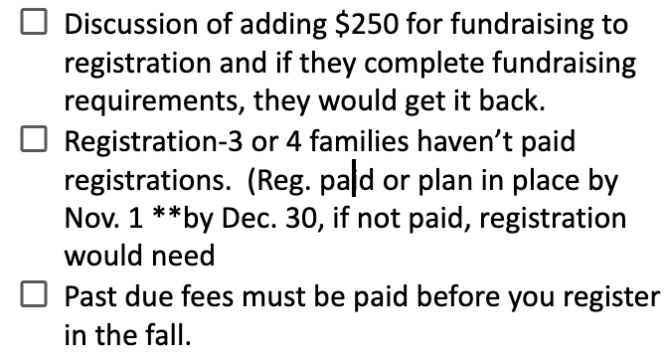
Action Items Future Meeting
 | Practice time with players on two teams

Other Topics

Facility Report?

Next Meeting:
9.11.24/6:30pm/Higher Grounds
Justin motion
2nd Chris

