Beaver Dam Hockey Association


Beaver Dam Family Center Ice Arena- 6pm

July 9, 2025
Agenda
Call to order | Justin - 6:05pm
Approval of minutes | Stacy/Andreya
Last Meeting Follow-up | None
Updates/Discussions
President
General Year Updates: | Facility: putting in ice - still too soft for practice, had work days - new paint and benches in 2 locker rooms  BDFC Board Meetings: approved raise for Opie, working doc for facility improvement that is reviewed monthly  Youth/Girls Hockey: Coed numbers are similar to last year, need just a few more at each level for both coed and girls.  SafeSport: need coordinator, does not need to be a board member
Vice President
General Year Updates: | Tournaments: Casey will send out dates, we will report to WAHA, add to website and start advertising  Golf Outing: looking for teams, sponsors, baskets and volunteers  Hockey 1 & 2: Closed registration at 40, sent out sign-up for families to come Sunday to get fitted for equipment.  Action: discuss how to prevent kids from other associations getting free ice time at learn to skates
Treasurer
General Year Updates | Finances – Invoices were sent out for work credits and volunteer hours. Current members and invoices that are up to several years old and past due.  Registration: Registration is open until August 4. There are 36 currently registered.  Scheduling: no spreadsheet only schedule on Crossbar  Fundraising: Pizza Ranch raised $650 to help fund learn to skate  Coordinator Positions/Committee needed  Ref coordinator - Shelley  Spirit wear - Aysha  Concessions - Corey  Jerseys - Natosha  Safesport - NEED  Fundraising - Tina  GameSheets - Andreya (recruit a few more) Casey will train  Action item - talk about who is entering volunteer slots in Crossbar
Secretary
General Year Updates | Website/social media/recruitment  Currently posting daily on both social accounts, pushing Open House to get new players registered before deadline

Board Member Elections: Please note that only members in good standing will be eligible to vote at the voters meeting per the BDHA Bylaws. Good standing is defined as: 1. Supports the purpose of the club and complies with financial membership requirements and these must be fulfilled 30 days prior to the meeting to vote.
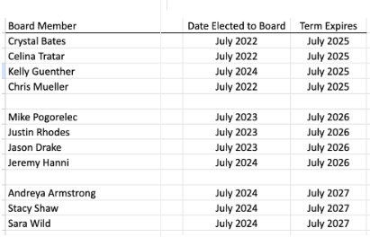
New nominations (4 positions): | Stacy nominated Kelly Guenther - accepted  Mike nominated Kayla Larson - accepted  Andreya nominated Casey - accepted  Casey nominated Becky - accepted  Stacy nominated Tina - accepted  5 were nominated with 4 open slots so there was a vote.  Board Members are:  Kelly Guenther  Kayla Larson  Tina Monroe  Casey Schaalma

Action Items- Previous Meeting (s)-
Action Items- Upcoming meeting(s)-

Next Meeting/Follow up to annual:
Thursday, July 10th @ 7pm
Virtual Meeting

