Feb. 27th, 2024
Start 6:31pm
Present: Moose, Chris, Lisa, Courtney, Greg and Sandra – Kara via phone call
Treasurer
- No update

Equipment

Fundraising
- June 4th at 3 Chipotle locations
- Chuck a puck is posted – just need one more for this Friday and it will be all filled
- Put a hold on volunteer opportunities until next board is in place

Volunteer fee- for the ones that already completed, waive for the following season?

Coach in Chief
- Josh S. – 10u Travel
- Mike – A Coach, Brad Peterson – B coach
- Jeremy – 14u
  - 27 players possibly, 2 teams?
- Brian – 16u
ALL IN FAVOR

-Look for the email from Steve K. potential coach

Old Business

Travel Tryout dates
- See Kara’s calendar – see option 3 – modified
Leaving 1st, 2nd, 3rd as is and 8th. 9th 6:30 10u/12u & 7:45 14u-18u – Make up day for try outs
- Wednes 3rd - 10u, 12u
- Monday 8th – 14u, 16u, 18u
- Tuesday – Make up day or coach requested
Cost for tryouts - $25 – ALL IN FAVOR
- Letter of intent for acceptance? April 20th?
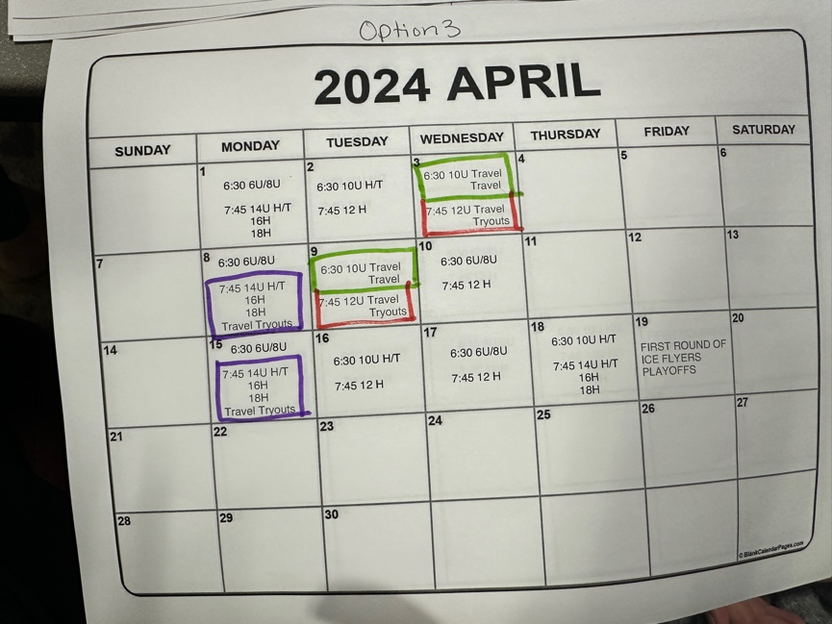

Bay Center gave 1 hour in March 28th
- Bring a friend skate?
- 8u an extra tryout before travel tryouts
- Try hockey for free – ALL IN FAVOR
  - Registration
  - Coaches on ice
  - Cap at 50
  - Contest – enter for LTP fees waived
  - QR code for registration for the next season

Google workspace transition
- Still have to log into the word press site. Ipage – not allowing us to log in
- We need Greg’s help
  - Create the google workspace. Domain expires June

Sponsorship T-shirt logos – all set
- Bay Center and Ice Flyer – can we check? Jess sent email during meeting

End of season party time/location
- Red Fish Blue Fish – April 13th 11a-2p
  - Will get back to us with price break down
  - Got rid of parking ticket issue

Year-end board member nominations and voting
- closing on the 10th of April
- announce on March 18th -27th nominations
- confirming 28th,29th,& 30th
- open voting on April 1st -5th

Helmet update from Ice Flyer connection
- Moose will follow up with Greg

New Business

Jersey for anonymous donor
- Yes, agree to give

Major donors
- Present to team managers
- List of the bigger donors for the next meeting
- Dollar amount up to team

Status of invoice paid for helmet stickers
- Invoice was sent to Kat and Tricia
  - Did it get paid?

Uniform swap in January?
- No further conversation about it at this point
- Need to get an okay from Greg

Open floor
- Present sponsorship package for Navy Federal

Brad wants to do an open dryland practice

Meeting adjourned
8: 25p

Next meeting March 13th 6:30p
- Nola

