- Go to https://lms.usahockeylearningcenter.com/learn/signin
- Click on Member Login
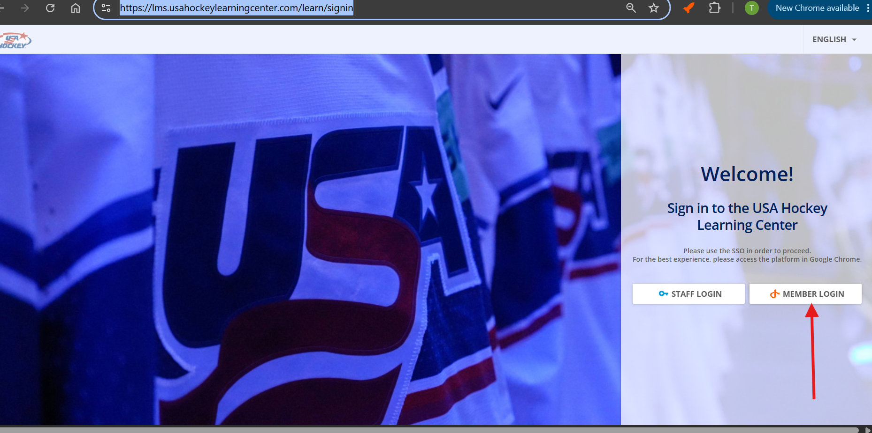
- Enter your Login information:
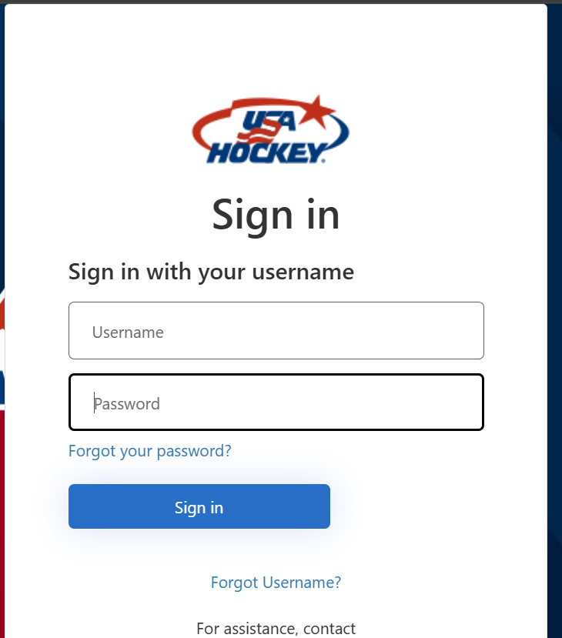
- Click on Coaches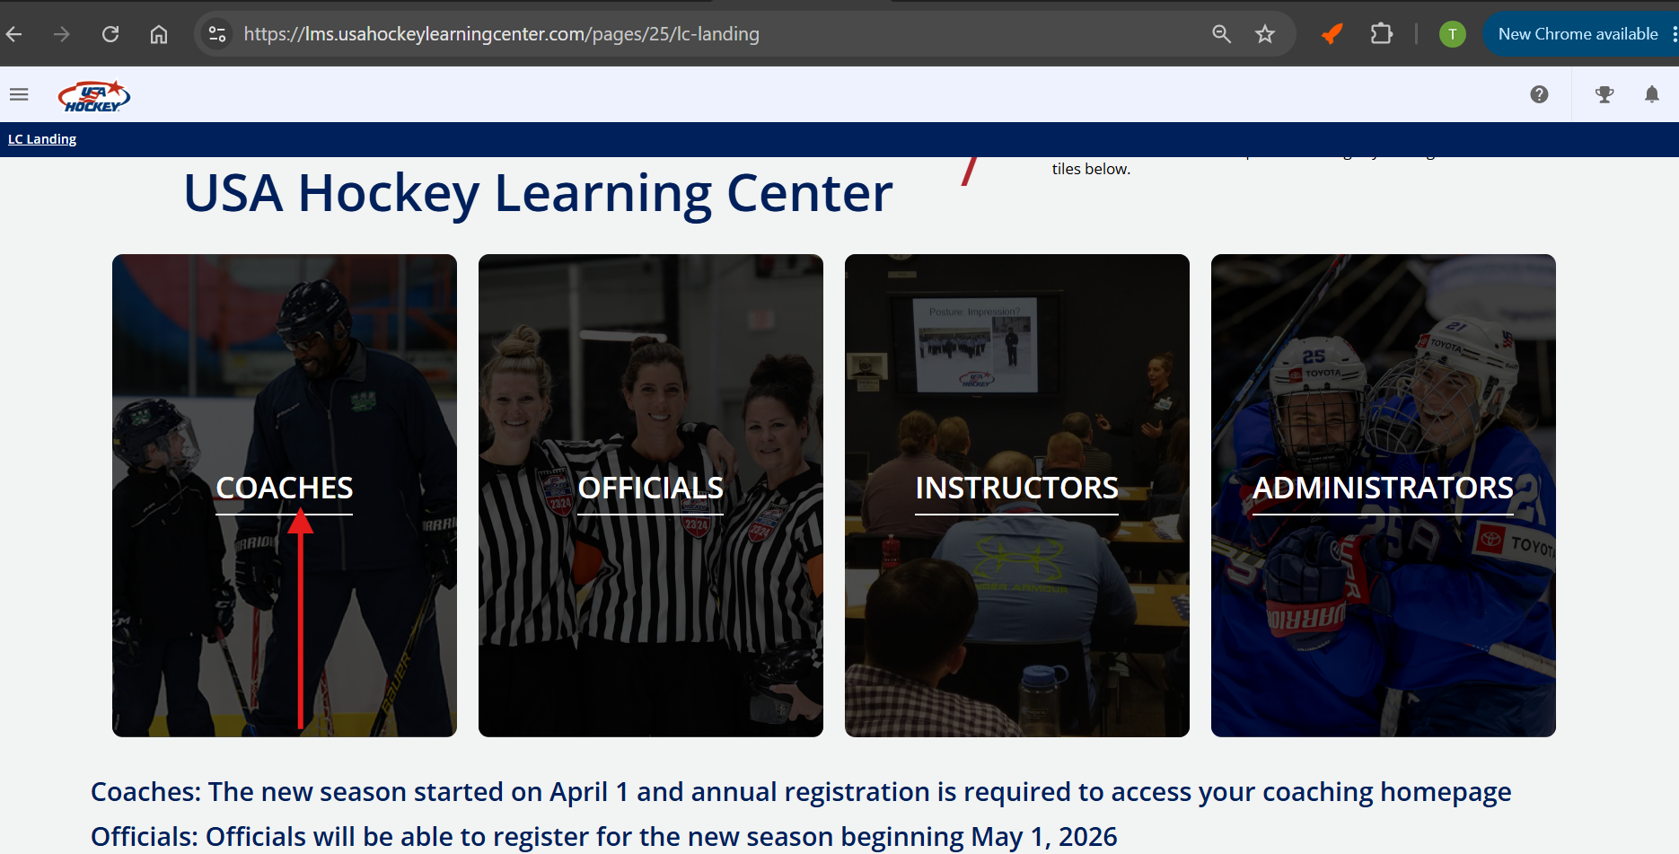
- On your profile page click on “VIEW MY ADDITIONAL INFO”
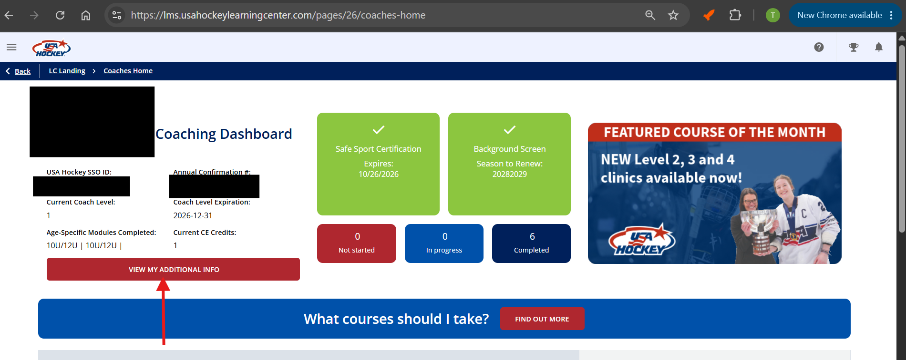
- It will then take you to your overview page
