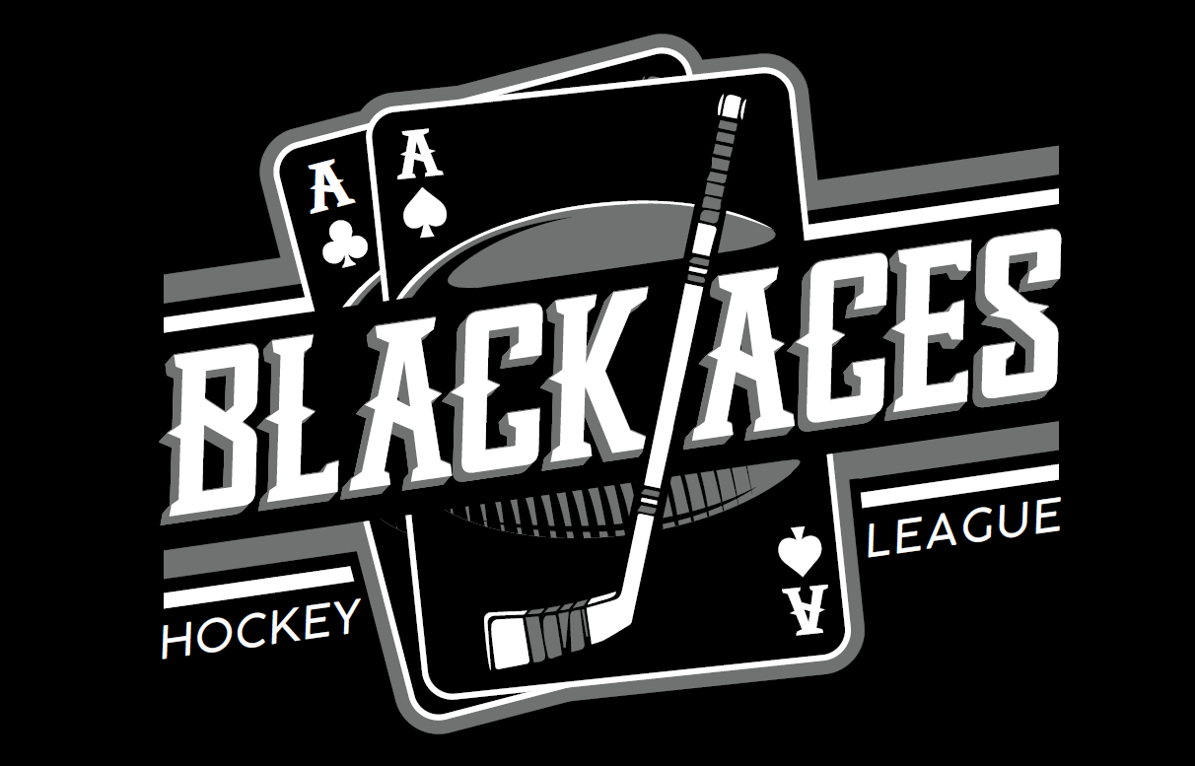
Registration Information/Rules

Overview and Features
League | Recreational; Adult (18+); No-Checking; COED teams - 2 divisions
Rink Locations | Family Sports Center (FSC)
Season Games | 8 regular season games; 1 Playoff single elimination, 1 Consolation Game,  1 Championship Game
Game Details | 3 – 15 minute periods; 1 hour game slots; on-line scheduling: pucks supplied
Team Roster Size | Minimum of 10 skaters and a maximum of 15 skaters and 1 goalie.
Team Draft | Prior to start of season, teams will be drafted by Captains based on hockey experience completed in registration to achieve skill-level parity.
Subs | Are coordinated only through division captains and must be a player registered within the league to play as a sub to fill in for a needed game
Fees | Player fee is $225. Goalies fee $0; $10 Non-District fee applies to any registrant (skaters and goalies) if you live out of District*
Payment Plan Options | Full Payment or 2 payment plan option; $125 at registration, remainder due on 15th of following month.
Scheduled Days of Play and Times | Mondays – Skills session for Black Aces registered players  Tuesdays – Avalanche Division (Intermediate/Advanced/Elite)  Thursdays – Nordiques Division (Beginner/Intermediate)  Game Times are 12:30 pm and 1:40 pm
Website | https://ssahl.org
Registration Link | https://ssahl.org
Ice Office Contacts | Dillon Whalen – Youth, Adult, Lunch League Hockey Coordinator DWhalen@ssprd.org  Alex Wegienka – Lunch League Co-Coordinator awegienka@ssprd.org  Susan Pfeiffer – Ice Office Administrator SusanP@ssprd.org 303-754-0584
Team and Player Information
All Players | Players MUST register, pay $225 registration fee and sign the waivers before they can play a game
(Captain) | - Dillon will be selecting team captains for each division prior to season starting. Please select the captain option in the registration if you are interested in helping and want to be a team captain for the season.  - Register for the season, pay $225 registration fee and sign Waivers before you get on the ice. After season begins, $50 dollar incentive refund will be applied to your season dues.  - Pay $10 Non-District Fee if you do not live in district.  - Captains lunch provided by the Avalanche Grill to select teams – week before season. Date/Time to be determined – Dillon will notify.  - Captains can be offered a captain spot for following seasons based on Dillon’s review of current season.
New Player | - Register for the season, pay $225 registration fee and sign Waivers before you get on the ice.  - Pay $10 Non-District Fee if you do not live in district.  - Players are drafted to teams by Captains, a week prior to start of season
Goalies | - Register for the season, (no registration fee this season) and sign Waivers before you get on the ice.  - Pay $10 Non-District Fee if you do not live in district.

Other Information
SSAHL and SSPRD Disclaimer | SSAHL and South Suburban Parks and Recreation reserve the right to modify or make additions to the league rules, Code of Conduct and the Registration Information/Rules document without notice, for the benefit of the overall league or to conform to the latest government guidelines. Updates are published on the websites ssprd.org and ssahl.org
*District Residency and where to obtain Photo ID | Anyone who rents or owns property in the South Suburban District is a District Resident. To find out more information about obtaining a photo ID, click on the following link: https://www.ssprd.org/About/Residency/Residency-Checker
Indemnification, Release and Waiver of Liability | This waiver is included in the registration and must be signed. It states that by registering, registrant releases and indemnifies the District, its employees, agents, contractors, or volunteers from and against any and all claims, demands, loss of injury to person or property, caused during participation in the activity.
Registration/Rules Form | South Suburban’s Black Aces Adult Hockey Lunch League attempts to practice and instill the values of good sportsmanship in all participants. “Black Aces Hockey League” will supply each player with a copy of the Registration/Rules Information in the registration confirmation email.

Draft & Player Ranking
Divisions | Black Aces Hockey League will be 2 divisions with a mixture of different skill levels drafted to each team.  Nordiques Division - Beginner/Intermediate Players – Thursdays  1 - Never Played or less than 1 year experience  2 - Adult League - D4 and D5  3 - Played some youth hockey or began playing as an adult  4 - Adult League - D3  Avalanche Division - Intermediate/Advanced/Elite Players – Tuesdays  5 - Adult League - D2 Level and High School  6 - Adult League - B or C Level and High School  7 - Collegiate Tier 1 or 2, Juniors  8 - Pro, Semi-Pro

USA Hockey Rule Book followed by SSAHL
Black Aces Hockey League follows the USA Hockey rule book with some additions or exceptions contained in this Registration/Rules Information Form.
Run Time/Stop Time | 15 minute run time, unless score differential is 3 or less, revert to stop time in the last 3 minutes; if at any time during the third period, the differential is more than a 3-goal differential, the clock returns to regular run clock.
Icing | Blue Line Icing
Face-Offs | - Start of Game  - Start of each Period  - When a goal is Scored  - When goalie freezes the puck  - Icing  - Offsides  - Delay of Game  - Puck out of play  - Or penalty has been called
Offsides | No Delayed offsides – Automatic whistle and faceoff
Ringer Rule | 3 goal maximum per game, applies to ALL Divisions. This rule applies to the Playoff and Championship game, therefore a player with 3 goals in regulation time is ineligible to participate in the shootout.  NOTE: If a single player scores a 4th goal, it doesn’t count and the team is assessed a 2 minute bench minor penalty for Delay of Game.
Shootout | In the event of a tie, there will be a 3 player shootout (there will be 3 pairs of shooters per team.) If the game is still tied, it goes to a sudden death shootout. If a player has achieved the “Ringer Rule” in regulation time they will not be allowed to shoot in the shootout) Home team decides if they would like to shoot 1st or 2nd.
Rosters | Maximum of 15 players on a roster - 15 skaters and 1 goalie. Only REGISTERED/ROSTERED players are allowed to play.
Jerseys | Team jerseys are supplied by Black Aces Hockey League.
Register before play | All players are required to REGISTER ONLINE, and in the process sign the online waiver, BEFORE ever skating.
Subs | Are coordinated only through division captains and/or league coordinator and must be a player registered within the league to play as a sub to fill in for a needed game.

Penalties and Suspensions
Penalty Times | Minor Penalty: 2 minutes Major Penalty: 5 minutes Misconduct: 10 minutes  When a call is made the clock continues to run unless in 3rd period the 3 goal differential 3 minute stop time. Clock will stop then for the call.
Maximum of 3 Penalties in One Game | A player receiving 3 penalties in a game will be ejected from the game immediately after the 3rd penalty. This is just an ejection from the current game, it is not a Game Misconduct
Game Misconducts & Fighting | Game Misconduct or Fighting – Removed from the league with no refund
Excessive Penalties | - Any player receiving a total of 20 minutes in penalties during the regular season, will receive a one (1) game suspension that will carry over into the Playoffs.  - Any player receiving a total of 40 minutes in penalties during the regular season will receive a two (2) game suspension that will carry over into the Playoffs.  - Any player receiving 60 or more minutes in penalties during the regular season will be suspended from the league for the balance of the season including Playoffs.
Miscellaneous Information on Penalties and Suspensions | - Players suspended for the balance of the season, including the Playoff season, will NOT receive a refund.  - Players receiving a Game Misconduct or Fighting will be removed from the league with no refund  - Any skater found playing who has not fully completed his/her suspension may be immediately removed from the ice and have another 2 games added to their suspension.  - A team Captain may be suspended for using ineligible players.  - Any suspensions and/or probations will carry over to the next Black Aces Hockey League season in which the player participates (winter, spring, summer).  - There are no appeals of the Referee’s calls.  - There is no video review if you are asked to leave for Game Misconduct or Fighting.  - The Black Aces Hockey League Coordinator and South Suburban Parks and Recreation Management’s decisions are final.

Additional Rules for Playoffs, Consolation & Championship – Overtime/Shootout
- In the event of a tie, there will be a 3 on 3 five-minute run clock overtime. In the event of a penalty the number of players will turn into a 4 on 3 with the team assed the penalty down a player. When the penalty expires, the player can return to the ice for a 4 on 4 until the play has received a whistle which will result in the play going back to a 3 on 3. If the game is still tied, it goes into a sudden death shootout.
- In the event of a tie, after Overtime has expired, there will be a shootout with 3 pairs of shooters (3 players from each team). Roster (except goalies) must shoot before any player can shoot a second time.
- If a player has achieved the “Ringer Rule” in regulation they will not be allowed to shoot in the shootout.
- If a player is serving a penalty when overtime ends, the player in the penalty box is ineligible to participate in the shootout. The only exception is if the penalty is a bench minor (too many men on the ice). All Divisions utilize the 3-goal limit per player per game and it still applies for Playoff Season; therefore a player with 3 goals in regulation or overtime is ineligible to participate in the shootout.
- Each team selects 3 skaters from their team to take a shot one at a time against the opposing goaltender, with teams alternating shots.
- After the 6 players have all taken their shots, the team with the most goals is declared the winner.
- Shootouts that are still tied after 3 skaters from each team have taken shots, the shootout continues with an additional pair of skaters and enters a 1 on 1 sudden death until one team has won the advantage (assuring that each team has taken an equal number of shots). The shootout may end earlier, if one team has scored more goals than the opposing team could score with its remaining shooters. All skaters eligible for the shootout on a team’s roster must shoot before any player can shoot a second time.

