O’FALLON HOCKEY CLUB BOARD OF DIRECTORS

Meeting Agenda for the August 20th , 2024 Meeting
At the O’Fallon VFW, 6:00pm
I. Meeting shall be called to order at 6:00 pm
A. Board members present: Lisa, Scott, Tricia, Jen, Mike E, Will
B. Additional attendance: None
C. Approval of the minutes from the previous meeting: Eker motioned to approve and Engfehr seconded, all approve.
D. Membership request to address the board: Will nominated Jen as VP, all in favor
II. New Board Member vote and new position appointments
A. Appoint Board Member Point of Contact for all events
1. City Fest
- Scott will supervise games
- Lisa will supervise parade
2. Pink at the Rink - Will Catalano
3. Alumni Night - Will Catalano
4. Senior Night - Mike Ecker
5. Banquet - TBD as time gets closer
B.Appoint Board Member Volunteer Coordinators
1. JV-Chris Sherman
2. Varsity - Mike Ecker
- Process for collecting money is 50/50 person will give to designated Board member who will immediately text the amount collected to Tricia at 773.405.6444.
III. Coach Loehring Updates
- Everything is going well
- Off ice will continue through out October and will be on Saturdays following practice
IV. MVCHA Updates
- 9/15 IMR team spreadsheet is due, we would like to submit by 9/8; assigned to Matt
- Board members need: Lisa will send link out to Board members
  - Background checks
  - Safesport
  - USA hockey number
- All schools meeting is 9/18, 6:00 p.m. at RP Lunch. Scott is out of town and will ask a coach to attend
V. Budget and Financial Update
- Reviewed July budget; ice cost is less than budgeted so revised annual budget. Still at a deficit but less.
- Will motioned to approve the revised budget; Jen seconded and all approved
VI. Upcoming event planning
- City Fest this Saturday
  - Parade
    - Need truck/trailer
    - Need a board member to arrange decorating
    - Candy, poster board ect pickup
    - Need Board Member or coach to walk with players or drive
  - Game Volunteers
    - Still in need of more volunteers
- Pink at the Rink
  - Finalize which clubs will participate
- Commiting to Varsity game with Belleville on 10/22 @ 5:15-7:15
  - Varsity only or JV and Varsity
- TBD waiting to hear if can get another sheet of ice from Ice Hawks
  - Triad JV game
  - Potentially more games
- Will is the Board member contact for Pink at the Rink;

VII. Fundraising
- Raffle
  - Online or paper raffle - hold on raffle, Lisa will research
  - What to raffle off
    - Item (gun raffle example)
    - money
  - Online Raffle Websites
www.zeffy.com/
https://rallyup.com/raffles/
https://join.betterworld.org/
https://raffall.com/en
https://www.eventgroove.com/fundraising/online-raffles/
https://www.galabid.com/raffle-global?&lang=US
www.rafflesnow.com

- Other Ideas - will continue to explore ideas and options
  - Super Bowl squares - Board is interested in running this in January: Tricia will research
  - Car wash serra Honda (Jenn has done this before)
  - Pancake Breakfast-would need host location
  - Holiday Online Popcorn sales; Will and Jen will research
  - Wristbands (for team and for sale ) maybe $5 each

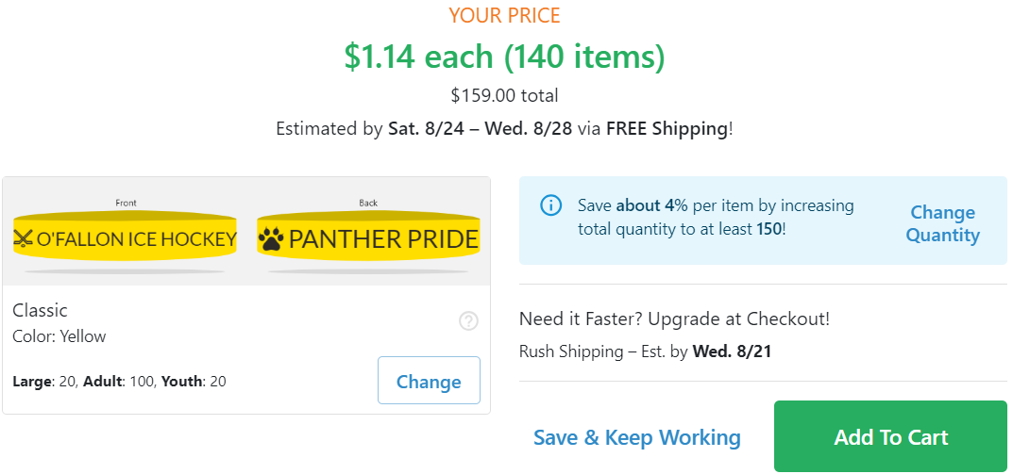

  - Any additional ideas

VIII. Other Needs and Discussions:
- Any Other Topic: None
- Next Board Meeting: September 24, 2024 at 6:00

