O’FALLON HOCKEY CLUB BOARD OF DIRECTORS

Meeting Agenda for the August 20th , 2024 Meeting
At the O’Fallon VFW, 6:00pm
I. Meeting shall be called to order at 6:00 pm
A. Board members present:
B. Additional attendance:
C. Approval of the minutes from the previous meeting:
D. Membership request to address the board:
II. New Board Member vote and new position appointments
A. Appoint Board Member Point of Contact for all events
1. City Fest
2. Pink at the Rink
3. Alumni Night
4. Senior Night
5. Banquet
Appoint Board Member Volunteer Coordinators
1. JV-Chris Sherman
2. Varsity
III. Coach Loehring Updates
IV. MVCHA Updates
V. Budget and Financial Update
VI. Upcoming event planning
- City Fest this Saturday
  - Parade
    - Need truck/trailer
    - Need a board member to arrange decorating
    - Candy, poster board ect pickup
    - Need Board Member or coach to walk with players or drive
  - Game Volunteers
    - Still in need of more volunteers
- Pink at the Rink
  - Finalize which clubs will participate
  - Finalize date: tentative 2 hours block on 10/22 @ 5:15-7:15
  - Varsity only or JV and Varsity

VII. Fundraising
- Raffle
  - Online or paper raffle
  - What to raffle off
    - Item (gun raffle example)
    - money
  - Online Raffle Websites
www.zeffy.com/
https://rallyup.com/raffles/
https://join.betterworld.org/
https://raffall.com/en
https://www.eventgroove.com/fundraising/online-raffles/
https://www.galabid.com/raffle-global?&lang=US
www.rafflesnow.com

- Other Ideas
  - Car wash serra Honda (Jenn has done this before)
  - Pancake Breakfast-would need host location
  - Holiday Online Popcorn sales
  - Wristbands (for team and for sale ) maybe $5 each

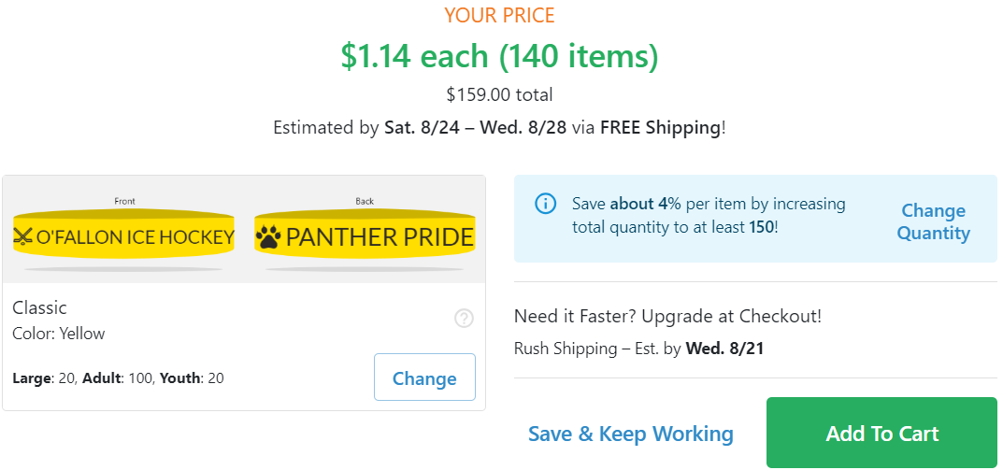
  - Any additional ideas

VIII. Other Needs and Discussions:
- Any Other Topic:
- Next Board Meeting:

