South Indianapolis Youth Hockey Association
5/8/24 Board Meeting Notes
Date of Meeting: 5/8/24 @7PM via Zoom
Next meeting:

Present: Tony Kerins, Andrew Parsons, Jay Washington, Tyler Klassen, Shannon Romine. Alicia Boesgard, Ashleigh Taylor, Henry (Rachael Brunett check in – did not attend entire meeting)
Absent: N/A

Agenda:

- 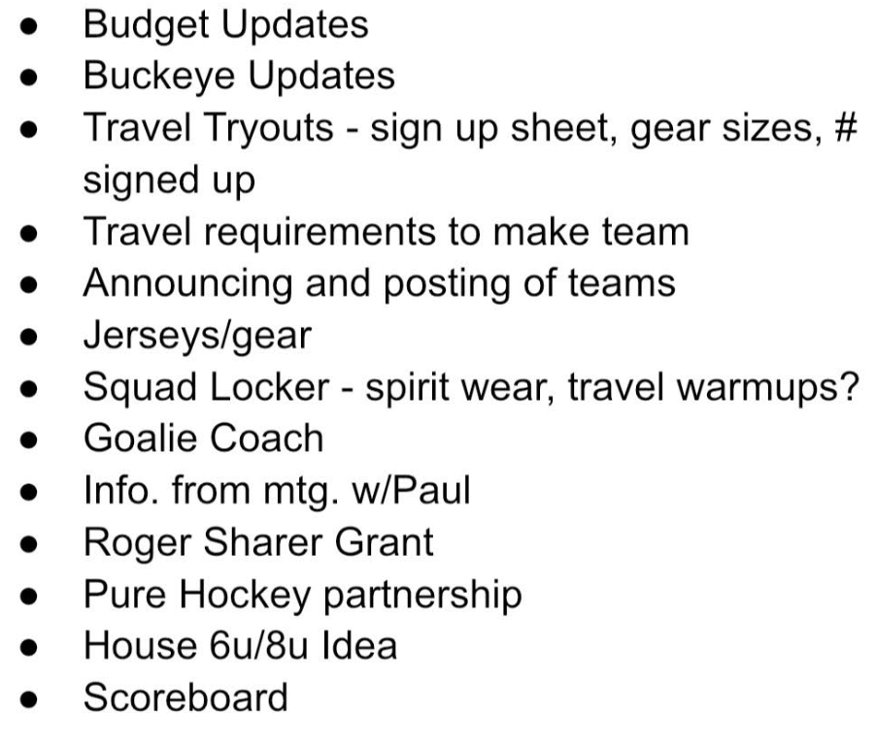

- Finances/Fundraising
- House Business
- Travel Business
- Coaching and Certifications
- Marketing/Communication
- Other Business
- Future Business

Notes:
Finances/Fundraising
- Budget updates – finished based on final numbers. Under $400/mo most likely
$300 deposit to accept team offer.
- Roger Sharrer Award submitted
- Working with Pure Hockey on potential sponsorship, Sharks night, etc.

House Business
Sycamore wants to work with us at 6u/8u. Should we consider a practice devoted to
skating only to lay better foundations. Tristate also willing to do the same. Ashleigh in
touch with Sycamore.

Travel Business
- Buckeye updates: Currently reviewing all the bylaws. Agreed to ask Jordan Taylor to stay as an alternate representative.

- Tryouts
Coverage – still open spots to cover for check in and sizing at tryouts
Numbers registered – 40 total across the three teams
Sizing – Jay has samples in process
Andrew will send out email asking kids to bring light and dark jersey for tryouts
Will ask assistant coaches to supervise locker rooms at tryouts
Will publish a statement about not accepting additional players that did not attend
interest skates or tryouts if cuts were made for that age team.

Coaching and Certifications
- New travel applicant – agreed that application process was over; will be up to that assigned coach to decide if he wants to add another assistant. Henry is overseeing.
- Goalie coach – Stars coach might help but wants paid; Ashleigh talking to another option
Will look at cost and impact to budgets

Marketing/Communication

Other Business
- Jay met with Squad Locker, rep has not sent requested info
- Andrew and Ashleigh met with Paul
Pop Weaver will be open for ice times
7/27 or 8/3 for glass cleaning with ice credit for volunteer hours (Alicia will coordinate
again)
Discussed ways to partner with Backcheck to raise funds through sponsorship and events that can be requested from the organization

- Friendship games – Erik discussed games with St. Louis organization and wrote up a statement that he will share with coaches and manage.
- Scoreboard still not scheduled, but working on it

Future Business
- Jay will look into volunteer opportunities that pay back to SIYHA (Speedway, Gainbridge). Will start with 1-2 events with proceeds likely to go to the individuals involved.

