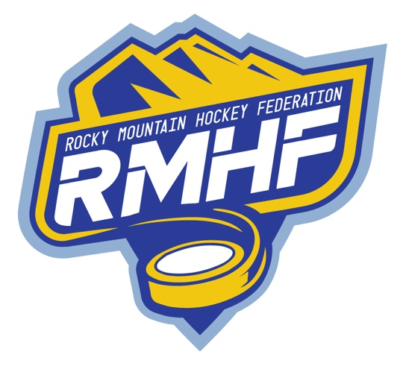
Rocky Mountain Hockey Federation
Rules and Regulations
2nd Annual October League Showcase
October 18-20, 2024

Game Scoring Responsibilities
Scoring and Clock Responsibilities for each game are as follows:
- Home team is responsible for Clock and Scoring
- If “HOME” team is an Out of State team and Colorado team is “AWAY” team, the Colorado team will be responsible for clock and scoring for that game. Out of state teams will not be responsible for clock or scoring for any game.
- If a Colorado team is playing at their home arena that team will be responsible for clock and scoring regardless of being “Home” or “Away”. (e.g. Arapahoe 12UAA is listed as “AWAY” vs NCYH 12UAA “HOME” and playing at SSSC Rink #1, Arapahoe 12UAA will be responsible for clock and scoring.)

GAMESHEET TOURNAMENT CODE – ipad-rmhf-showcase

1 - A check of credentials and qualifications will take place before each team competes. Required documents shall include:
USAH 1-T Roster – must be submitted three weeks in advance of the showcase.
Travel permits for all teams (as required)
2 - Only USA Hockey registered teams will be allowed to enter. The RMHF follows all 2021-2025 USA Hockey Rules and only USA Hockey certified officials will officiate games.

The USA Hockey Sanctioned Tournament SafeSport Program Protocol will be adhered to.

3 - An entry fee of an amount to be calculated after the showcase event with each team sharing an equal portion of per game expenses. There is no admission fee for spectators.
4 - This will be a USA Hockey sanctioned showcase for Tier II and Recreational Divisions include:
- Tier II and Travel Rec: 18U, 16U, 14U, 12U, 10U
- The showcase is open to teams properly registered with USA Hockey
- Only USA Hockey Officials will officiate showcase games.
5 - There will be a minimum of five teams at each age division competing in a showcase format. Games will be scored in Game Sheets. Points will be awarded according to the following point system: 2 points for a win, 1 point for a tie, and 0 points for a loss.
6 - Game Length / Penalty Minutes:
Tier II/ Travel AA - All games will have 3-stop time periods as well as 5-minute warm-up with period duration as follows:
10U AA – 12:01 / Penalty Length 1:30
12U AA- 14:00 / Penalty Length 1:30
14U AA- 16 minutes / Penalty Length 2:00
16U AA - 16 minutes with no ice-make / Penalty Length 2:00

Recreational - All games will have 3-stop time periods as well as a 5-minute warm-up with period duration as follows:
10U A/B – 12:01 / Penalty Length 1:30
12U A/B – 14:00 / Penalty Length 1:30
14U A/B – 14:00 / Penalty Length 2:00
7 - No game will be played under curfew rules - however if at any time during the third period the score differential is 4 or more, the game clock will go to running time. Stop time will only resume when the deficit is reduced to less than four goals. When in running time, a penalty will start when play resumes.

8 - Showcase officials reserve the right to end any game or move any game to running time if the officials and/or referee deem the game has become unsafe, or to recover time in the showcase schedule.
9 – Once time-out will be permitted per team per game.
11 - A tie game after regulation play will end in a tie with each team being awarded 1 point.
13 - Teams are required to check in one hour before their scheduled game time for locker room assignments and all teams will be flexible and cooperative in the event that start times or rink assignments need to be changed. The first game of the day will start on schedule.
14 - Penalty Box will be covered by volunteers from participating teams in each game. The team designated as HOME shall cover their penalty box and the team designated as VISITOR shall cover their penalty box. NO coaching from the penalty box. The RMHF will have varying scoring and clock procedures for each facility. These procedures will be shared in advance of the showcase.
15 - Teams must be ready to take the ice within 2 minutes after the Zamboni doors have closed unless directed otherwise by showcase officials. The warm-up period will start when the Zamboni doors close.
16 - Locker rooms will be assigned prior to each game and keys will be checked out at the showcase table or at venue's front desk before each game. The Head coach, or one of their assistants if they are not available, is totally responsible for the locker room. This responsibility CANNOT be delegated to a parent volunteer, or any other individual that is not an assistant coach on the team. All meetings being held in a locker room between a player and a coach must be monitored by an additional adult. Teams are required to leave their locker room clean and damage free. Showcase officials will inspect for damage and cleanliness after each game. Teams will be held responsible for following the USAH locker room policy and any damage to the locker rooms will be repaired at the expense of the team/player responsible for the damage. Teams will be refused a locker room for the remainder of the Showcase if there are issues. Locking the locker room during the game is the responsibility of the team. The RMHF and showcase venues are not responsible for lost or stolen items.
17 - The showcase committee through its directors will handle protests and disputes. The director will act in the best interest of the players, coaches, and the game in general. The director’s decisions are final and not subject to appeal. Issues relating to officiating are not subject to the jurisdiction of the showcase director. Coaches may make a formal written appeal regarding officiating to the showcase committee no sooner than 12 hours after the game in question has ended. At that time, a meeting of the showcase committee and the director of officiating will convene to consider the appeal. The decision of the showcase committee and the director of officiating will be final. The fee for a written appeal is $150.00 and is payable when filing the appeal with the showcase director.
19 - Any player receiving a major penalty for fisticuffs (fighting) will receive a 1-game suspension from USA Hockey. The RMHF will impose an additional 2 games, unless reviewed and overturned by the showcase committee. The player must leave the ice surface and team bench area immediately. Any player receiving 4 penalties in a game will receive a game misconduct.
20 - Any player, coach, team, team official, parent, or spectator who demonstrates rude, vulgar, damaging, or unsportsmanlike conduct during the duration of the showcase at any of the showcase venues and/or on hotel property is subject to discipline by the RMHF showcase committee. This may include removal from ice arena/hotel property, suspension from games, or expulsion from the entire showcase/hotel stay.
21 - All players are required to wear mouth guards.
22 - Only the head coach or the team manager may express concerns to the showcase director and/or other showcase officials.
23 - No noise devices allowed. This includes, but is not limited to, bells and horns.
24 - The following rules are mandated by CAHA:
1. Any team which enters a showcase, which fails to appear on time for a scheduled game or refuses to play, shall (1) forfeit all of its games, (2) shall pay for all expenses, including but not limited to referee’s fees and all ice costs for each forfeited game and shall be denied entry in any showcases for the remainder of the season.
2. All showcase participants must place on file with the showcase committee before the first showcase game, a copy of the Team Roster Form which has been approved and signed by their USA Hockey Registrar. If any team shall fail to comply with this rule, that team shall forfeit all games until the proper signed and sealed team roster is presented to the showcase committee. The team violating this rule shall remain obligated to and shall pay all financial obligations to all opponents for the forfeited game costs and the league or showcase entry fees.
25 - All teams must register in the age-appropriate level/division per the USA Hockey sanctioned levels. Any team found in violation of these rules will forfeit 100% of the showcase registration fee, no exceptions.
26 – Games will be results will be posted on Game Sheets within 24 hours of game being completed. Standings will be shown on the CAHA Website.
27. – The RMHF WILL NOT provide warm-up pucks for local teams.

