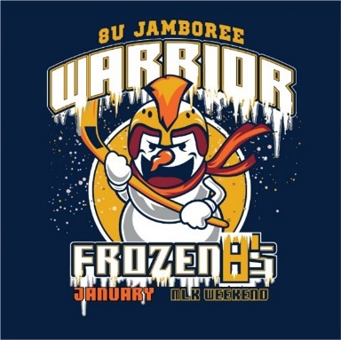

5th Annual 8U Warrior Frozen 8’s Jamboree
January 16th – 19th 2026
Credentials Check and Qualifications
- Teams are required to check-in one hour prior to their first scheduled game. A mandatory credential check shall include the following documents: (must have certified signed rosters before allowed to play in jamboree).
- Official USA Hockey Certified 1-T roster for the 2025-2026 season signed by associate registrar. Must be received no later than 2 weeks prior to the tournament.
  - Must include the following: Players, Player Numbers, Goalies Identified, All Coaches and at least one Team Manager.
- Coaches must be listed on the team roster or will not be allowed on the bench.
Age Classification and Level of Play
- This is a USAH sanctioned jamboree. All players and teams must be properly registered with USA Hockey.
-8U Advanced
-8U Intermediate
-8U Beginner
Fees and Registration
- Non-refundable entry fee due upon team registration no later than January 2, 2026.
  - Beginner $700
  - Advanced & Intermediate $750
- No fee for spectators to watch games.
- Teams will be notified of acceptance upon receipt of application and fee.
- If your team is not accepted, the entry fee will be refunded by January 30, 2026.
Safe Sport Compliance
- The USAH Sanctioned Tournament Safe Sport Program Protocol will be adhered to.
Skills Competition
- A skills competition will be offered for players to test their individual skills against their peers.
- Separate registration to participate due no later than January 4, 2026.
Rinks and Location
All games will be played at South Suburban Sports Complex: 4810 E. County Line Rd, Littleton, CO 80126
Arrival Time
Teams should arrive at the rink at least one hour prior to their game. Games may start early and teams should be dressed and ready to play 10 minutes prior to their scheduled game time.
Games (All games played with blue pucks supplied by Arapahoe hockey)
Intermediate and Advanced games will be divided with hard boards. Beginner games will be divided with soft dividers.
- Beginner division – Guaranteed (6) 26 minute, runtime, 4v4 cross ice games, mini nets and no goalies.
- Advanced & Intermediate – Guaranteed (6) 26 minute, runtime, 4v4 half ice games, intermediate nets with goalies.
- Arapahoe to provide clock personnel to manage time.
- A buzzer will sound every 2 minutes to signal line changes.
- Game results will not be displayed on the scoreboard or on CAHA electronic scoring system.
Any team that fails to appear on time for a scheduled game or any team failing to provide a valid 1-T roster to the Tournament Director prior to the first game of the tournament will be subject to:
- Forfeit all tournament games as determined by the Tournament Director.
- Pay for all expenses, including but not limited to referee fees and ice costs for each forfeited game.
- Denied entry in any CO tournaments for the remainder of the season and in the case of a CAHA team, any approved travel permits will be rescinded.
Rules and Regulations
The goal of our jamboree is to promote the enjoyment of ice hockey, good sportsmanship, teamwork and fair play.
- Current USA Hockey ADM league rules shall govern hockey play.
- A penalized player will be removed from their current shift and replaced with another player from the team.
- Tournament rules are posted online at: www.ayhl.com
- All games will be officiated by registered officials in good standing with USAH.
  - Referees are typically younger and limited with prior experience. Ensure parents know we teach good sportsmanship at all times.
- As a courtesy to all teams and spectators – No Noise Makers – no horns, cowbells, drums etc. will be permitted in the building.
- Games will count towards maximum allowed per ADM policies.
- Game scores will not be kept or posted on ESS.
Jerseys
- All players must wear a numbered jersey in the proper team color. It is recommended that teams bring both sets of jerseys to each game.
- Home teams are to wear a white or light colored jersey and the Visiting team wear dark colored jerseys.
- The Tournament Director reserves the right to change color designation if necessary.
- Neck Guards are mandatory for all participants. If a player is not wearing a neck guard, they will be asked to leave the game by the officials and cannot participate until they one is worn.
Locker Rooms
- Locker rooms are the responsibility of the head coach and cannot be delegated to a volunteer or individual that is not on the team’s 1-T roster.
- Two teams will be assigned to a locker room due to there being four teams on the ice at once while four more teams getting ready for the next games.
- You may dress your players in the skate rental area. Once players are dressed, teams may assemble by the rink glass to talk to players.
- Teams are required to leave their locker room clean and damage free.
- It is recommended that players come dressed for their team’s scheduled events.

Awards
- All players will receive a participation package.

