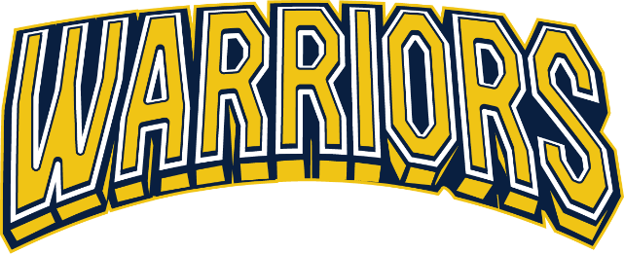

2026 – 2027 Arapahoe Youth Hockey League (AYHL)
Warriors Recreational Fall/Winter Programming Information and Fees
 | 10U  (2016 – 2017) | 12U  (2015-2016) | 14U  (2012 – 2013) | 16U (2010-2011)  18U (2008-2009)
League Fees | $1,550 | $1,550 | $1,600 | $1,600
SSPRD Non-Resident (if applicable) | $30 | $30 | $30 | $30
Deposit | $500 + ($30 non-resident if applicable) | $500 + ($30 non-resident if applicable) | $500 + ($30 non-resident if applicable) | $500 + ($30 non-resident if applicable)
Payment Options | Full OR Deposit + payments | Full OR Deposit + payments | Full OR Deposit + payments | Full OR Deposit + payments
Payment Due Dates | $525-October 15th;  $525-November 15th | $525-October 15th;  $525-November 15th | $550-October 15th;  $550-November 15th | $550-October 15th;  $550-November 15th
Additional Season Fees (collected by Team Manager) | Estimated Team Fees: $400 - $600 for additional tournaments and team events | Estimated Team Fees: $400 - $600 for additional tournaments and team events | Estimated Team Fees: $400 - $600 for additional tournaments and team events | Estimated Team Fees: $400 - $600 for additional tournaments and team events
Weekly Practices* | 1 – shared ice; Tues, Wed, Thurs or Fri | 1 – shared ice; Tues, Wed, Thurs or Fri | 1 – shared ice; Tues, Wed, Thurs or Fri | 1 – shared ice; Mon, Tues, Thurs or Fri
Games | 16 games;  1 or 2 per weekend | 16 games;  1 or 2 per weekend | 16 games;  1 or 2per weekend | 16 games;  1 or 2per weekend
Skills & Drills | Bi-weekly - Mondays | Bi-weekly - Mondays | Bi-weekly - Mondays | -
Tournaments Included | Mile High Meltdown | Mile High Meltdown | Mile High Meltdown | Mile High Meltdown
Additional Tournaments | Max 2 In-State | Max 3 In-State | Max 3 In-State | Max 3 In-State
Registration Deadline | September 1 | August 15 | August 15 | August 15
Evaluation Dates** | Sept 14 & 15 | Aug 31 & Sept 1 | Aug 29 & Aug 30 | Aug 29 & Aug 30
Season Length*** | September – February | September – February | September – February | September - February
Equipment required | Full hockey gear | Full hockey gear | Full hockey gear | Full hockey gear
Sports Apparel Included | Reversible jersey, socks, helmet decals | Reversible jersey, socks, helmet decals | Reversible jersey, socks, helmet decals | Reversible jersey, socks, helmet decals

* Day and time slot will be determined once teams are formed
** Evaluation dates subject to change – will follow travel tryout dates
*** Consists of 2 seasons: Fall Season: September – October
Tiered season: November – February (tiering placements 10/26 – 11/1)

