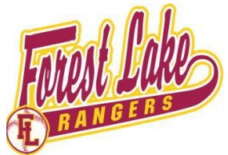

FOREST LAKE BASEBALL ASSOCIATION
High School Scholarship

Welcome to the 2026 FLBA High School Scholarship Application. In 2026, we will be awarding two scholarship winners that will receive $1000 from Forest Lake Baseball Association (FLBA).
If an applicant does not complete the application completely, that applicant will be eliminated from consideration.
Scholarship criteria:
- Applicant must plan to enroll in college for the 2026 - 2027 academic school year.
- Applicant must have participated in baseball with FLBA for a minimum of 3 seasons.
- Applicant must submit a video essay (minimum 45 seconds) of themselves, including the following criteria:
  - Name
  - Post-High School aspirations
  - Community involvement – explain how you have given back to your community during your high school career.
  - Impact – explain how playing baseball in Forest Lake has impacted your life
- Application deadline is 4/10/2026.

Player Information
Name: _________________________________________________ Date of Birth: _______________________

College Enrolled in for Fall 2026: __________________________________________________________________________________________

GPA: _____________________________________________________________________________________

Video Link: ________________________________________________________________________________

Please submit the completed scholarship form and video to
FLBAboard@gmail.com

