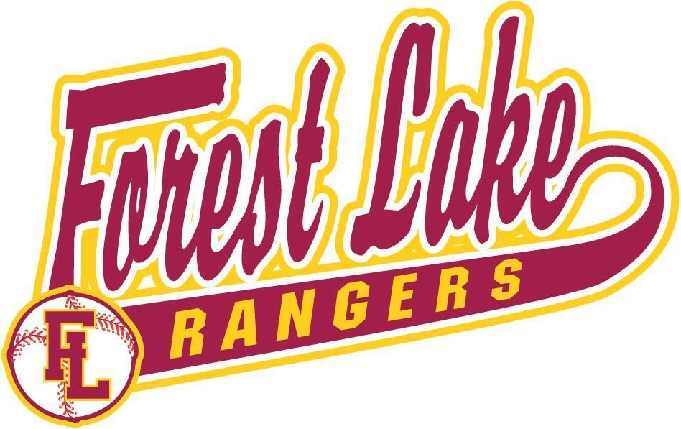
2025
FLBA
Traveling Baseball Manual

www.flbaseball.org

TABLE OF CONTENTS
FLAAA 4
BOARD OF DIRECTORS 4
PHILOSOPHY OF THE FOREST LAKE BASEBALL ASSOCIATION 5
Commitment to Baseball 6
CODES OF CONDUCT
Code of Conduct for COACHES 6
Code of Conduct for PLAYERS 6
Code of Conduct for PARENTS 7
GSBL & MYAS CODE OF CONDUCT 7
FLBA 2023 SCOPE OF PROGRAM 8
PLAYERS
2023 Age Eligibility Rules 8
Playing on School Teams 8
FLBA Residency Requirements 9
Player Attendance Expectations 10
FLBA Player Discipline/Removal 10
COACHES
Coach Selection 11
Coach Incentive Grant 11
Coach Development 11
Coach Discipline/Removal 11
Coach Grievance Procedure 12
GAMES/TOURNAMENTS
Duration of Playing Season 12
Number of Games Played 12
Tournament Guidelines 12
Registering for Tournaments 13
AAU 13
Affiliations 14
How to get Tournament Fees Paid 14
TEAMS
Team Selection Process 14
Size of Teams 15
Absence Policy for Tryouts 15
Player Association Waiver Request 16
Team Information 16
Team Manager 16
FEES AND FUNDING
Payment/Collection of Fees 17
Policy of Reduction of Fees 17
Fee Reduction for Coaches, Board Members & Board Volunteers 17
Sponsors 17
Funding requests going to FLAAA 17
Team Fundraising 18
Volunteer Hours 18

EQUIPMENT 18

FIELDS/GYMS 18

Using School Gyms 19
UNIFORMS
Ordering Team Uniforms 19
Uniform Rules 19
UMPIRES 20
MEDICAL CONSENT FORM 20
MEDICAL DISCLAIMER 20
BIRTH CERTIFICATE 20
FALL BALL 20
FIELD AUTHORIZATION LETTER 21

FOREST LAKE AREA ATHLETIC ASSOCIATION
Forest Lake Baseball Association (FLBA) is a sport organization within the Forest Lake Area Athletic Association (FLAAA). The mission of FLAAA is:

Supporting and participating in the positive development of Youth
The general philosophy of FLAAA is to support all organized, approved youth activities in a positive environment. The primary activities are athletics that are activities operating under the umbrella of FLAAA. The primary areas of support are the communities included in the boundaries of Independent School District #831.
The goal of FLAAA is to encourage positive learning from coaches as well as to model and develop good citizenship now and in the future for the betterment of the individual and its communities. FLAAA also supports other non-athletic youth activities, such as humanitarian needs, community events, schools and individual requests as approved by the Board of Directors.
FLAAA’s programs include softball, football, volleyball, baseball, and basketball. Although FLAAA works closely with the Forest Lake School District, they are not affiliated or funded by them in any way. Funding for FLAAA comes from the sale of pull tabs at various locations.
FLAAA contributes funds to maintain and improve the city (Fenway) and school district playing
fields.

BOARD OF DIRECTORS
FLBA is managed by a Board of Directors who is assisted by many volunteers. The Board is responsible for the policy direction of the organization as well as implementing many of the tasks necessary to provide the program.
The Board meets every month on the second Sunday of the month at 6:30pm. Meeting times may change during May-July. Visitors are always welcome at Board meetings. The FLBA website has the dates/times/locations listed.
The Board consists of 13 members who hold up to 3-year terms. The current Board of Directors consists of the following individuals:
Executive Board of Directors:
Brandon Henry Jeremy Trapp |  | John Vette
651-303-2002 651-235-8431 |  | 320-492-6326
President | Vice President | Secretary
Lori Harms | Tyler Kroschel
651-428-5828  Treasurer | 651-235-8283  Travel Director
Board of Directors:
Melanie Hicks | Ann Madden Amy Remitz
651-274-8056 NorthStar Director | 651-253-1469 651-278-1235
Luke Hanegraaf | Brandi Anderson | Corey Kloos
651-248-0923 | 763-248-0856 | 651-597-9655
Fall Ball Director  FLAAA Representative |  | Field Coordinator
Bub Lovas
651-235-8133
Kale Henry, Forest Lake High School Coach, advisor to the Board. 612-325-1977
Volunteers who assist with the program:
Randy Johnson
FLAAA Rep/Umpires

Board elections are held in September of each year. If interested in a Board position, contact the Board Chair. Contact info can be found on the website.

PHILOSOPHY OF THE FOREST LAKE BASEBALL ASSOCIATION
It is the philosophy of FLBA to provide a program that emphasizes fun, development of sound baseball skills and healthy competition. At the younger ages, the emphasis will be on the development of sound baseball skills, moving toward a more competitive program at the older ages. Ages 9 -11 are considered “Developmental”, ages 12-13 “Transitional” and ages 14-19 “Competitive”. Some guidelines for each group are as follows:
Developmental (ages 9 -11):
- Stress sound baseball skill development over competition.
- Coaches should attempt to get players a minimum of 3 innings of play in every league game.
- Coaches should attempt to give players exposure to both infield and outfield positions in game situations (not necessarily in every game).
- There should be more emphasis on practice and less focus on games and tournaments.
Transitional (ages 12-13):
- Focus on skill development with increasing competition each year from 12 to 13.
- Coaches should attempt to get players a minimum of 2 innings of play in every league game.
- Players should be given opportunities to play many positions, especially early in the year, with increasing position specialization each year from 12 to 13.
- Game and tournament focus increases from 12 to 13 but practices should still play a MAJOR role in overall season activities.
Competitive (ages 14-19):
- No playing time is guaranteed but coaches are encouraged to get every player some playing time in every league game.
- Skill development focused on primary position(s).
- Finer points and refined skills taught in practices. Practices are still critical to player and team development!

Commitment to Traveling Baseball
- Traveling Baseball is a very serious commitment.
- Players are expected to be present at all practices and games.
- Traveling Baseball MUST take priority over other sports during the Baseball season.

FLBA CODES OF CONDUCT
The Forest Lake Baseball Association adheres to the following Codes of Conduct. All coaches are expected to practice the Coach’s code and share the Player’s and Parent’s Code with their team/parents.

Code of Conduct for Coaches*
- I will not berate the officials or "trash talk" to my opponent.
- I will not use profanity.
- I will encourage good sportsmanship by demonstrating positive support for all players, coaches, contest administrators and officials at every game.
- I will place the emotional and physical well-being of my teammates and opponents ahead of my personal desire to win.
- I will treat other players, coaches, fans and officials with respect regardless of race, gender, creed or ability.
- I will demand a sports environment that is free from drugs, tobacco, electronic cigarettes (vaping) and alcohol and will refrain from their use at all MYAS sporting events.
- I will do my best to remember that youth sports are supposed to be FUN and that winning and losing are part of everyone's experience.
- I will express my concerns through the proper channels in a dignified manner.
- I will respect the volunteers that are assisting with the conduct of these events.
- I will respect and adhere to the rules governing eligibility and competition.
- I will not post on any social media site with the intent to initiate, hurt, intimidate or humiliate any player, coach, official, spectator or the FLBA program. The posting of negative, demeaning or derogatory comments will not be tolerated. These acts shall be considered harassment and may result in the immediate removal from the club. Furthermore, if I see anything of concern from or about an official, another FLBA coach, player or FLBA member on a social media site, I will immediately contact an FLBA board member.
*Violations of these codes can result in discipline/removal from the team.

Code of Conduct for Players*
- I will not berate the officials or "trash talk" to my opponent.
- I will not use profanity.
- I will encourage good sportsmanship by demonstrating positive support for all players, coaches, contest administrators and officials at every game.
- I will place the emotional and physical well-being of my teammates and opponents ahead of my personal desire to win.
- I will treat other players, coaches, fans and officials with respect regardless of race, gender, creed or ability.
- I will demand a sports environment that is free from drugs, tobacco, electronic cigarettes (vaping) and alcohol and will refrain from their use at all MYAS sporting events.
- I will do my best to remember that youth sports are supposed to be FUN and that winning and losing are part of everyone's experience.
- I will express my concerns through the proper channels in a dignified manner.
- I will respect the volunteers that are assisting with the conduct of these events.
- I will respect and adhere to the rules governing eligibility and competition.
- I will not post on any social media site with the intent to initiate, hurt, intimidate or humiliate any player, coach, official, spectator or the FLBA program. The posting of negative, demeaning or derogatory comments will not be tolerated. These acts shall be considered harassment and may result in the immediate removal from the club. Furthermore, if I see anything of concern from or about an official, another FLBA coach, player or FLBA member on a social media site, I will immediately contact an FLBA board member.
- During out of town tournaments I will represent Forest Lake Baseball Association in a positive way. I will represent Forest Lake Baseball Association both on the field and off the field in a positive manner by adhering to all tournament rules as well as hotel property rules. I am responsible for any damage to property that occurs. Any violation of this part of the code of conduct could result in discipline, suspension or removal from the team or removal from future out of town tournaments. *Violations of these codes can result in discipline/removal from the team.

Code of Conduct for Parents*
- I will encourage good sportsmanship by demonstrating positive support for all players, coaches, contest administrators and officials at every game.
- I will place the emotional and physical well-being of the athletes ahead of my personal desire to win.
- I will demand a sports environment that is free from drugs, tobacco, electronic cigarettes (vaping) and alcohol and will refrain from their use at all MYAS sporting events.
- I will remember that the game is for the kids - not the adults.
- I will do my best to make sure that youth sports are a FUN and POSITIVE experience.
- I will treat other players, coaches, fans, volunteers and officials with respect regardless of race, sex, creed or ability.
- I will not berate the officials.
- I will not undermine the coaches' instructions or directions.
- I will not use profanity.
- I will communicate my concerns through the proper channels in a dignified manner.
- I will not post on any social media site with the intent to initiate, hurt, intimidate or humiliate any player, coach, official, spectator or the FLBA program. The posting of negative, demeaning or derogatory comments will not be tolerated. These acts shall be considered harassment and may result in the immediate removal from the club. Furthermore, if I see anything of concern from or about an official, another FLBA coach, player or FLBA member on a social media site, I will immediately contact an FLBA board member. As a parent, I understand that I am accountable for the actions of my child on social media sites. I will stress to my child the importance of proper conduct on these sites and provide parental oversight to prevent any type of cyber-bullying by my child.
*Violations of this code may result in officials asking parent(s)/fan(s) to leave the ballpark.
*Multiple violations may result in parent(s)/fan(s) being banned from all baseball events for the remainder of the year.

GSBL & MYAS CODE OF CONDUCT
For current Code of Conduct, please click the following tab: https://www.forestlakebaseball.org/player-resources/player-code-of-conduct/6586

FLBA 2024 SCOPE OF PROGRAM
Forest Lake Baseball Association will offer a Traveling Baseball Program for youth ages 8-19. We will provide opportunities for both league and tournament play. Given an adequate number of players in each age group, the competition levels and number of teams are expected to be as follows for 2024, but are subject to change. .
9’s | Up to two teams designated based upon tryout scores
10’s - 12’s | Up to 3 teams, potentially at the AAA, AA, and A levels
13’s | Up to 3 teams, using a AAA, AA, and A level format
14’s | Up to 2 teams, at the AAA, and AA levels
15’s | 1 AAA team
16s - 19s | 1 “AAA” level team of 16’s (VFW) only
The actual number and level of teams will be determined upon completion of tryouts.
Teams will be placed in VFW, MBA, MBL, and Gopher State Leagues as decided by the Board.

PLAYERS

2024 AGE Eligibility Rules
9-14-Year-Old Teams:
In general, players will play with their grade level UNLESS they are too old under league rules. The league restriction is:
9-year-old Team (3rd grade) | Must be 9 (or younger) on April 30, 2024
10-year-old Team(4th grade) | Must be 10 (or younger) on April 30, 2024
11-year-old Team(5th grade) | Must be 11 (or younger) on April 30, 2024
12-year-old Team(6th grade) | Must be 12 (or younger) on April 30, 2024
13-year-old Team (7th grade) | Must be 13 (or younger) on April 30, 2024
14-year-old Team(8th grade) | Must be 14 (or younger) on April 30, 2024
Exceptions:
- An exceptional player may request approval to play above his grade/age level. The parents must request approval from the Eligibility Committee* prior to tryouts.
- Players may request approval to play below their grade level (if they meet league restrictions). This request must be made to the Eligibility Committee* prior to tryouts.
- If a player chooses to try out to play above his grade/age level and end up cut, they will not be automatically placed on grade/age appropriate team.
Once a decision has been made to play above or below the player’s grade level, the player will stay with that group in future years. All age eligibility requests to play up or below grade/age level need to be completed at 11U and below.
15-19-Year-Old Teams:
The high school level coaches will place players on the team that best suits the player, as long as the player qualifies under league rules.
For questions contact Travel Director
*Eligibility Committee Petition form can be found at www.flbaseball.org

FLBA RESIDENCY REQUIREMENTS
9-14-Year-Old

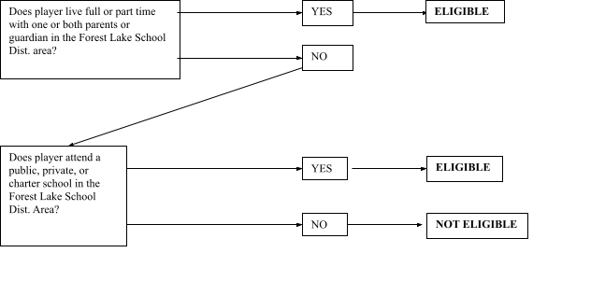
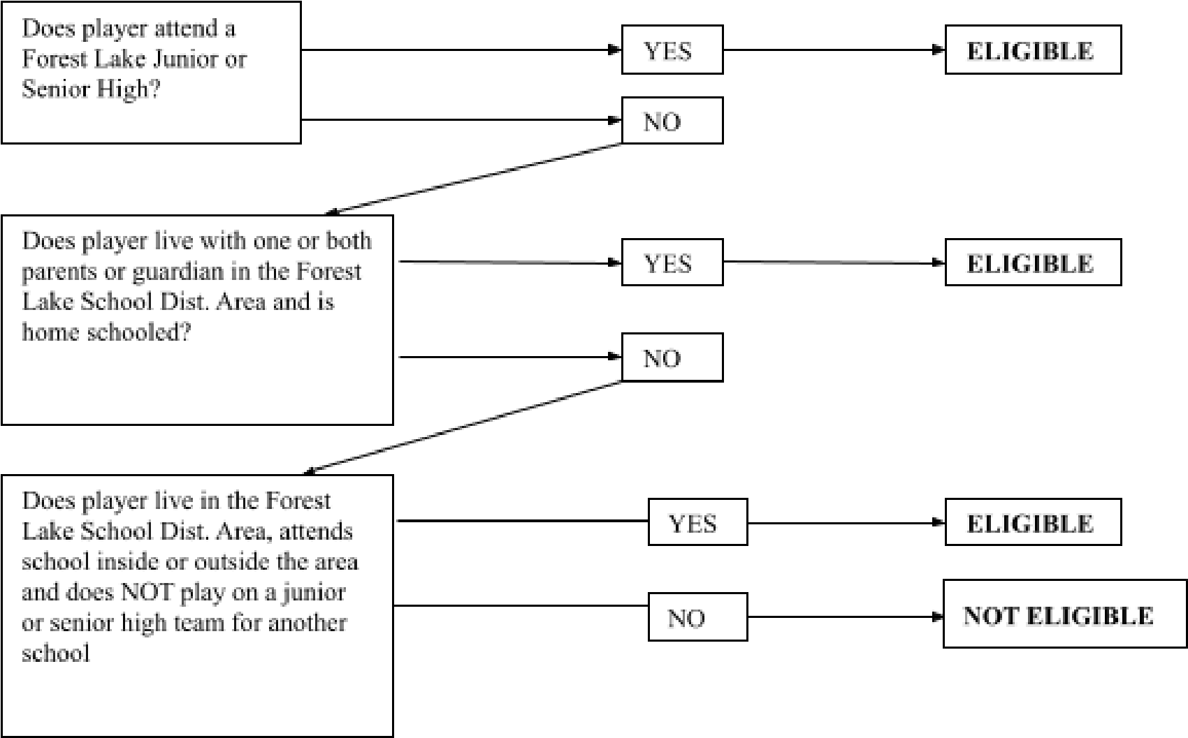
15-19-
Year-Old Teams

Player Attendance Expectations
Players are expected to be at ALL practices, games and tournaments Player attendance guidelines are as follows:
- 1-4 absences – Coach discretion on consequences
- 5th absence – Cannot start the following game
- 6th absence – Suspension for one game
- 7th absence – Suspended indefinitely, pending an appeal to the FLBA Board.
- Extended illness, injury, or tragedy in the family does not count as an absence.
- Participating in any Junior High Baseball game or practice does not count as an absence.
- Players should ALWAYS notify their Coach as early as possible when they will be absent.
- The Head Coach is allowed some discretion for extenuating circumstances.

FLBA Player Discipline/Removal
Players may be disciplined or removed from a team following violations of the FLBA Players Code of Conduct.
A player will be corrected immediately (1st warning) by the coach for:
- Throwing equipment (bat or helmet)
- Swearing
- Verbally or physically abusing an umpire, coach, another player or spectator.
- Any violation of the Player Code of Conduct.
Process for dealing with violations after 1st warning:
- 1st offense: the player is ejected for the remainder of the game (must remain on the bench). Coach will present a brief written report of the situation to the FLBA President
- 2nd offense: the player is not allowed to participate further until the player, his parents, and the coach meet with the FLBA Executive Board to discuss the player’s behavior and develop a plan of correction. The FLBA President must be informed of the situation and the plan of correction. The best course of action which can include suspension from the team or complete removal from the team.
- 3rd offense: removal from the team.
- If removal is agreed to as the best course of action, a representative from the Executive Board will contact the parents with the details of the situation. Once removed from an FLBA team, the player may NOT join another FLBA team under any circumstances and the full registration fee will be forfeited.
If removal from the team is warranted, the following must occur:
- If a head coach determines that removal is warranted, he should discuss it with his full coaching staff before taking action.
- If the full coaching staff determines that removal is the correct course of action, the head coach should discuss the circumstances of the situation with the FLBA President and the Travel Director before taking any action.
- If removal is still agreed to as the best course of action, the head coach should contact the parents with the details of the situation. Once removed from a FLBA team, the player MAY NOT join another FLBA team under any circumstances and the full registration fee will be forfeited.
*Any violation of the Code of Conduct may be grounds for immediate suspension, duration of suspension to be determined by the Executive Board.

COACHES

Coach Selection
Coaches need to apply each year for a head coaching position. Head coaches are assigned for one year only. There is no guaranteed right to the position in following years. A Board Committee will select a head coach for each team based on any of the following
- information in the application,
- past record with FLBA,
- parent evaluation,
- an in-person interview
The best qualified coach for each age group will be selected. Priority will be given to a non-parent coach if skills and abilities are equal to or better than that of a parent coach. Unless necessary, there will be no parent coaches at the 15-16-year-old level.
Assistant coaches will generally be selected by the head coach. However, the Board Coach Selection Committee reserves the right to assign an assistant coach when there are well-qualified persons seeking coaching positions.

Coach Incentive Grant
FLBA wants to recruit and retain the best possible coaching staff for the program. As such, we recognize the extraordinary commitment made by coaches who give of their time and talent. The Board of FLBA desires to recognize this effort with an incentive grant to coaches. In order to be eligible for the incentive grant the coach must meet the following criteria:
- Have no child on the team they are coaching
- Have demonstrated high level coaching skills during the season
Any Board member can nominate a coach for an incentive grant at the conclusion of the season. The grants will be approved by the board. The Board decision on incentive grants is final.

Coach Development
It is recommended that coaches attend one or more coach training sessions put on by the U of M, Bethel College or other qualified organizations. In addition, it is required that coaches attend one training session put on by FLBA prior to the start of the season. Assistant coaches are encouraged, but not required, to attend coach development sessions.

All board members, head coaches and assistant coaches will complete and pass the Trusted Coaches program prior to contact with players:
- Positive Coaching Alliance
- First Aid Training
- Concussion Training
- Background Check

Coach Discipline/Removal
Coaches are expected to adhere to the Coaches Code of Conduct as put out by FLAAA, FLBA, and the baseball leagues. They are also expected to follow the FLBA rules and the rules of the league in which they play. Violations of the code and/or rules can result in discipline or removal of the coach. Parents, Assistant Coaches or others can file a grievance against the coach if there is noted conduct or other concerns. The process for reviewing and acting on grievances will be followed.
*Any Coach ejected from a game must notify the Travel Director within 24 hrs.

Coach Grievance Procedure
Even the best of coaches will occasionally have a parent who disagrees with his/her actions or decisions. Usually these can be resolved with an honest discussion between the two. However, sometimes additional steps need to be taken. Forest Lake Baseball Association has developed a step by step procedure for these situations. If differences cannot be resolved between the coach and the parent, an impartial grievance committee will review the situation and decide on a course of action.
Step #1: | 48 Hour Rule-Wait 48 hours before acting. This “time out” MUST be taken to allow emotions to cool.
Step #2: | Talk to your Team’s Coach- Find an appropriate time, away from the team, to discuss the problem.
Step #3: | File an Official Grievance-An official grievance form can be obtained either from the Head Coach or Team Manager or by calling FLBA President. It can also be found on our website www.flbaseball.org
Step #4: | Grievance Committee Review-A grievance committee of the Executive Board will gather information and decide on a course of action to resolve the issue.

GAMES/TOURNAMENTS

Duration of Playing Season
The official playing season for FLBA goes from May to the 1st of August each year. (Play may go longer if moving on to national competition.) Coaches are expected to plan for play during this entire time. Individual participation in baseball activities at other times of the year is encouraged. There may be opportunities for Fall Baseball through
MYAS.

Number of Games Played
Coaches are expected to follow these rules for MAXIMUM number of games played as listed below:
AGE | Maximum Number of Games
9 | 25 (12 league games and 13 other)
10 | 35 (16 league games and 19 other)
11 | 35 (16 league games and 19 other)
12 | 40 (16 league games and 24 other)
13 | 40 (16 league games and 24 other)
14 | 40 (16 league games and 24 other)
15 | 45 (16 league games and 29 other)
16 | 45 (18 league games and 27 other)
17-19 | 45 (16 league games and 29 other)
Total number of games does not include regional or national tournament games IF such tournament participation was EARNED during the current year’s qualifying process.

Tournament Guidelines
Coaches are expected to follow the guidelines for tournament participation as listed below:
AGE | # of 2-3 day tournaments allowed | # of one day tournaments allowed | Tournament total cost not to exceed
9 | 2  Includes any/all State | No limit: must stay within total cost | $1000
10 | 4  Includes any/all State | No limit: must stay within total cost | $1,800
11 | 4  Includes any/all State | No limit: must stay within total cost | $1,800
12 | 5  Includes any/all State | No limit: must stay within total cost | $2,300
13 | 5  Includes any/all State | No limit: must stay within total cost | $2,300
14 | 5  Includes any/all State | No limit: must stay within total cost | $2,300
15 | 5  Includes any/all State | No limit: must stay within total cost | $2,300
16 | 3  Includes any/all State | No limit: must stay within total cost | $1,400
17-19 | 1  Includes any/all State | No limit: must stay within total cost | $500
Total number of tournaments and total cost allowed does not include regional or national tournament participation IF such tournament participation was EARNED during the current year’s qualifying process.
FLBA will cover a gate fee IF the tournament was selected by the board tournament committee. Gate fees for tournaments selected by the coach or the team, including state tournaments, will be covered FLBA for one tournament, and beyond that, by the participating team. Team selected tournaments must pay the admission fee or “Gate Fee” by the team. These fees WILL NOT be paid by FLBA. Coaches should NOT include this fee when requesting payment for tournaments.
It is recommended that each team have only one out of town “stay over” tournament each season.
There may be special circumstances to these tournament rules. In such cases the Coach must get Board approval before registering for tournaments.
***Teams playing in tournaments that exceed FLBA limits may not use FLBA equipment or uniforms and cannot register as a FLBA team unless approved by FLBA.

Registering for Tournaments
Tournament information can be obtained from:
www.myas.org MYAS Tournaments
http://www.msf1.org/baseball.htm MSF Tournaments
http://www.mnmba.com AAU/MBA Tournaments http://www.mbt.bz/ MBT Tournaments

Affiliations
FLBA will participate in the Gopher State, VFW and the MBA Leagues. Coaches can participate in tournaments sponsored by MYAS, MBT, VFW, MSF, or Junior Legion. However, due to the extra cost involved, participation in AAU is not encouraged.
FLBA is a member of the Forest Lake Area Athletic Association. FLAAA supports youth programs for approximately 1500-2000 boys and girls annually. FLAAA has been instrumental in supporting sports and other youth activities in our community.

How to get Tournament Fees Paid
Requests for payment of tournament fees go to the Treasurer. Reimbursement form can be found on the website under Forms.
Each request must have proper documentation including name of tournament, dates, and who to mail the check to. Reimbursements will be processed within 14 days once received.

TEAMS

Team Selection Process
9 – 12-year-old players:
FLBA will place teams at the appropriate level (AAA, AA, or A) where they will be the most competitive based on past performances, tryout scores and number of kids trying out.
· All players must be registered with FLBA prior to tryouts.
- Top team for each age level will have 12 players, while lower teams can be adjusted to up to 13 players contingent upon tryout scores and registration numbers. All decisions by the board will be final.
· Tryout Evaluators will rate each player and place in rank order.
· The top 8 players will be assigned to the top designated team. o If you are a top 8 player, you must play on the top level team.
· Ties for the 8th spot are resolved using a Tie-Breaker method. The first tie breaker will be the hitting score. The second tie breaker will be the pitching score and final tie breaker will be the infield score in that order.
· The top level team Head Coach will pick an additional 4 players.
· If only 1 second tier team is created, the top 8 players remaining will be assigned to that team. (Ties for the 8th spot will be determined as outlined above). The Head Coach will pick an additional 4 players. · If a third team is added in addition to the top two designated teams, the top 8 players remaining will be assigned to that team. The Head Coach will pick an additional 4 players.
· If 2 equal tier teams are created, the teams will be formed using the following procedure: o The top 16 Players will be placed locked and then placed by draft on teams. o Each coach will then get 4 picks using the draft format.
o Ties for the 16th spot will be determined as outlined above
13-year-old players:
· All players must be registered with FLBA prior to tryouts.
- Top team for each age level will have 12 players, while lower teams can be adjusted to up to 13 players contingent upon tryout scores and registration numbers. All decisions by the board will be final.
· Tryout Evaluators will rate each player and place in rank order.
· The top 8 players will be assigned to the “AAA” Team . o If you are a top 8 player, you must play on the “AAA” or top level team.
· Ties for the 8th spot (at “AAA”, “AA”, and “A”) are resolved using a Tie-Breaker method. The first tie breaker will be the hitting score. The second tie breaker will be the pitching score and final tie breaker will be the infield score in that order.
· The “AAA” Head Coach will pick an additional 4 players.
· If only 1 “AA” team is created, the top 8 players remaining will be assigned to the “AA” team. (Ties for the 8th spot will be determined as outlined above) The “AA” team Head Coach will pick an additional 4 players.
· If 1 “A” team is added in addition to 1 “AAA” and 1 “AA” team, the top 8 players remaining will be assigned to the “A” team. The “A” team Head Coach will pick an additional 4 players.
· If 2 equal “AA” teams are created, (which would eliminate the “A” team) the teams will be formed using the following procedure: o The top 16 Players will be placed locked and then placed by draft on teams. o Each coach will then get 4 picks using the draft format.
o Ties for the 16th spot will be determined as outlined above
14-year-old players (1 “AAA” team or 1”AAA” team and 1 “AA” Team and 1 “A” team)
- The top 7 players will be assigned to the “AAA” Team.
- The “AAA” Head Coach will pick an additional 5 players
- Ties for the 7th spot are resolved using a Tie-Breaker method. The first tie breaker will be the hitting score. The second tie breaker will be the pitching score and final tie breaker will be the infield score in that order.
- The top 7 players remaining will be assigned to the “AA” team. The “AA” team Head Coach will pick an additional 5 players. (Ties for the 7th spot will be determined as outlined above)
15-16’s
- All players must indicate interest with the High School baseball coach.
- Pre-season workout sessions will be held to determine teams and league placement.
- The High School Head Coach acts as an advisor to the teams and can request moving a player to a higher-level team. All coaches and players involved should agree on the move.
- Dual rostering will be allowed between teams at this age level, but all players must retain allegiance to their primary team. All coaches must agree when players are asked to play on their “secondary” team on a game-by-game basis.
- Dual rostering with the Legion team will be allowed, but all players must meet the minimum attendance requirements set by the FLBA to remain on an FLBA team.
- Teams will be created by the high school coach based upon performance this season.

For all age groups, in the event of no coach at roster formation, the team will be determined by the rank order of the roster size for that age group.
Size of Teams
All teams will have a minimum of 11 players, with roster size at the discretion of the board based upon registration numbers, unless Board Tryout Directors approve otherwise.

Absence Policy for Tryouts
To be eligible to be placed on highest level team in age group, player must attend tryouts or submit medical exemption that includes a doctors note within 48 hours of first day of tryout date. A player’s past participation (number of years, along with level of play) will factor into decisions made by the committee.
The following criteria shall be followed (for ALL absent players):
- The absent player shall receive a total score of zero (0) for the tryouts
- The absent player will always have to be a coach pick (outside of locked players)
- Injury absence must require a letter from the player’s doctor stating severity of the injury, recovery time expected and completeness of recovery.

Player with NO previous FLBA history and medical exemption (1st year in program/prior year cut):
1. Player eligible to be a pick only at the lowest level of completion established at level for which they are registered (A or AA only)
Player WITH previous FLBA history and medical exemption (played with FLBA prior year):
- Player eligible to be a pick only at the same level of competition at which they played the previous year OR a pick at a lower level of competition (player cannot be picked for a higher level of competition than what was participated in the previous year.
FLBA recognizes that our athletes at times will be participating in state tournaments for other sports and in an effort to support multi-sport athletes, if a player is in a state tournament over tryout weekend the following must be done:
- Notify FLBA Travel Director at least 5 days in advance providing proof of participation and that the state tournament will conflict with the designated tryout time.
- ALL players must attend at least 1 day of tryouts in order to calculate a score.

Player Association Waiver Request

Players wishing to play for another association may petition the Forest Lake Baseball Association Executive Board for a waiver. Waivers must be presented in writing to the FLBA Board no later than 7 days prior to scheduled tryouts. A petition must include, at a minimum, a complete explanation of the reason for the request and the impact granting the request would have on the player and the association. The Executive Committee will review each request independently and present to the entire FLBA Board for discussion and a formal vote to grant or deny. The decision by the FLBA Board is final.

When a waiver to another association is granted, it is to be considered permanent. A player must petition the board with a waiver acceptance request to rejoin the Forest Lake Baseball Association for future seasons.

Team Information
Coaches/Team Managers are expected to provide information to the FLBA Board prior to the start of the baseball season. The information should include the following and should be sent to the Secretary
- Name and contact information for the head coach, assistant coaches, team manager and all players.
- Contact information should include home address, phone numbers and email address.

Team Manager
Every Team is required to have a team manager (TM). It is the role of the TM to assist the head coach with the administrative tasks of running the team. The specific responsibilities of the team manager are determined by the Head Coach, but the following are suggested:
- Collect any fees due
- Coordinate coaches t-shirt and hat
- Team Roster: Prepare and submit annual team roster
- Set up and maintain Team website through MYAS
- Tournament entry forms: Prepare and submit tournament entry forms. Request and secure payment from the Treasurer. Contact info can be found on website under Board Members.
- Publicity: prepare news updates on your team (pictures can be used) and get to FLBA Travel Director.
- Information to parents: Maintain good communication with parents around the logistics of the team. Make sure everyone has information on schedules, locations, tournament info etc.
- The Board contact for Team Managers is the Team Manager Coordinator

FEES AND FUNDING

Payment of Fees
*Player fees are due with the player online registration form. See registration form for more information.
Players are not allowed to play until fees are paid in full. A team that does not have a full roster due to players not having fees paid can recruit a paid player from another team to fill in, if that player is qualified under league/tournament rules.
Player fees are nonrefundable once players are selected and a team is formed, unless under special circumstances. A player who is injured prior to the start of the season. will receive a refund minus administrative and uniform fees. In the event that a player is injured after teams are formed but before the season starts, the Board may decide to refund a portion of the player fees on a case by case basis.
Any extra team funds collected will be considered optional for families and are encouraged by the board to be minimal and reasonable.

Policy on Reduction of Fees
Forest Lake Baseball Association intends to make traveling baseball opportunities available to all youth in the Forest Lake area regardless of ability to pay the required fees. If an individual/family is unable to pay the required fee, a reduced fee can be applied for. The reduced fee request must be received before the registration deadline. Players will not be allowed to play until their fees are paid or a fee reduction plan is approved and in place. All information about reduced fees will be confidential. Names of families requesting assistance will not be listed in FLBA minutes.
**Players/families who are requesting a reduced fee will be required to “volunteer” (work off) the amount of fee reduction approved by doing field maintenance or concessions at tournaments, helping at fundraisers or other FLBA activities. This needs to be agreed upon prior to tryouts.
Families requesting a reduction in fees are required to contact the Board Chair.

Fee Reduction for Coaches, Board Members & Board Volunteers
Head coaches will receive a registration rebate of $300 and Board Members will receive a registration rebate of $100 from the player’s fee for only one child, regardless of how many are playing in the program.

Sponsors
FLBA Board makes every attempt to secure sponsors for all players in an effort to reduce costs to players and families. If a team wishes to have another team sponsor, it may do so as long as the sponsor provides for items that are beyond what is provided for each team. For example, an individual team sponsor may provide jackets, bags, team banquet, etc. Equipment and Uniforms that are provided by FLBA may not be replaced by an individual team sponsor.

Funding Requests Going to FLAAA
Coaches or parents making a funding request to FLAAA for FLBA related expenses must contact Luke Hanegraaf, the FLAAA baseball representative.

Volunteer Requirements
If it is determined that volunteer hours are required, the FLBA Board is allowed designation of up to 6 hours of volunteer requirement per family. FLBA will ensure there are enough slots for all families. It is up to each family to schedule their family’s volunteer time. FLBA will not create new slots for families that did not schedule accordingly.

Association and Team Fundraising
The Forest Lake Baseball Association reserves the right to coordinate mandatory fundraising activities for all players in the association. These funds raised help pay for fees, support tournaments, and enhance equipment and fielding projects for our association. FLBA reserves the right to set minimum fundraising sale standards and to allow families to “opt out” by paying a predetermined fee set by the Board. Those families who do not complete the required fundraising sales will be charged electronically the predetermined opt out amount. Any player whose family does not complete the mandatory fundraising sales and who does not complete the opt out transaction will be subject to non-playing status as determined by the Board.
Teams can do individual fundraising but must obtain prior Board approval. Fundraising monies must be deposited with FLBA and disbursed for team purposes (contact FLBA Treasurer for more information).

EQUIPMENT
- Equipment will be handed out prior to the start of the season. Equipment can be obtained earlier if requested.
- All equipment is inventoried before handing out. It is the Head Coach’s responsibility to make sure all equipment is handed in at the end of summer play.
- Equipment can be obtained for fall ball after turning in for inventory at the end of summer play.
- If equipment needs to be replaced or repaired, contact the Vice President and it will be taken care of ASAP.
- Turn in all unused game balls at the end of the season.
- At the end of the season we would like your opinion on what new equipment is needed for the program.

FIELDS/GYMS
- No practices will be allowed until the Coach has completed Trusted Coaches certification. No exceptions will be made.
- FLBA has use of school district fields (Forest Lake Area High School, Forest Lake Area Middle School and Schumacher), Fenway fields and city owned fields at Kulenkamp Park.
- Generally, on school owned fields, two FLBA teams will share a home field, therefore, it is important that you work with the coach sharing the field to set up a game/practice schedule that will work for both of you. A good working plan is to have one team “own” Monday-Wednesday-Friday while the other team takes Tuesday-Thursday-Saturday.
- The Fenway field scheduling will be done by the Field Director.
- The fields at Kulenkamp Park are shared with other city-wide teams.
- Although the school district or city is responsible for the maintenance of the fields, we heavily use them, so it is a good idea to periodically have each team do some upkeep on their home field.
- In the event that another team is using your assigned field when you arrive for a practice or game, use the field authorization letter (Attached) to show that your team has priority. Please be considerate of others trying to use these fields and be as cordial as possible when you ask them to leave.
- Scheduling practice fields will be governed by the baseball fielding software.
- The fields will be prepared prior to your scheduled games. This will include smoothing the area around home, bases and mound. Chalk baselines will be applied. Sometimes due to weather or other unforeseen circumstances, the field may not be prepared. Please make do as best you can and report this to the FLBA Field Director.
- It will be important to get your game schedule to the Field Director as soon as it is established in order for him to relay it to the field crew. It is also important to get any rescheduled game information to the Field Director so the field crews can be informed.
- School district policy prohibits the use of any tobacco, electronic cigarettes (vaping), alcohol or drugs on their property. This applies to coaches and spectators. FLBA is at risk of losing the use of these fields if this policy is not followed. Coaches should ask spectators to obey this rule.
* Questions with field preparation or availability should be directed to the FLBA Field Director. Contact info can be found on the website.

Using School Gyms
All gym time used by coaches or volunteers of Forest Lake Baseball Association must be arranged through the Field Director.
Pre-Tryouts: Coaches wishing to secure gym time for practices before teams are formed should make the practice open to anyone in the age group they are working with.
Post –Tryouts: Coaches may secure gym time for their team only.
Every attempt will be made to give gym time evenly to all interested coaches.
NOTE: Forest Lake Baseball is not responsible for any injury, claim, loss damage, cost liability or expense related to any practice or workout that is NOT scheduled through Forest Lake Baseball. Individuals arranging a private practice time could be held liable for any injury or loss sustained.

UNIFORMS

Team Uniforms
Player uniforms are included in the “player fees”; that includes 1 uniform jersey, and 1 cap. Uniforms I made should be fitted at scheduled fittings prior to tryouts.
The uniform jersey and additional items of the uniform ordered will be delivered before your 1st game.

Uniform Rules
During competition, all Forest Lake Traveling Baseball teams will be expected to wear the designated FLBA Jersey, Pants, and Caps. It is also required that they wear a maroon belt and maroon socks. FLBA will not provide those 2 items. Players may wear their own catcher’s equipment if desired. FLBA requires maroon or black batting helmets with no added logos, numbers, or names may appear on the outside of helmets unless approved by FLBA.
You may contact anyone on the Uniform/Apparel Committee for questions/concerns.

UMPIRES
Ages 16 and above: Umpires for the 16-19-year olds are provided through the leagues. Information and contact numbers will be provided at the league Coaches meeting.
9-15-year olds: Umpires are provided through an agreement that FLBA has with an independent umpire association. Issues with this arrangement should be handled by the Head Coach only as follows:
- For a late or no-show umpire, wait until 15 minutes prior to actual game time and call the umpire coordinator.
- As a last resort, recruit a parent to do the umpiring for the game. If no protective equipment is available, be sure the umpire stands behind the mound and not behind the catcher.
- To reschedule umpires for cancelled or changed games contact the umpire coordinator.
- Anyone having complaints about umpire competency should call the Umpire Coordinator.
* General Umpire Questions or concerns, please contact the FLBA Umpire Director: Randy Johnson 651-239-9396

MEDICAL CONSENT FORM
It is advisable that team managers keep a “Consent to Treat” form on each player in the event that medical care is needed for a child when parents are not available. Forms will be provided by FLBA and should be filled out by parents prior to the start of play.

MEDICAL DISCLAIMER
Forest Lake Baseball Association is not responsible for any injury, claim, loss damage, cost liability or expense related to a player, coach, parent, volunteer or spectator participating in any game, practice, clinic, training camp or fundraising event.

BIRTH CERTIFICATE
Team Managers should keep a file with a copy of each player’s birth certificate. These should always be taken to tournaments in the event that a player eligibility question comes up.

FALL BALL
MYAS (Minnesota Youth Athletic Services) offers a fall baseball program. FLBA encourages interested players to play ball in this program but does not organize teams or control how teams are put together. Coaches can sign up through MYAS (www.myas.org) and form their own teams. FLBA will provide equipment and fields. For any additional information please contact the Fall Ball Coordinator.
FOREST LAKE BASEBALL ASSOCIATION
FIELD AUTHORIZATION LETTER
To Whom It May Concern,
For School District owned fields:
The holder of this letter has priority on field ______________ for use from April 1, 2025 through October 15, 2025 (With the exception of school events) for school district owned fields.
For City owned fields (Kulenkamp/Fenway):
The holder of this letter has priority on field ______________ for use on Monday, Wednesday and Friday from 5pm until dark from April 1, 2025 through October 15, 2025.
Forest Lake Baseball Association has paid for the maintenance of these fields and has arranged for their use with the School District or the City of Forest Lake.
If you have questions, please contact Corey Kloos, the FLBA Field Director, at 651-235-8283.

Thank you,

Tyler Kroschel
FLBA Travel Director

