Long Jump Summary Sheet for Volunteers
Need 5-7 people/pit - 2 shifts - Duties to be assigned by Coordinator.

EQUIPMENT:
Rake, broom, two measuring tapes (one to be placed on the runway and the other for measuring the jumps), and flight sheets.

ORDER OF TEAMS:
GG, GB, BG, BB, MG, MB, YG, YB, IG, IB, YW, YM.

FLIGHT SHEET:
Shall be arranged from Long to Longest. Have your first flight ready to jump at 8:30AM. When the second official jump has been completed, the next flight should be ready to start.

CHECKING IN/OUT:
Competitors can temporarily leave the event (check out) to compete in another event, but CANNOT check out until the 3rd call for that event and MUST notify the judge. They have 5 min to return at the conclusion of that event. If there is a conflict, the following are the priorities:
- Third call on any running event
- High Jump attempts
- Other field events
Late entries shall not be allowed to enter the competition after all competitors who reported on time have taken their first competitive attempt. If the competitor does not notify the event judge, he/she is "checking out", the competitor shall forfeit all attempts for which he/she has been called and was not present.

JUMPS:
Gremlins: 2 practice jumps and 3 official jumps (regular season, JV, and Varsity meets)
All Others: 3 practice jumps and 3 official jumps (regular season, JV, and Varsity meets)

MEASURING DEVICES:
- Use commercially made tape measures of steel or fiberglass only
- Measuring devices other than measuring tapes, such as Datum Line recorder, can’t be used

DUTIES PER PIT:
Event Coordinator:
Assists with training volunteers at the Practice/Training meet. On meet day, the coordinator oversees all volunteers to ensure event is running smoothly & rules are being followed on meet day. Responsible for checking volunteers in and out of shifts, notifying the Volunteer tent if they need extra help, submitting sign in sheets to the volunteer tent at the end of the meet, and covering jobs when needed.

Landing Pit Crew: (2 people) *Positions 1 & 2 on the diagram
There 2 people to rake the pit. There is no need to rake pit during practice jumps. The takeoff board measurer will block the runway while raking is done.

Landing Pit Measurer: (1 person) *Position 3 on the diagram
This person places the “0” point of the tape measure for a good jump (scratch jumps aren’t measured) to the mark in the sand closest to the takeoff board (scratch line). The mark in the landing pit may be made by any part of the body, the hands, arms, or clothing of the competitor.

Takeoff Board Measurer: (1 person) *Position 4 on the diagram
This person is at the other end of the tape measure and places the tape measure (make sure it’s pulled straight) at the sand pit side of the takeoff board (scratch line) to read the distance. All measurements are rounded down to the nearest ¼ inch. Call out the measurement. For safety: Block the runway while it’s being raked, so that athlete knows the pit is not clear. When raking is done, move off the runway. This is the signal that the pit is clear to jump.

Takeoff Board Judge: (1 person) *Position 5 on the diagram
This person sits the whole time, but you need good handwriting. This role has two important components; to call out the jump as foul or fair and to write down each jumper’s distance. Failed attempts or "fouls" shall be recorded as an "F" or "FOUL" on the Field Events Sheet.

Starter: (1 person) *Position 6 on the diagram
This person stands at the far end of the runway (furthest from the pit) and puts them in the order they are listed on the flight sheet. Be sure to keep them in order and double check their name before they start. The younger ones tend to move around while waiting. There are usually coaches there to help keep them in line.

Starter’s Assistant: (1) *Position 7 on the diagram
Assist where needed, help keep athletes in order, and cover other jobs if a volunteer needs to step away to watch their child compete or use the restrooms.








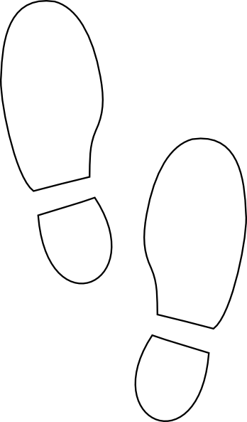
Starter
Starter’s Assistant
Takeoff Board Judge
Takeoff Board Measurer
Landing Pit Measurer
Landing Pit Crew
Landing Pit Crew
Takeoff Board
Runway
Landing
Pit

