Shot Put Summary for Volunteers
Needs 4-6 people - 1 shift - Duties to be assigned by Coordinator.

Equipment:
Rake, broom, two measuring tapes (one to be placed on the runway and the other for measuring the jumps), and flight sheets.

Order of Teams:
YG, YM, IG, IB, YG, YB, MG, MB, BG, BB

Flight Sheet:
Shall be arranged from Long to Longest. Have your first flight ready to jump at 8:30AM. When the second official jump has been completed, the next flight should be ready to start.

Checking In / Out:
Competitors can temporarily leave the event (check out) to compete in another event, but CANNOT check out until the 3rd call for that event and MUST notify the judge. If the competitor does not notify the event judge, he/she is "checking out", the competitor shall forfeit all attempts for which he/she has been called and was not present. They have 5 min to return at the conclusion of that event. If there is a conflict, the following are the priorities:
- Third call on any running event
- High Jump attempts
- Other field events

Late entries shall not be allowed to enter the competition after all competitors who reported on time have taken their first competitive attempt.

Throws:
3 practice throws and 3 official throws (dual, tri, JV meet & Varsity meet)

Measuring Devices:
- Use commercially made tape measures of steel or fiberglass only
- Measuring devices other than measuring tapes, such as Datum Line recorder, can’t be used.

How to Measure a Throw:
Landing Point:
Find the mark made by the shot where it first hit the ground. The shot must land entirely within the sector. On the line is considered out of bounds. The zero end of the tape measure should be put at the edge of the landing mark that is closest to the throwing circle.

Throwing Circle:
Pull the other end of the tape measure back through the center of the circle. Make sure that the tape is straight and not twisted. Pull the tape through the center of the circle and read the measurement where the tape crosses the inside edge of the stop board. If the distance measured is not a whole inch, record the distance rounded down to the nearest ¼ inch.

DUTIES:
Event Coordinator:
Assists with training volunteers at the Practice/Training meet. On meet day, the coordinator oversees all volunteers to ensure event is running smoothly, announces the rules at the start of each flight; watches for fouls; and hands the shot put to the athlete outside of the ring. Responsible for checking volunteers in and out of shifts, notifying the Volunteer tent if they need extra help, submitting sign in sheets to the volunteer tent at the end of the meet, and covering jobs when needed.

Registrar:
Registers the athletes in their respective age groups

Measurer 1:
Put the zero end of the tape measure on the edge of the mark that is closest to the throwing circle.

Measurer 2:
Measures the distance from the measurement stick (landing spot of the shot) to the inside of the toe board. Announces distance thrown.

Shot Put Return:
Rolls the shot put to the shot put ring after each throw.

Shot Put Retriever:
Retrieves the shot put after they are rolled back.

Recorder:
Records the throw measurement after each throw.







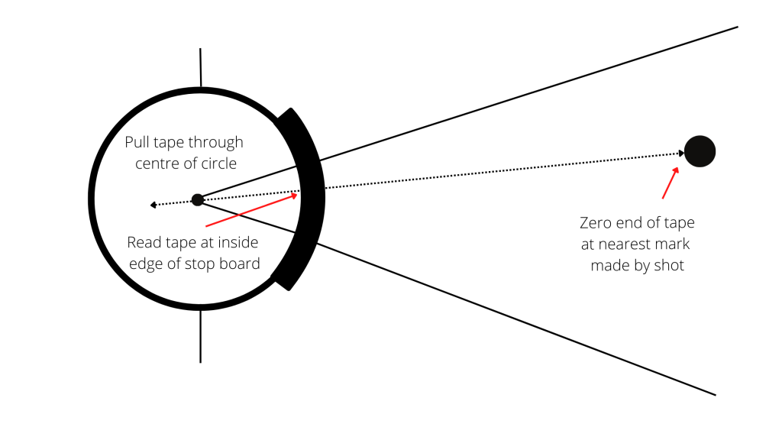
Shot Put Diagram – Volunteer Positions
Shot put Retriever
Shot put Returner
Recorder
Registrar
Measurer 2

Measurer 1

Coordinator

Adapted from: Reference: https://coachingyoungathletes.com/2022/07/21/how-to-measure-a-shot-put-throw/

