Introduction

Systems

Collapse Defensively

F3 High

Shots! Shots! Shots!

Transition

Special Teams

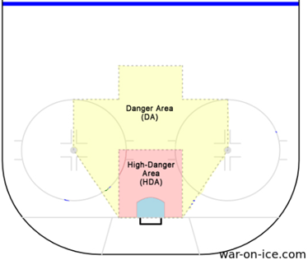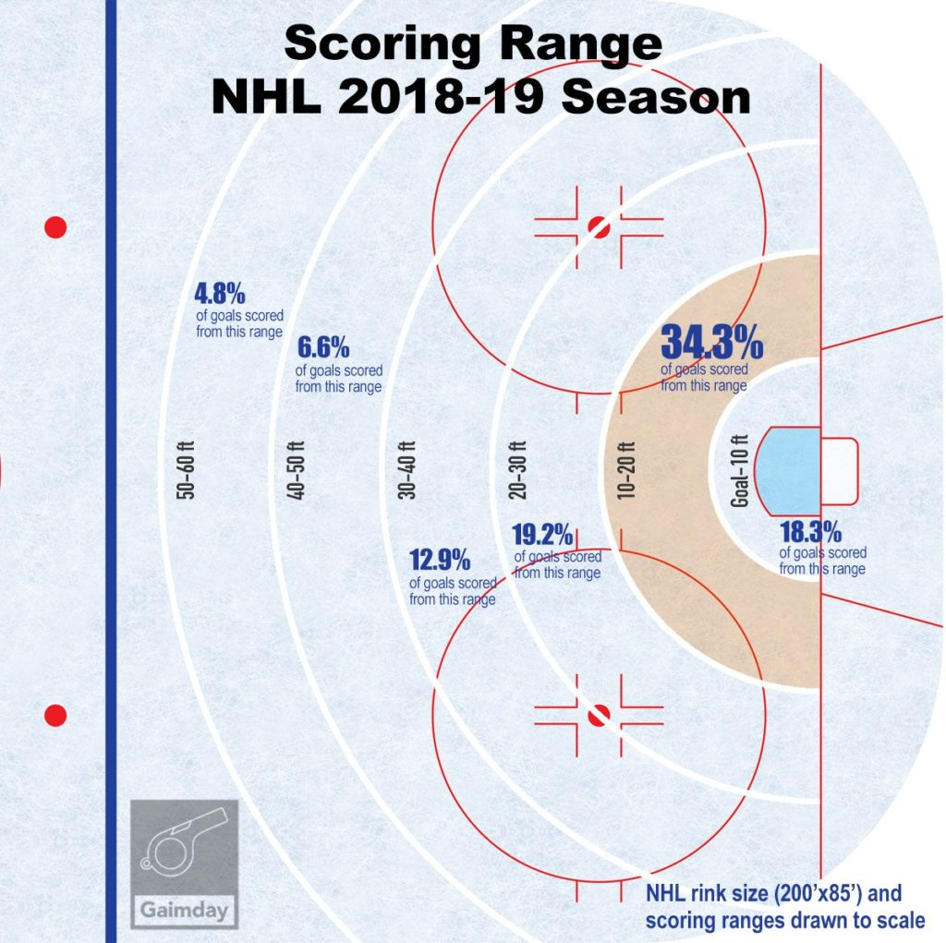

Collapse Defensively
- 88.6% of all NHL goals occur within 40 feet of the goal (Top of circles)
- Clog up the high-danger area with all 5 players

Why?
  - Limit high-danger shots
  - Limit second and third chances

How?
  - Man on Puck with a box behind
  - Protect the net - Pick up sticks
  - Angles and Anticipate puck movement
  - Contain to the outside
  - Keep puck and opposition outside
  - Stick in passing lanes and support

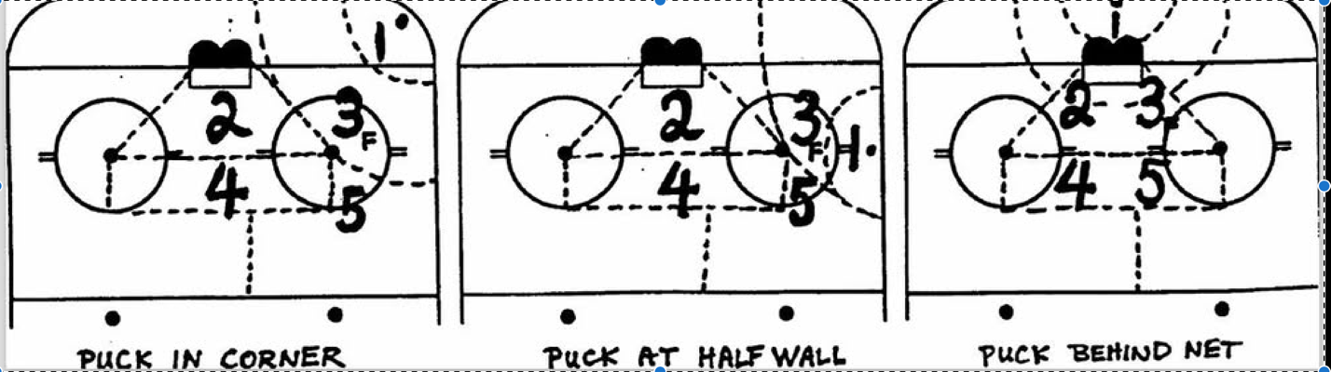

F3 High
- F1 pressures the puck.
- F2 supports F1.
- F3 stays above the tops of the circles.

Why?
  - Have a forward in the high-danger area ready to shoot.
  - Allow defensemen to pinch on wingers.
  - Minimize odd-man rushes against.

Shots!
- You cannot score if you do not shoot.
- Attack with depth and width
- Learn how to identify a high-quality shot
- Most goals are created in four primary ways:
  - One-timer, off the rush (transition), point shots/tips or power plays

Why?
  - 88.6% of all NHL goals occur within 40 feet of the goal

Transition
- Attacking: Depth and width
- Defending: Backcheck through the high-danger area, then sort out coverage.
  - Get numbers back.

Why?
  - Attacking: Organization creates higher-quality scoring chances.
  - Pull defenders toward less dangerous areas to open the high-danger area.
  - Defending: Backchecking through the high-danger area reduces high-quality chances.
    - Take away time and space

Special Teams
  - Offensively:
    - Breakout: slingshot
    - In zone: 1-3-1
  - Defensively
    - Forecheck: Wedge
    - In zone: Opportunist Pressure
      - Backs and Bobbles
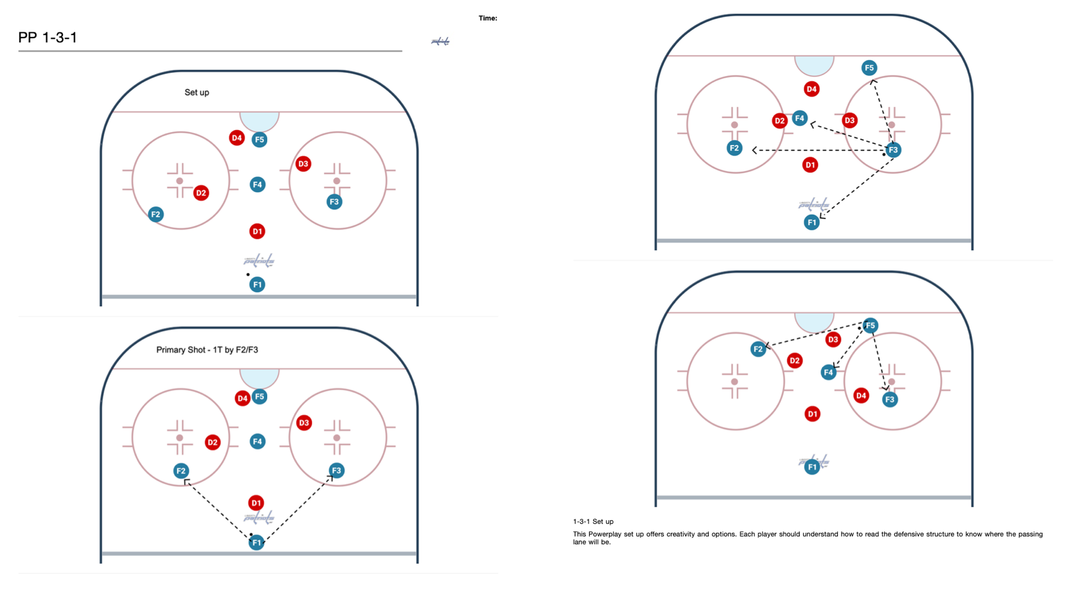

Important locations on the ice
Dots - keeping the puck outside the dots helps the strong-side defenseman maintain inside leverage during a rush.
Goal Posts
- If beaten on a rush, recover toward the goal post to cut off the puck carrier.

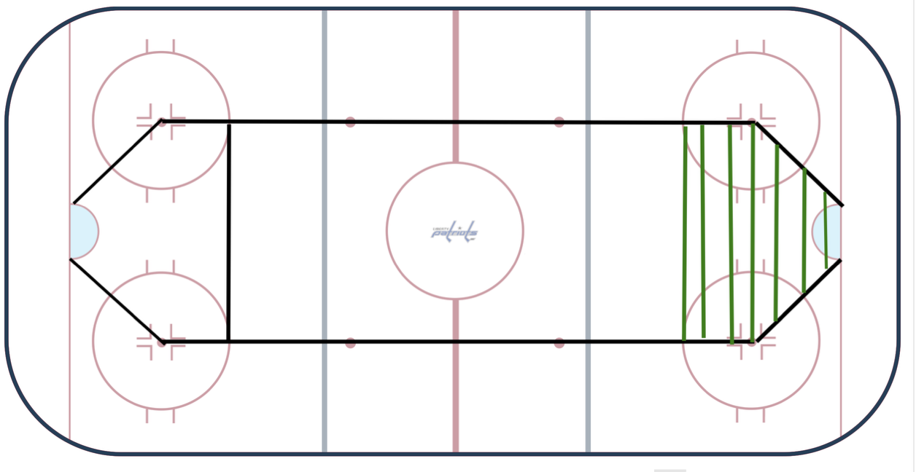

Situation Awareness
- Where are you on the ice?
  - Offensive zone vs neutral zone vs D zone
  - Middle of the ice vs boards
- What is the situation?
  - 1 on 1? 2 on 1? 2 on 2? 3 on 2? 3 on 1
- Who is the next player?
  - Backchecker vs additional opponent
- Is the puck carrier left-handed vs right-handed?
  - Off-wing puck carriers are more dangerous because their stick is toward the middle of the ice, creating a better shooting angle

