Lesson #6: Special Teams

Systems

Collapse Defensively

F3 High

Shots! Shots! Shots!

Transition

Special Teams

Learning Objectives
- Being able to define the following:

  - Slingshot
  - Wedge
  - 1-3-1
  - Dice/Box + 1
  - Overload
  - Bumper
  - QB
  - Flank
  - Net Front
  - Triangle
  - Diamond
  - Box
  - Zone Entry

- What is our PP breakout?
- What is the objective of our PP?
- How to manipulate a PK
- What is our PK Forecheck?
- How to switch from a box to a diamond

Definitions
- Slingshot/Drop Pass - a power play breakout where a player carries the puck up ice, then drops it back to a trailing teammate who builds speed to lead the rush.
- Wedge - a defensive formation where three players form a tight triangle or “wedge” at defensive blueline, supporting a higher forward who pressures the puck in the neutral zone
- 1-3-1 PP Set Up - a power play formation with one player high at the point, three across the middle (two on the half-walls and one in the slot), and one net-front player, often used to create passing lanes and shooting options on the power play.
- Dice/Box + 1 - Power Play setup where four players form a box shape around the slot and one player (the “+1”) positions in the middle to create passing options, quick shots, and screen the goalie. Ideal for 5 on 3 power plays
- Overload - an offensive setup where most players position on one side of the ice to outnumber defenders, create passing lanes, and generate high-quality scoring chances.
- Bumper - is the player positioned in the high slot who connects plays between the point and the flanks, creating quick passing options and one-touch scoring chances.
- QB - refers to the player who runs the power play from the point, directing puck movement and setting up plays much like a football quarterback
- Flank - refers to the side positions on the ice, typically at the top of circles, where wingers or defensemen position themselves to receive passes, cycle the puck, or take shots
- Net Front - refers to the area directly in front of the opponent’s goal, where a player screens the goalie, deflects shots, and looks for rebound scoring chances
- Triangle - penalty-kill formation where three players form a tight triangle in front of the net or slot to block shooting lanes, protect the high-danger area, and force the attacking team to the perimeter.
- Diamond - penalty-kill formation where four players form a diamond shape in the defensive zone, with one forward pressuring the puck, two players on the sides supporting, and one player protecting the slot in front of the net. Used vs. 1-3-1 and umbrellas
- Box - penalty-kill formation where four players form a tight square or “box” in front of the net to protect the slot, block shots, and force the attacking team to the perimeter. Used vs. an overload

Review
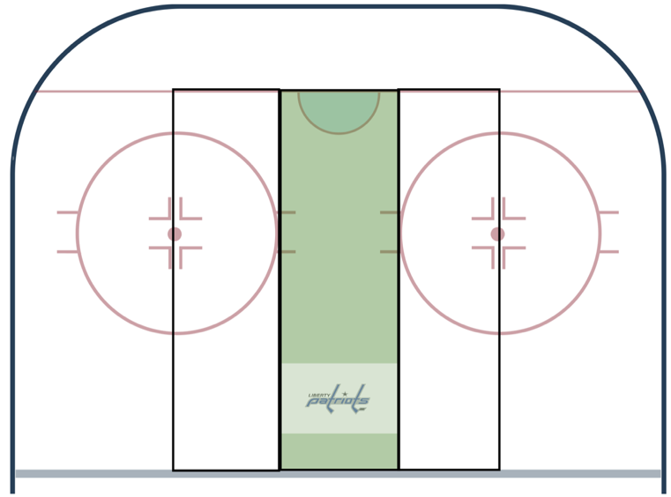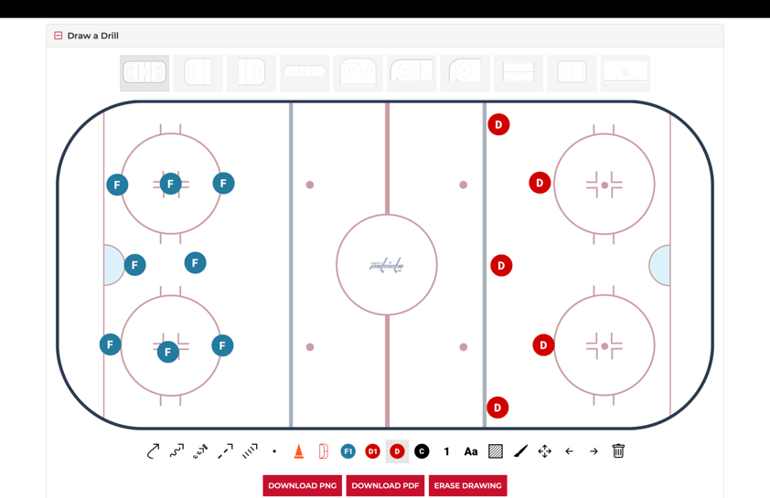

Power Play Breakout - Slingshot/Drop Pass

Why?
  - To cause defenders to become flat-footed (not moving) and create time and space for an organized zone entry

How?
  - All five players back
  - First three players break out normally
  - F4 and F5 trail the play
  - Once the forechecker commits to the first breakout, puck gets dropped back to F4 and F5
  - Either take the rush or set it up

Objective of the Power Play
- Manipulate the defense to get a high-danger shot

How to manipulate a Penalty Kill
- Get organized
- Know how to rotate with other players
  - Bumper and net-front
  - Flanks and QBs
- Read the weak-side players
  - D covering Bumper - look toward opposite flank
  - Forward covering bumper - look at QB or net-front pops out
  - If no one is covering bumper - look at bumper

1-3-1 Power Play
- Know your position
- Know your outlets based on the weak side of the PK
- Fluidity of positions is key
- Stay wide to create passing lanes
  - Look far post/bumper
  - Make the goalie change angles
  - Quickness of shot release is more important than accuracy (must hit the net) and power
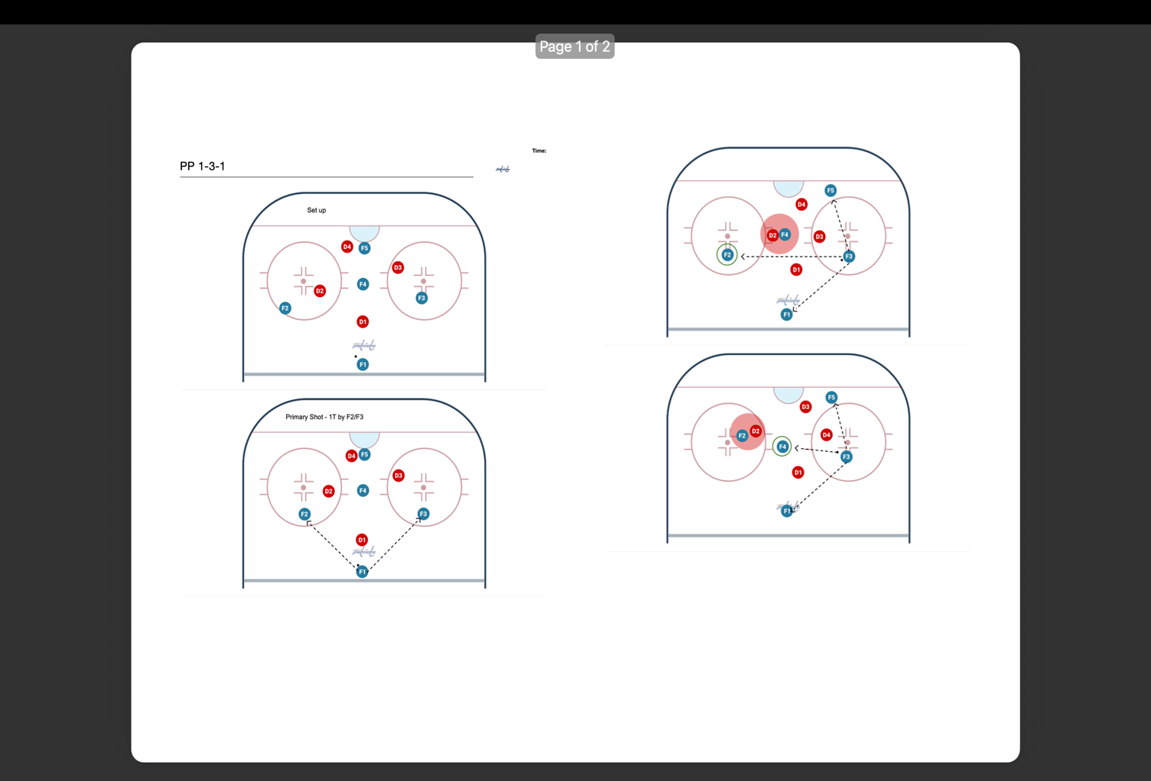
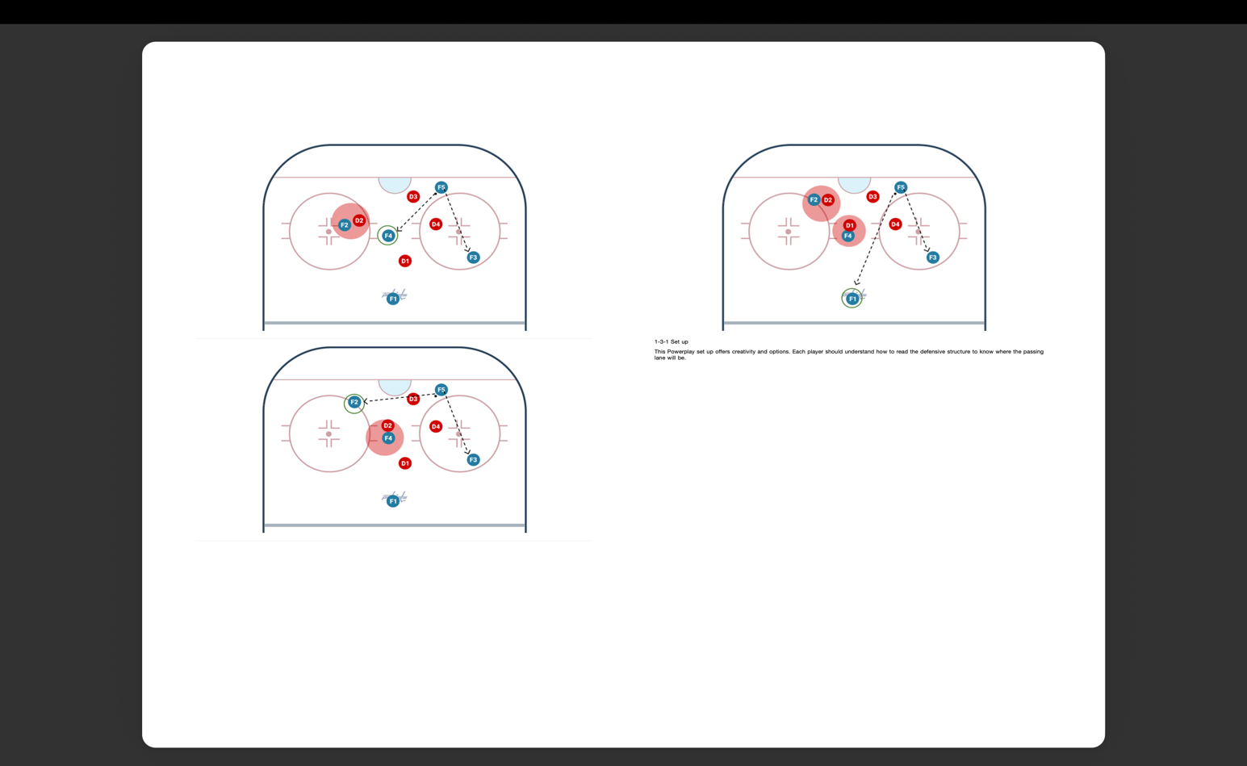

Dice/Box + 1
- 5 on 3 setup
- Know your position
- Know your outlets based on the weak side of the PK
- Fluidity of positions is key
- Stay wide to create passing lanes
  - Look far post/bumper
  - Make the goalie change angles
  - Quickness of shot release is more important than accuracy (must hit the net) and power
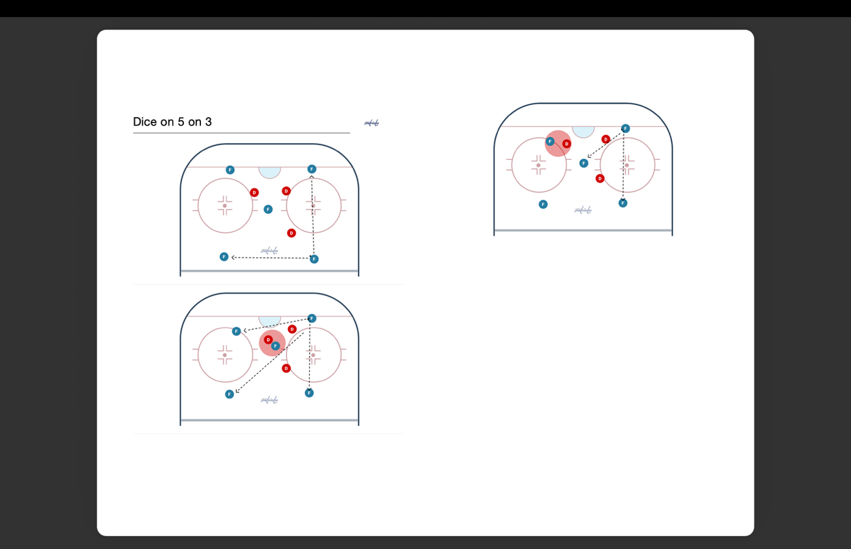

PK Forecheck
- We do not run a traditional forecheck
- We run a neutral-zone trap (see below)

Neutral-Zone Trap
- One player angles the puck carrier with three across the blue line
- Strong-side player jumps the puck carrier
- Weak-side player is responsible for chips and dumps
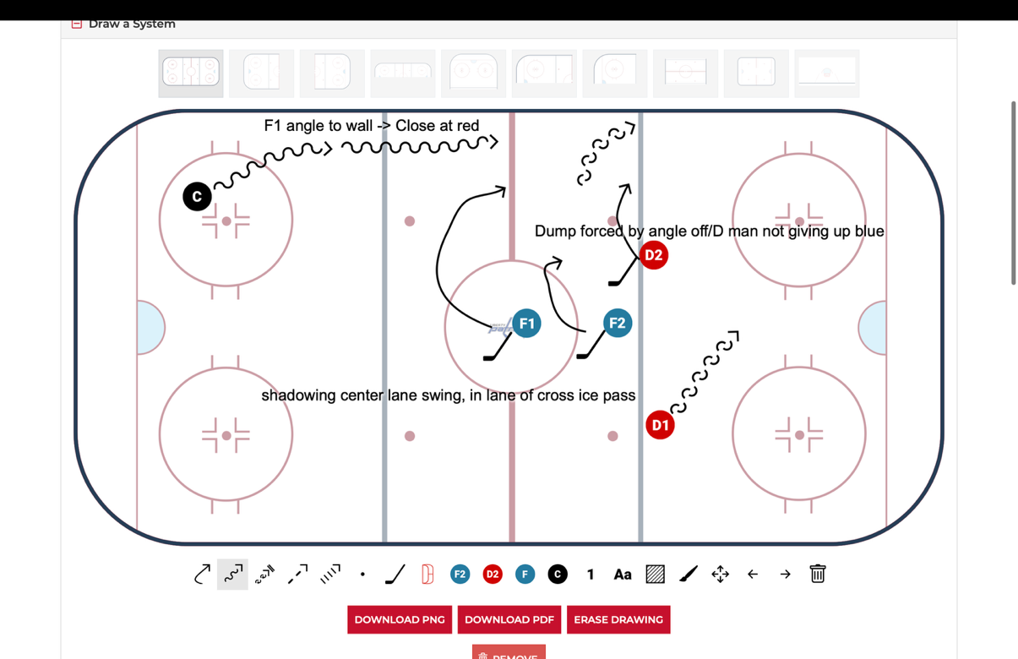

Box vs. Diamond
- Box vs. overload
  - Weak side forward needs to collapse
- Diamond vs. umbrella or 1-3-1
  - Weak side forward needs to collapse to account for bumper
