Lesson #5: Transition

Systems

Collapse Defensively

F3 High

Shots! Shots! Shots!

Transition

Special Teams

Learning Objectives
- Being able to define the following:

  - Odd-Man Rush
  - 2 on 1
  - 3 on 2
  - Passing Lanes
  - Skating Lanes
  - Shooting Lane
  - Puck Vision
  - Player Vision
  - Soft area
  - Time and space
  - Backcheck through the house
  - Activating weak-side D
  - Attacking weak-side D
  - Shooting Locations

- What is the objective of a pass?
- How to Defend an odd-man Rush
- How to exploit an odd-man Rush

Definitions
- Odd-Man Rush - a fast-break situation where the attacking team has more players than the defenders, creating a numerical advantage during transition play.
- 2 on 1 - odd-man rush where two attackers face one defender, giving the offense a strong chance to pass or shoot for a high-quality scoring opportunity.
- 3 on 2 - an odd-man rush where three attackers advance against two defenders, allowing multiple passing and shooting options to create a prime scoring chance.
- Passing Lanes - the direct, unobstructed path between the puck carrier and a potential receiver.
- Skating Lanes - The route or path a player takes through open ice to advance the play, maintain spacing, or create time and space - without running into defenders or teammates.
- Shooting Lane - a clear path between a player and the opponent's net that allows for an unobstructed shot.
- Puck Vision - What the puck can see from ice level
- Eye Vision - What a player can see from their vantage point
- Soft Area - A pocket of ice where a player is not immediately pressured by defenders and can make a play - shoot, pass, or carry the puck.
- Time and space - refers to the amount of time a player must decide and the open area available to maneuver or execute a play effectively.
- Backchecking Through the house - a defending player hustles back into the middle slot area (“the house”) to protect the front of the net and disrupt the opposing rush or scoring chance.
- Activating Weak-Side D - having the defenseman opposite the puck join the offensive rush to create an additional scoring option.
- Attacking Weak side D - focusing the play or puck movement toward the defenseman farthest from the puck, often to create mismatches, open passing lanes, or scoring opportunities.
- Shooting Locations - the areas on the ice where players take their shots - and these spots greatly affect the quality and likelihood of scoring.
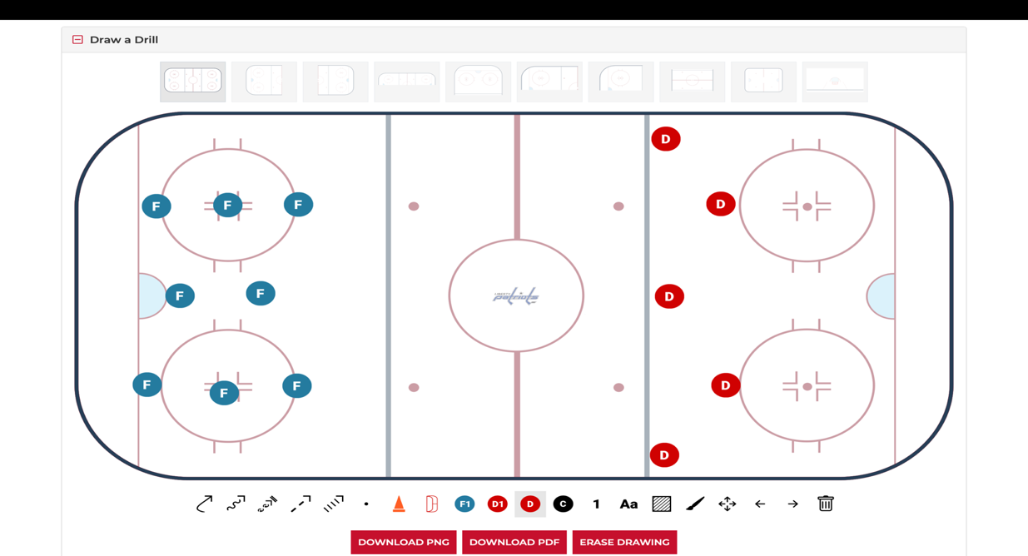
What is the objective of the pass?
- The objective of a pass in hockey is to move the puck to a teammate in a better position to maintain possession, advance the play, or create a scoring opportunity
- It is NOT to fire a puck so fast that the receiving player cannot handle the pass

Situation Awareness
- Where are you on the ice?
  - Offensive zone vs neutral zone vs D zone
  - Middle of the ice vs boards
- What is the situation?
  - 1 on 1? 2 on 1? 2 on 2? 3 on 2? 3 on 1
- What a player is next?
  - Teammate vs opponent
- Is the puck carrier left-handed vs right-handed?
  - Off-wing puck carriers are more dangerous due to stick in middle of ice and better angle of attack for shot.

Defending an odd Man Rush

1 on 1
- Line up outside shoulder with forwards inside shoulder
- Use stick to block center of ice
- If you get beat, get beat on the outside
- If you get beat, pivot and skate toward near post

2 on 1
- Figure out what hand the puck carrier is
- If puck carrier is on his off-wing (puck in middle), angle toward strong-side post to push the forward out of middle of ice
- If puck carrier is on his wing (puck toward boards), angle toward far side post to play more of the pass
- Communicate with backchecker

2 on 2
- Play as two (2) 1 on 1’s
- Communicate with partner if offensive players switch sides
- Usually stay on your side and let players switch sides
- Step up after the offensive players switch sides and before new passing lanes open

3 on 2
- Play it as two (2) 2 on 1’s
- Take away passing lanes
- Figure out what hand the puck carrier is
- If puck carrier is on his off-wing (puck in middle), angle toward strong-side post to push the forward out of middle of ice
- If puck carrier is on his wing (puck toward boards), angle toward far side post to play more of the pass
- If far forward pushes hard to net, weak D must go with but not get tied up
  - Strong-Side D must anticipate a drop to the trailer forward

Attacking an odd-man rush
- Where are you on the ice?
  - Offensive zone vs neutral zone vs D zone
  - Middle of the ice vs boards
- Speed
- Gap of defensemen
- What is the situation?
  - 1 on 1? 2 on 1? 2 on 2? 3 on 2? 3 on 1
- What a player is next?
  - Teammate vs additional opponent
- Is the puck carrier left-handed vs right-handed?
  - Off-wing puck carriers are more dangerous due to stick in middle of ice and better angle of attack for shot.
- Stop in front of the net with stick on the ice
- No Sauce

Review
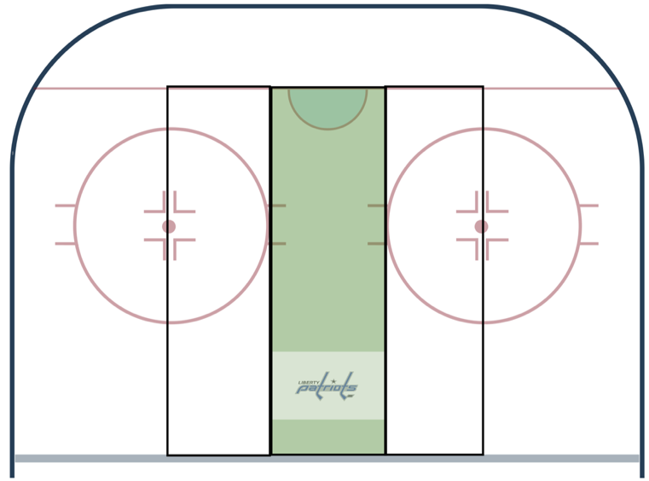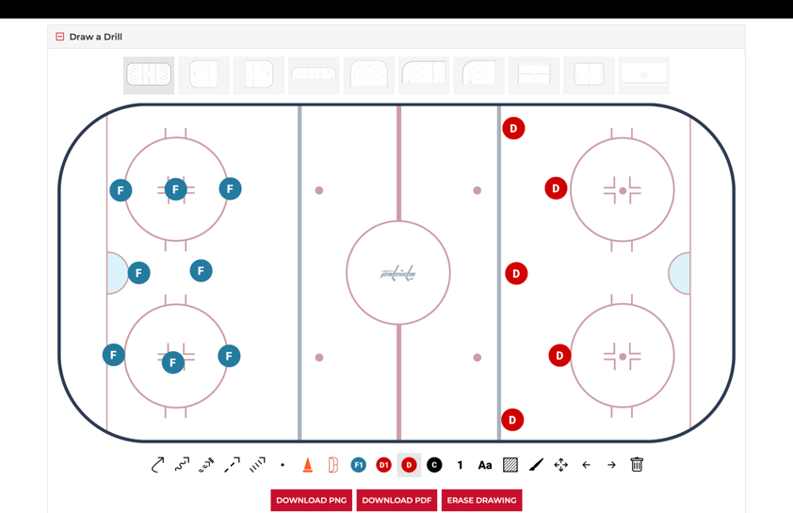

1 on 1
- Plan ahead
  - Have a plan prior to crossing the blue
  - Don’t over handle or run out of space
  - Use the defender as a screen
  - Don’t skate toward the corner
- Speed and Gap
  - Attack with pace or change up speed
  - If D is below the top of the circles –SHOOT
- Read Defender
  - Stick in middle - go wide
  - Hips are turned - cut inside

2 on 1
- Plan ahead
  - Have a plan prior to crossing the blue
  - Don’t over handle or run out of space
  - Use the defender as a screen
- Speed and organization
- Maintain spacing
  - Depth and width - harder for the defender to cover. Make the goalie change his angle
  - Consider an early pass
  - If puck carrier is slightly ahead - drop pass
  - If puck carrier is slightly behind, non-puck carrier goes hard to the net
    - Puck carrier can cut inside
- Force the D to commit
  - If D is lined up to near post - Pass
  - If D is lined up with far post - shoot
- Clean Pass
  - Look for one-timer
  - Pass needs to be catchable
  - No sauce
- Clean release off passes
  - Quickness of shot is more important than accuracy (hit the net) and power

3 on 2
- Plan ahead
  - Have a plan prior to crossing the blue
  - Don’t over handle or run out of space
  - Use the defender as a screen
- Speed and organization
  - Puck carrier needs to draw one defender
  - Timing matters-F2 and F3 should stagger (depth and width)
- Depth and width
  - All 3 lanes
  - Force defenders to make a choice
- Create a mini 2 on 1
  - Puck carrier - move the puck laterally early to shift the defenders and goalie
- If defenders collapse - look F3 (trailer)
- If no passing lanes available, puck carry can curl and look for weak-side defensemen joining rush
- Clean release off passes
  - Quickness of shot is more important than accuracy (hit the net) and power

