Lesson #2: Collapse Defensively

Systems

Collapse Defensively

F3 High

Shots! Shots! Shots!

Transition

Special Teams

Learning Objectives
- Being able to define the following:

  - The House
  - Picking up sticks
  - Angles
  - Stick position
  - Pin
  - Up and out
  - Activating weak-side D
  - Staying between puck and net
  - Time and space
  - Shooting Lane
  - Shoulder check

- Individual positioning
- Team positioning
- Breakout positioning

Definitions
- The House - the high-percentage scoring area extending from the goal posts to the faceoff dots and up to the tops of the circles.
- 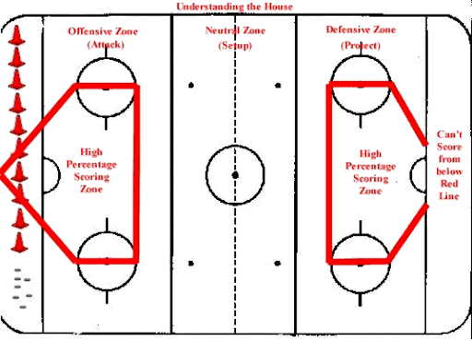
- Picking Up Sticks - lifting an opposing player's stick so they can no longer handle or play the puck.
- Angling - the defensive tactic of steering a puck carrier toward the boards or a less dangerous area using body position and stick placement.
- Stick Positioning - strategic placement of a player's stick to block passing lanes, disrupt puck carriers, and create defensive or offensive advantages.
- Pin - using the body or stick to hold an opponent against the boards, limiting movement and ability to play the puck.
- Up and Out - a defensive principle in which a player clears the puck up the boards and out of the defensive zone to relieve pressure.
- Chip - a quick, controlled play in which a player lifts or taps the puck off the boards or over an opponent's stick into open space.
- Activating Weak-Side D - having the defenseman opposite the puck join the offensive rush or play to create an additional scoring option.
- Time and Space - the amount of time a player must decide and the open area available to maneuver or execute a play.
- Staying Between the Puck and the Net - maintaining body position between the puck carrier and the net to deny a direct path to a scoring chance.
- Shooting Lane - a clear path between a player and the opponent's net that allows for an unobstructed shot.
- Shoulder Check - a quick look over the shoulder to locate teammates, opponents, and open ice before making a play.

Why do we Collapse Defensively?
- 88.6% of all NHL goals occur within 40 feet of the goal
- Clog up the high-danger area with all 5 players and active sticks

Why?
  - Limit high-danger shots
  - Limit second and third chances

How?
  - Man on Puck with a box behind
  - Protect the net - Pick up sticks
  - Angles and Anticipate puck movement
  - Contain to the outside
  - Keep puck and opposition outside
  - Stick in passing lanes and support
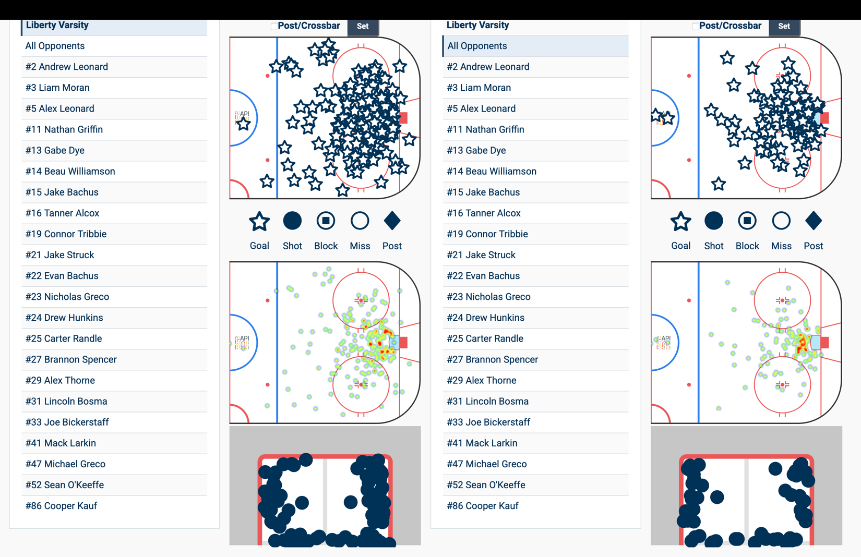
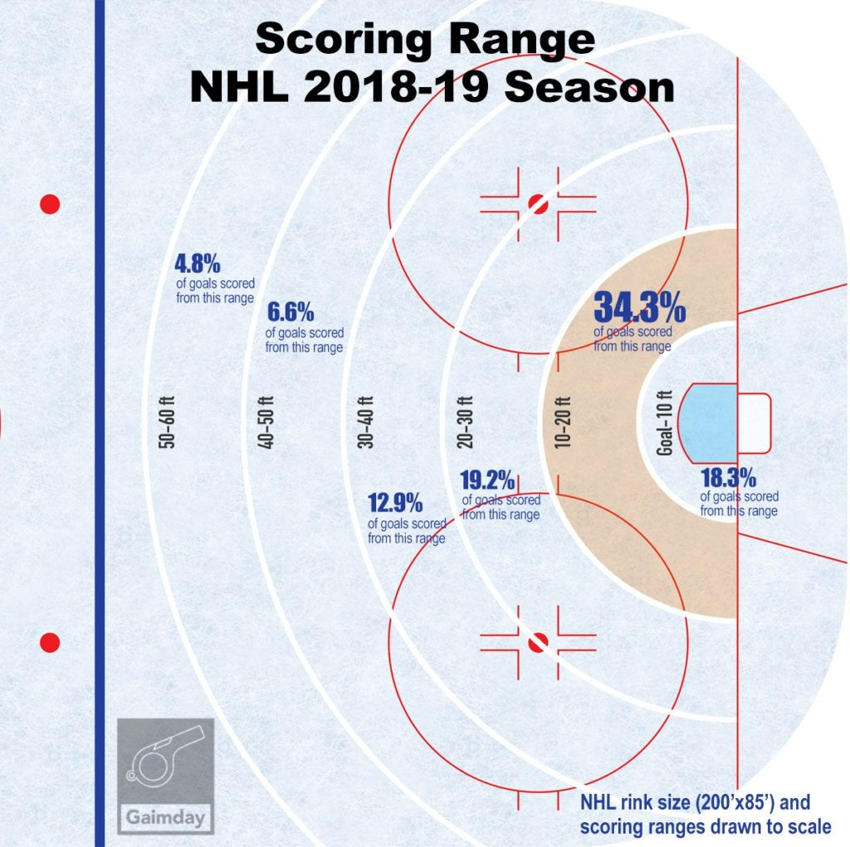

Defensive Zone Coverage

Strong-Side
- Objective: Close time and space until the puck carrier moves the puck or controlled contact is achieved.
- Good defensive position
- Stick in passing lane
- As time and space close, go stick-on-stick and body on body

Weak-Side
- Objective: Support the strong-side defenseman and prevent passes to the front of the net.
- Position near the post relative to the puck carrier.
- Stick in passing lane
- If we gain possession , the weak-side defenseman releases to the opposite corner for a D-to-D pass and breakout.

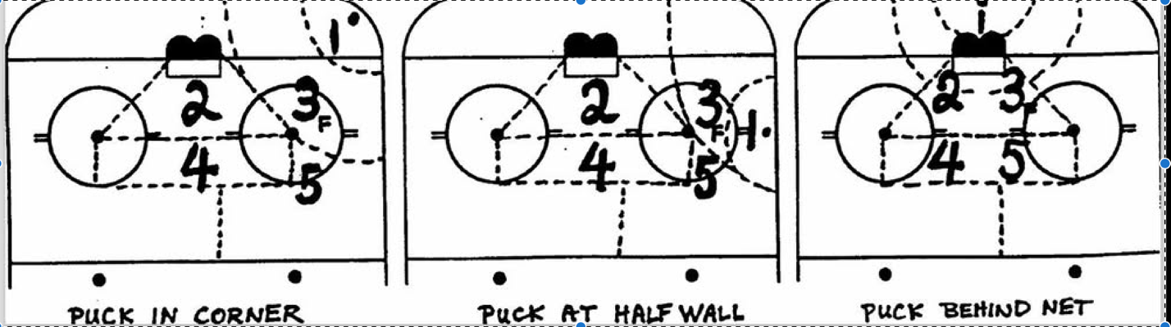

How Do We Work as a Team to Regain Possession?
- Stop the puck carrier’s motion

How?
    - Angling and stick positions to guide the puck carrier into the boards by limiting time and space
    - Once time and space are limited, use controlled body contact to separate the player from the puck.
      - Separate the player’s hands/stick from the puck.

Why?
    - Players are easier to defend when they are not moving.

- Strong support from the center/defenseman to retrieve the loose puck

How?
    - Maintain good defensive position to (1) retrieve the loose puck or (2) add pressure if the offensive player gets past the first defender.

Why?
    - Winning the loose puck leads to breakouts and transition offense.
    - Add pressure to the puck carrier to minimize time and space.

- Chip to open space

How?
    - Offensive team will be aggressively trying to regain possession
    - A soft chip to the opposite corner can relieve pressure.
    - D2/center releases from the net-front to retrieve the puck.
    - Weak-side winger releases to the half-wall.

Why?
    - Trap F2/F3 by flipping the ice and starting the breakout.
- Breakout

How?
    - At minimum, the winger must get the puck out of the zone.
      - Use the board to chip it out of the defensive zone
    - The weakside winger must read the center (*the center may still be engaged in the corner).
      - Center supporting the puck - stay wide.
      - Center still tied up in the corner - support the breakout.

Why?
    - Organization on the breakout leads to organization on the rush and more scoring opportunities.
- Weak-Side D (originally the strong-side D) Joins the rush

How?
    - Get out of the corner and join the rush.
    - Create depth and width in our attack.
      - If the winger supports the breakout, get wide.
      - If the center supports the breakout, read the winger and find space late.

Why?
    - Create an additional advantage on the rush.
    - Create more width and depth on the attack.
    - Push the pace.

Backchecking

How?
  - Use active sticks to take away passing lanes.
  - Use good angles to force the puck carrier outside the House.
  - Protect the House first, then sort out coverage.

Why?
  - Minimize odd-man rushes by protecting the area where we are most vulnerable: the House.

PLEASE NOTE:
- Communication is the most important aspect.

