Lesson #4: Shots!

Systems

Collapse Defensively

F3 High

Shots! Shots! Shots!

Transition

Special Teams

Learning Objectives
- Be able to define the following:

Shooting Percentage

One-Timer
  - Shooting Lanes
  - Puck Vision
  - Eye Vision

Soft Areas
  - Point Shots

Shooting Locations

Skating Lanes
  - Expected Goals (xG)
- How most goals are scored
- Where to Shoot

Definitions
- Shooting Percentage - measures how often a player (or team) scores goals compared to how many shots they take. This evaluates scoring efficiency - not just volume.
- One-Timer - is a type of shot where the player shoots the puck immediately after receiving a pass, without stopping or controlling it first.
- Shooting Lanes - are the open pathways between the puck carrier and the net through which a shot can travel without being blocked by defenders or teammates. Understanding and creating shooting lanes is a huge part of offensive and defensive play.
- Skating Lanes - The route or path a player takes through open ice to advance the play, maintain spacing, or create time and space - without running into defenders or teammates.
- Shooting Locations - the areas on the ice where players take their shots - and these spots greatly affect the quality and likelihood of scoring.
- Puck Vision - What the puck can see from ice level
- Eye Vision - What a player can see from their vantage point
- Soft Areas - A pocket of ice where a player is not immediately pressured by defenders and can make a play - shoot, pass, or carry the puck.
- Point Shots - Shots between the top of the circles and blue line
- Expected Goals - measure the likelihood that a shot will result in a goal based on factors like shot location, type, and situation.

Shooting Locations
- High-danger - Shooting percentage - 20-30%
  - Low Slot: The area directly in front of the crease, between the faceoff dots.
  - Net Front: Right on the goalie’s doorstep - rebounds, deflections, and screens.
  - Backdoor: The weak-side of the net when the goalie is moving laterally.
- Medium Danger
  - Top of the circles
  - Mid-slot
  - Inside hash marks
- Low Danger
  - Blue line shots (defensemen)
  - Corner or sharp-angle shots (near goal line)
  - Outside the dots
  - Please note: Must have traffic or needs to be a passing play/one-timer
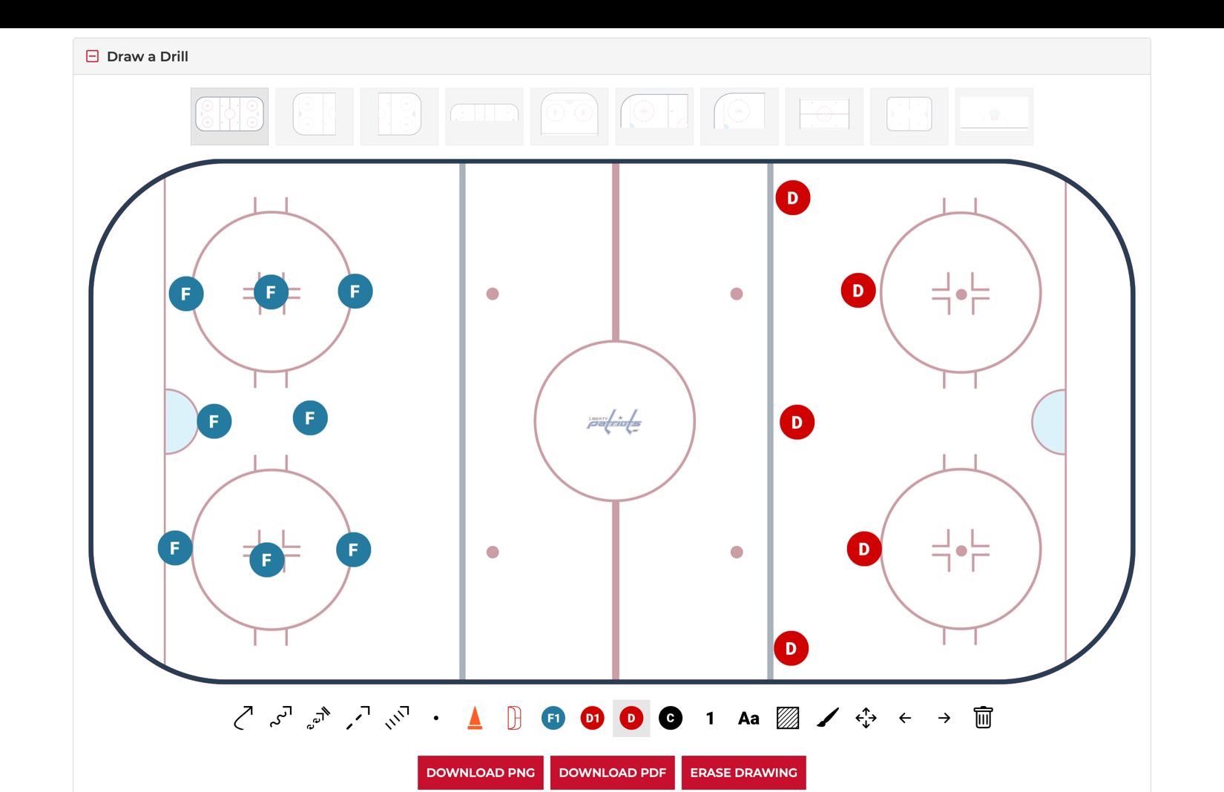

Soft Areas

How?
  - Find soft ice by floating into open lanes after passing
  - Delay slightly after entering the zone to let coverage shift away.
  - Time their movement - arriving just as the puck does, not standing still waiting.
  - Call for pucks or use stick placement to signal readiness.
- Examples
  - Between the defense and forwards in the offensive zone - especially between the hash marks and the top of the circles.
  - Backside of coverage - behind a defenseman’s shoulder when they’re focused on the puck.
  - High slot - between the dots where defenders often collapse too late.
  - Weak-side low - opposite side of the puck where defenders overload to one side.
  - Net front or backdoor - when a defender turns their head or puck-watches.

Skating lanes

Why?
  - Spacing: Prevents crowding and overlapping with teammates.
  - Speed: Allows players to build momentum and carry the puck effectively.
  - Support: Makes passing and puck retrieval easier.
  - Structure: Keeps team play organized during rushes, breakouts, and forechecks.
- Examples
  - Weak side post
  - Trailing
  - Getting to the net as the shot arrives
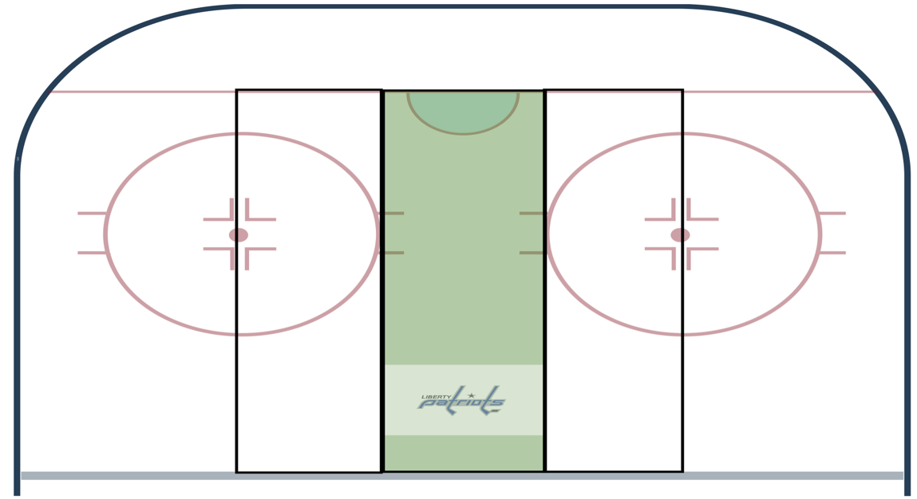

Shooting Percentage
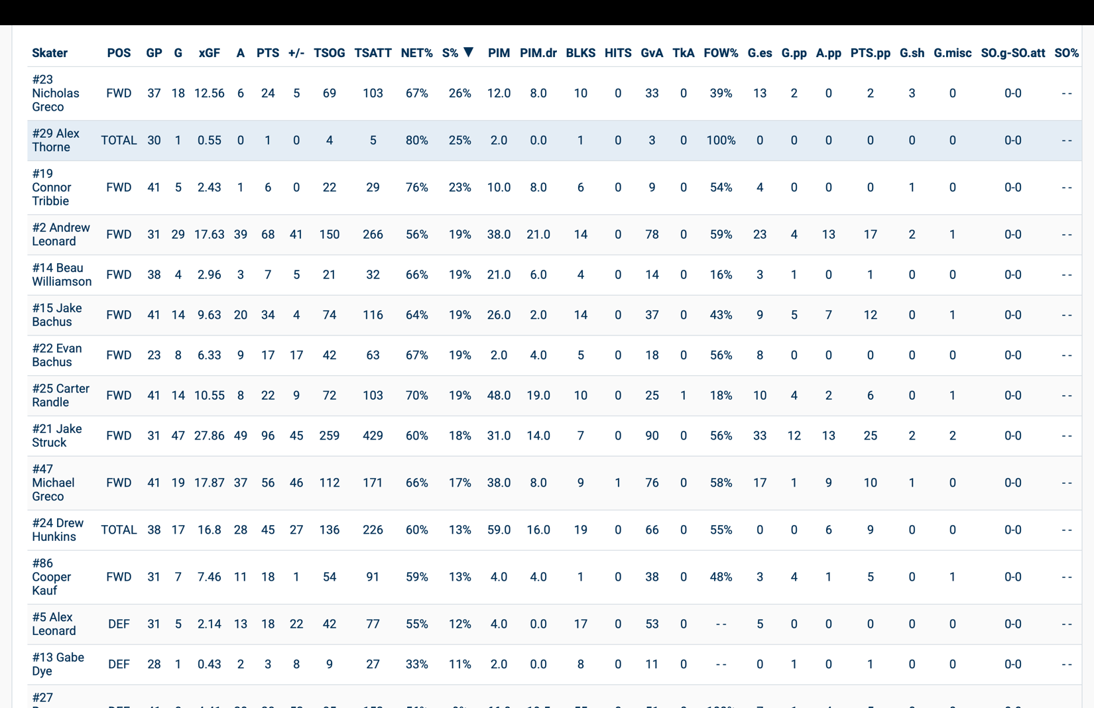

How are most goals are scored?

Transition
- One - Timers
- Point shots
- Power play

Transition

Why?
    - Teams can exploit a tactical advantage to score quickly off a turnover

How?
    - Teams manipulate the defenders to get a predicable scoring chance
    - Do not make a move at the blue line
    - Do not try to beat the defensemen when we have a numerical advantage
- One - Timers

Why?
    - It is hard for a goalie to react quick enough for incoming shot

How?
    - Player finds a soft area in the defense

- Point Shots

Why?
    - Most teams collapse defensively which will open the defense on the blue line

How?
    - Shot must get to the net
    - Chaos around the net
    - Forwards in front - depth and width
    - Please note: Must have traffic or needs to be a passing play/one-timer
- Power Plays

Why?
    - Extra Man

How?
    - Learn how to manipulate the PK to get a quality scoring chance

