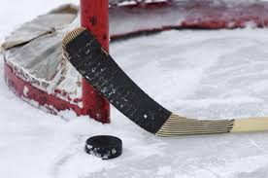
- USA HOCKEY REQUIRES PLAYERS SUSPECTED OF A CONCUSSION TO BE EVALUATED BY A QUALIFIED MEDICAL PROFESSIONAL AND SUBMIT A SIGNED RETURN TO PLAY FORM TO THEIR ORGANIZATION BEFORE RETURNING TO PLAY

- COACHES ALLOWING PLAYERS TO RETURN TO PLAY WITHOUT CLEARANCE WITHOUT A SIGNED FORM COULD BE SUBJECT TO DISCIPLINE AS OUTLINED BY SAFE SPORT

- COMPLETED FORMS SHOULD BE SENT TO NEDPLAYERSAFETY@GMAIL.COM WITH THE SUBJECT LINE CONCUSSION REPORTING FORM
CONCUSSION REPORTING FORM | CONCUSSION RECOGNITION TOOL
 | 
MORE INFORMATION

