Eagan Hockey Volunteering | Quick start | Page 1 of 2

Volunteer Sign-Up Instructions
Use the Eagan Hockey site to access your dashboard and sign up for available sessions.
Important: Go to eaganhockey.com. Do not go to the CrossBar website.

STEP 1  Open the Dashboard  From eaganhockey.com, click the Dashboard link at the top of the page.  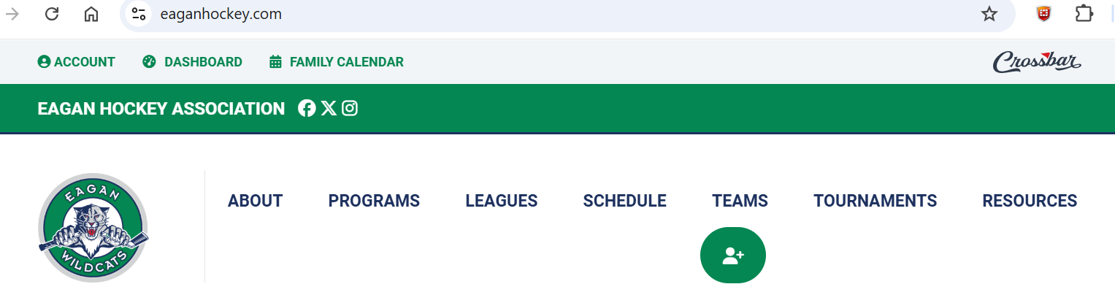  If on mobile, look for the three lines to the left of the logo for the drop-down menu; select Dashboard.  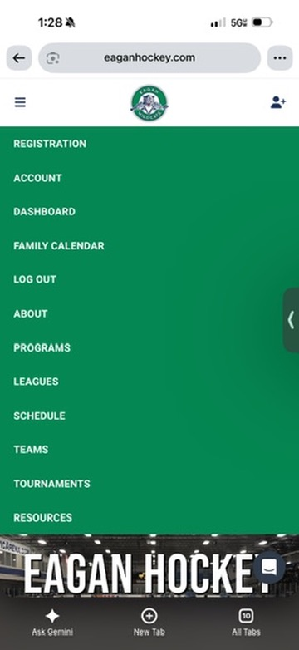 | STEP 2  Go to the Volunteer tab  When your Dashboard opens, select Volunteer from the left-side menu.  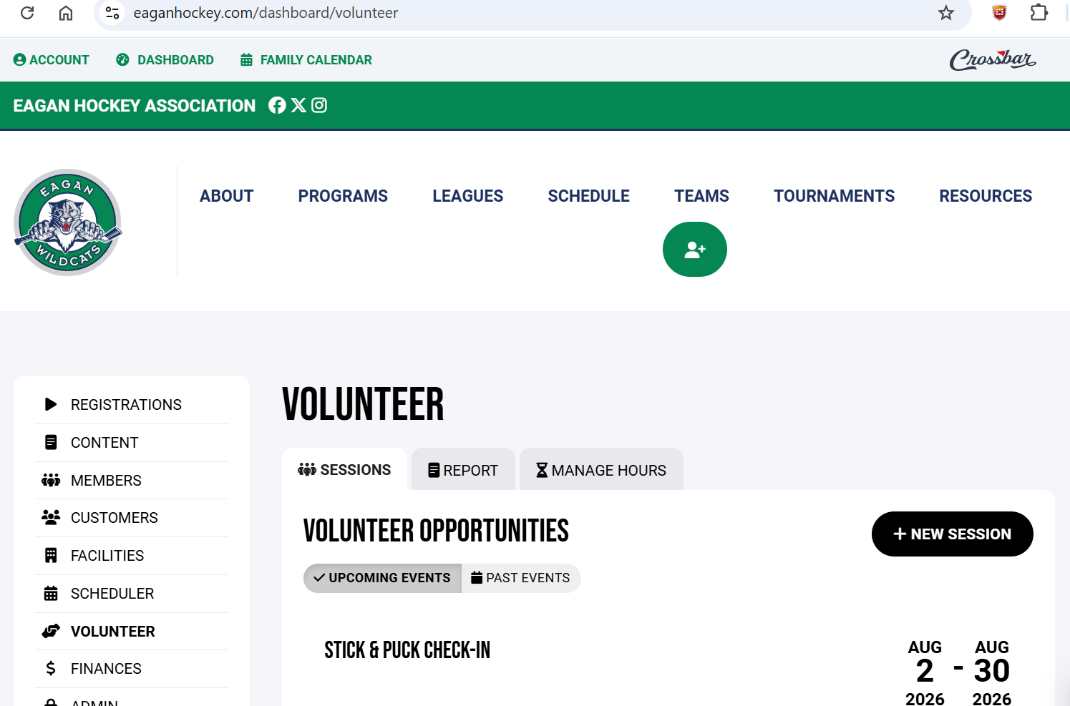

Eagan Hockey Volunteering | Sign-up steps | Page 2 of 3

Select a Volunteer Session
Use the available session section to find and sign up for open sessions.
STEP 3  Review available sessions  Available sessions will display in the Volunteer section. Click More Information to view details and sign up.  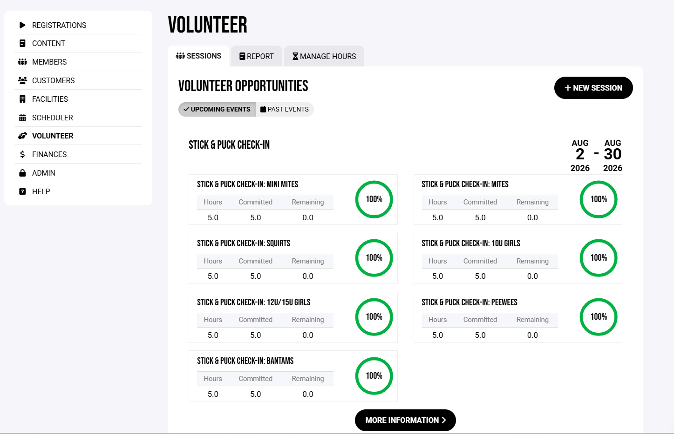 | STEP 4  Choose a session  Click the green plus sign, then choose the person associated with your account who will complete the volunteer session.  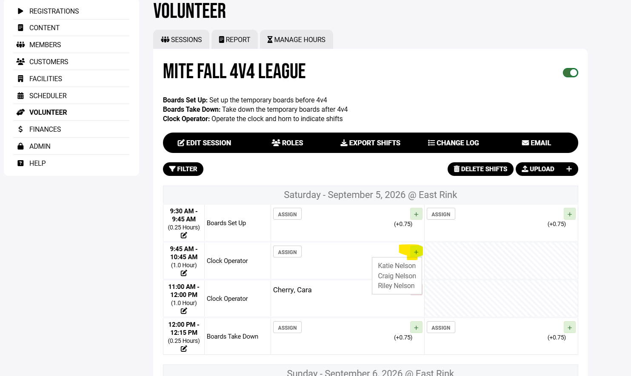

Eagan Hockey Volunteering | Sign-up steps | Page 3 of 3

Volunteering Completion
After completing your session, your balance will display in your Account.
STEP 5
View committed hours
Go to your Account, then click into your player’s profile. Committed and completed hours will show under Volunteer Hours. 