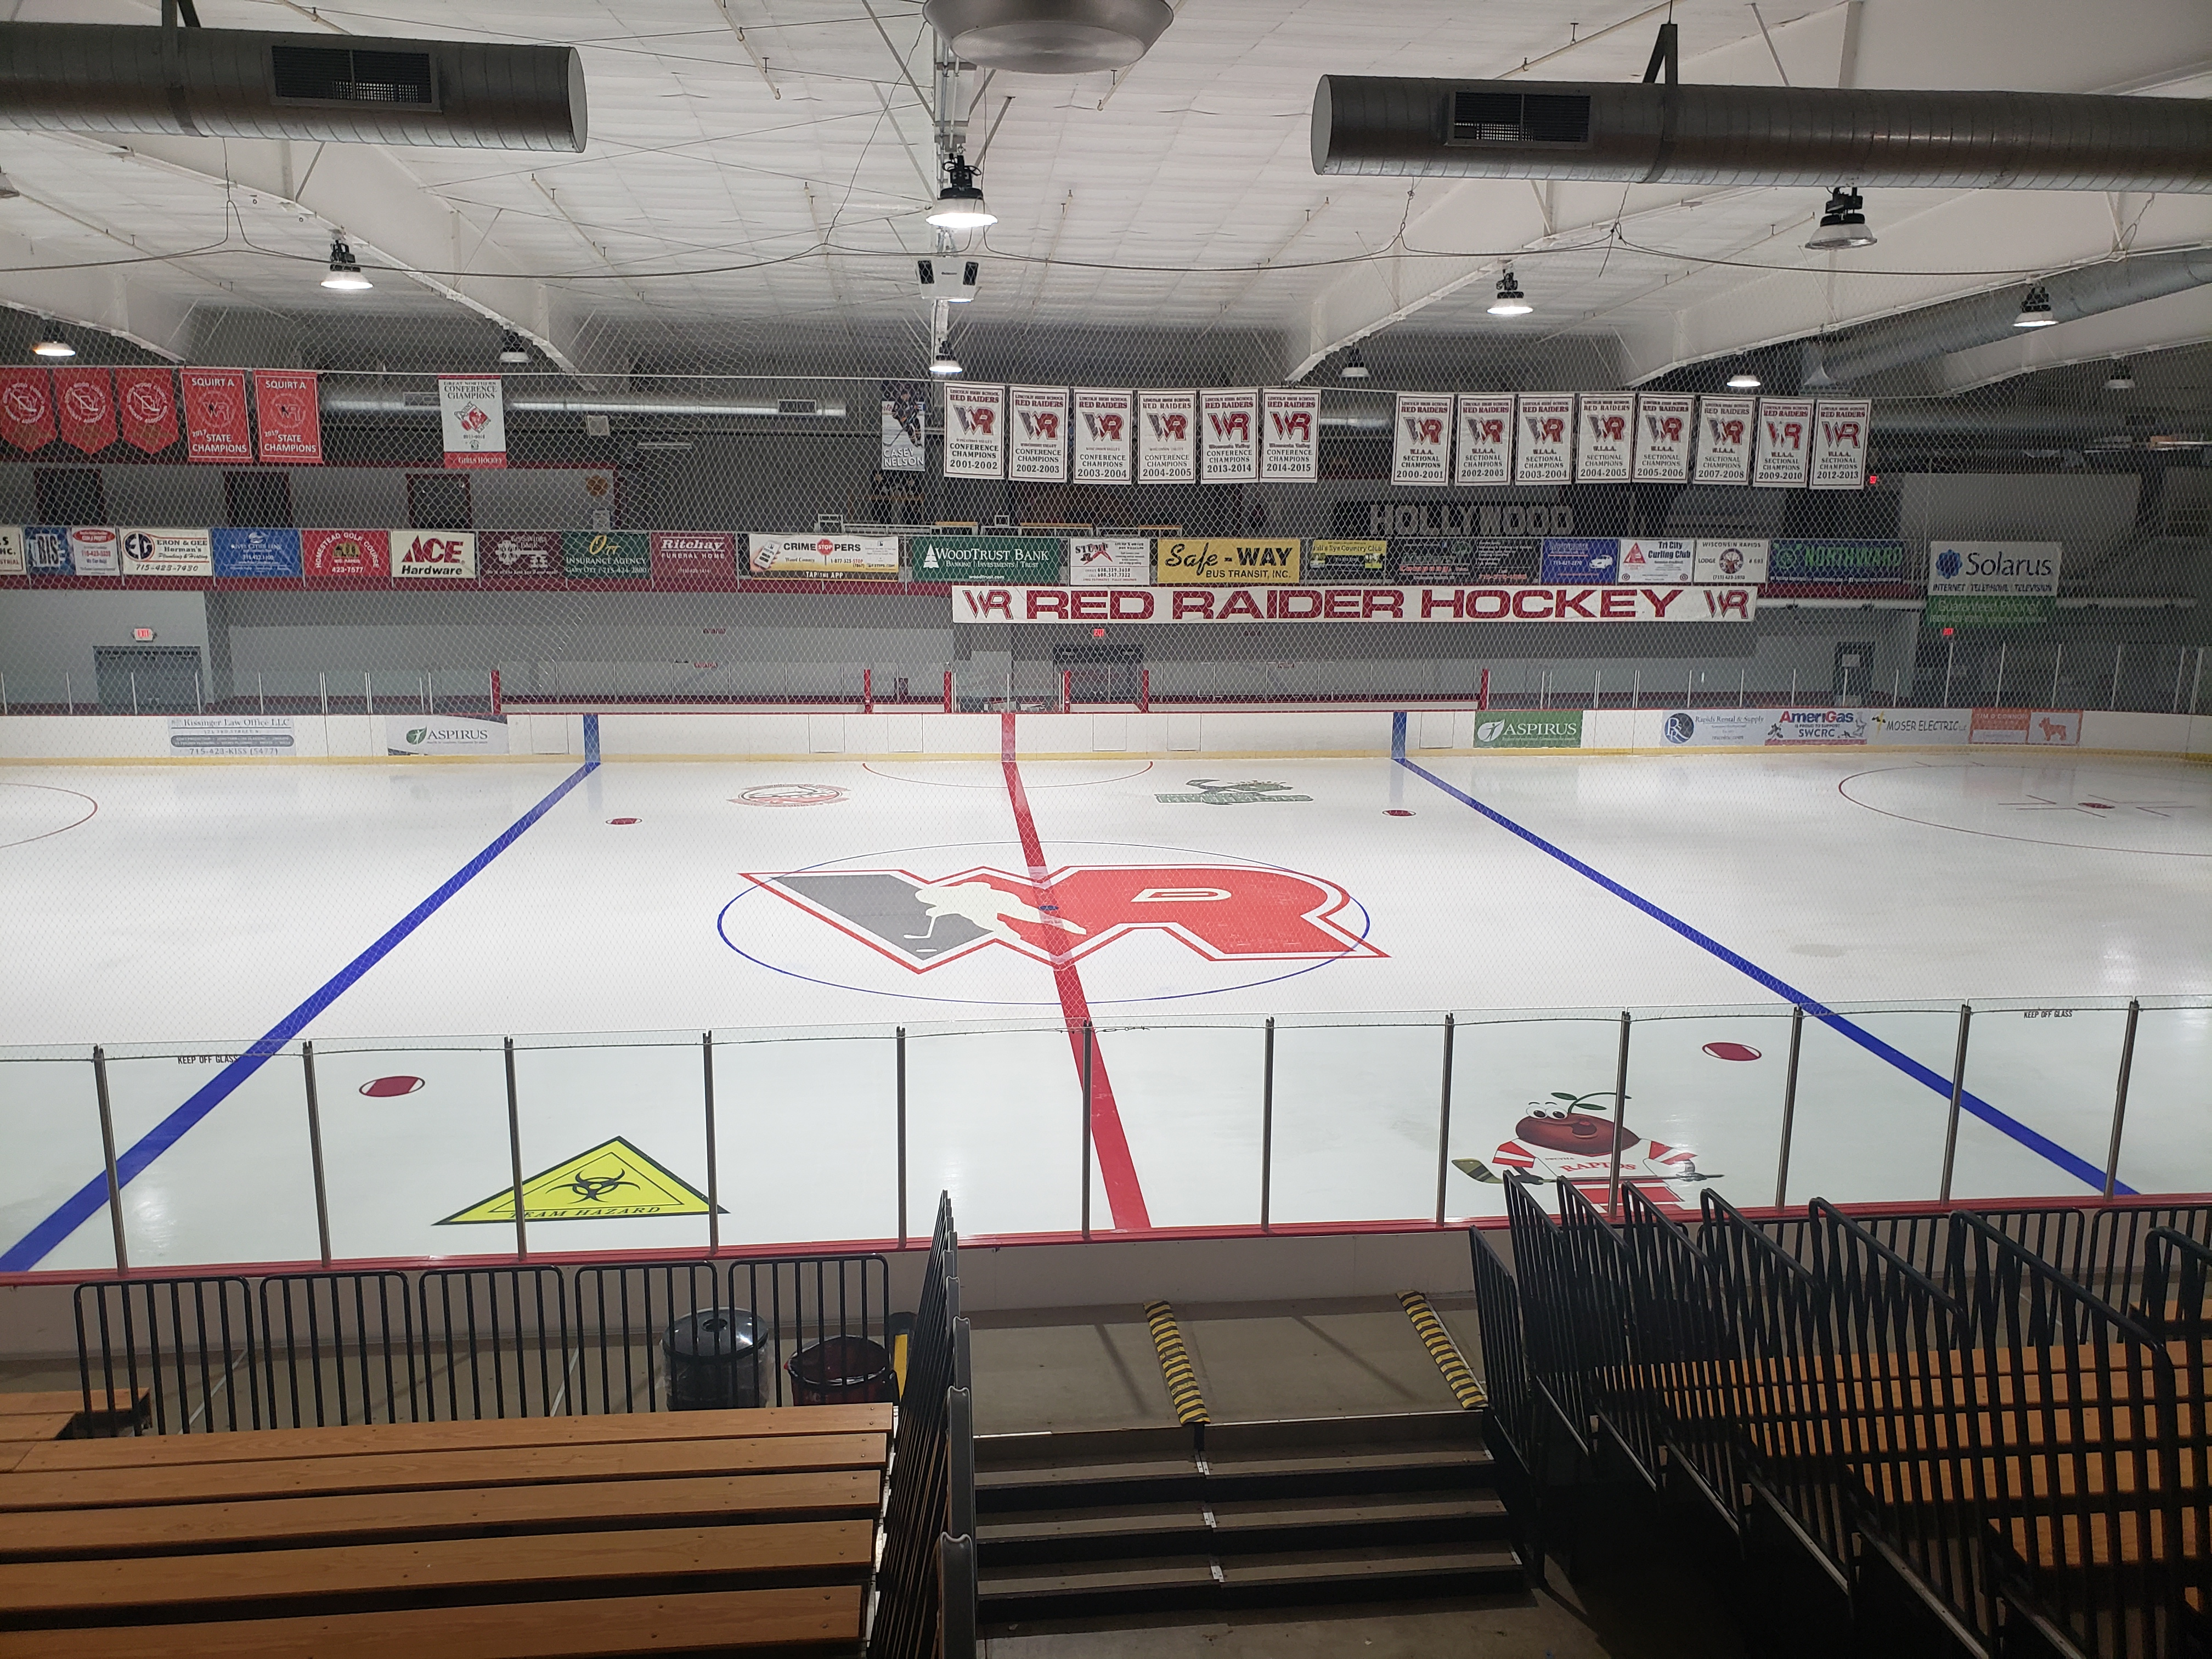
South Wood County Recreation Center
Banner Sponsorship Contract

Company/Organization: ________________________________
Contact Name: _______________________________________
Address: ____________________________________________
City: __________________ State: ______ Zip: __________
Phone: __________________ Email: ____________________

Terms & Conditions
All copy and content must be approved by the sponsor and SWCRC. Artwork must be supplied print-ready in a high-resolution format. Sponsorships are for a one-year term (July 1–June 30), subject to availability. Existing advertisers have first right of renewal. Sponsorships renew annually unless cancelled by the sponsor. Pricing is subject to change. No guarantee of business results is implied.

Sponsorship Options

☐ 70" x 40" Banner (Small/Single) - Annual $200
☐ 70" x 40" Initial Production $200 – First Year ONLY

☐ 130" x 40" Banner (Large/Double) - Annual $300 |
☐ 130" x 40" Initial Production $250 First Year ONLY
☐ Primary Dasher Board (96" x 33") – Annual $600

☐ Dasher Board (96" x 33") – Initial Production $420 First year ONLY

Special Instructions / Artwork Notes:
__________________________________________________________
Banner options include full color digitally printed graphics, set-up and installation.
Graphics Printed by Quality Plus Printing 3515 8th Street South, Wis. Rapids, WI 715.423.7440
On board advertisements include full color digitally printed graphics, set up and installation.
Ads On Boards produces advertisements on hockey dasher boards
__________________________________________________________
I approve all the details outlined in this agreement and will meet all the terms as stated.

Sponsor Signature: ________________________ Date: __________
SWCRC Manager: ____________________ _____ Date: __________
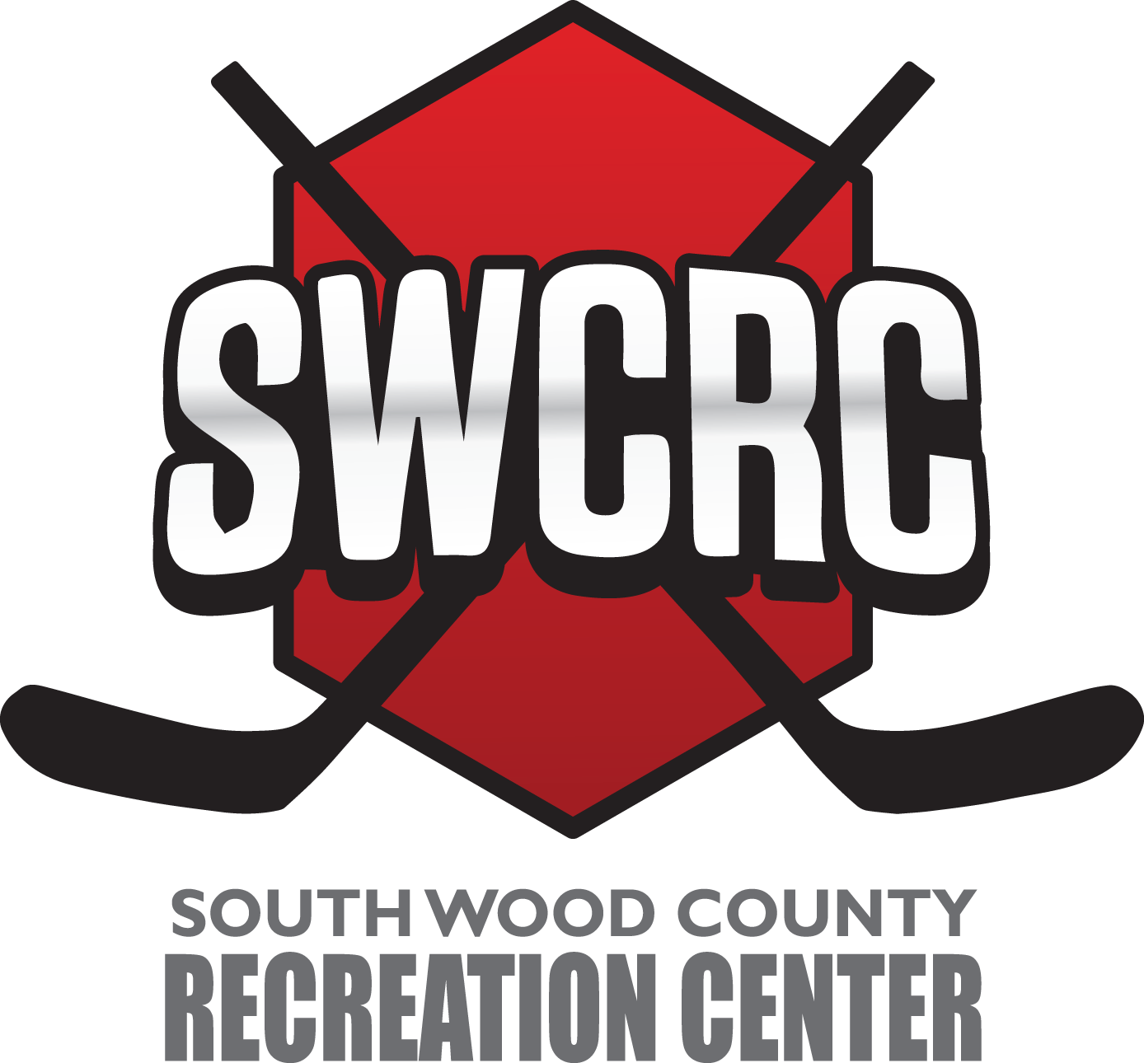
SWCRC
Attn: Jim Arnold
2711 16th Street South
Wisconsin Rapids, WI 54494
715-421-3311
www.swcrc.net

