Northfield Hockey Association’s Locker Room Policy
In addition to the development of our hockey players and enjoyment of the sport of hockey, the safety and protection of our participants is central to NHA’s goals. NHA adheres to USA Hockey’s SafeSport Program as a means to help protect its participants from physical abuse, sexual abuse and other types of misconduct, including emotional abuse, bullying, threats, harassment and hazing. To help prevent abuse or misconduct from occurring in our locker rooms, NHA has adopted the following locker room policy. This policy is designed to maintain personal privacy as well as to reduce the risk of misconduct in locker rooms.

At Northfield Ice Arena there are nine locker rooms available for our program’s use. Some teams in our program may also occasionally or regularly travel to play games at other arenas, and those locker rooms, rest rooms and shower facilities will vary from location to location. NHA team organizers will attempt to provide information on the locker room facilities in advance of games away from our home arena. At arenas for which you are unfamiliar, parents should plan to have extra time and some flexibility in making arrangements for their child to dress, undress and shower if desired.

Locker Room Monitoring
NHA has predictable and limited use of locker rooms and changing areas (e.g., generally 30-45 minutes before and following practices and games). This allows for direct and regular monitoring of locker room areas. While constant monitoring inside of locker rooms and changing areas might be the most effective way to prevent problems, we understand that this would likely make some players uncomfortable and may even place our staff at risk for unwarranted suspicion. We conduct a sweep of the locker rooms and changing areas before players arrive, and if the coaches are not inside the locker rooms, either a coach or voluntary locker room monitors (each of which has been screened) will be posted directly in the locker rooms and changing areas during periods of use, and leave the doors open only when adequate privacy is still possible, so that only participants (coaches and players), approved team personnel and family members are permitted in the locker room.

Parents in Locker Rooms
Except for players at the younger age groups [Mite levels, U8, Squirt, U10], we discourage parents from entering locker rooms unless it is truly necessary. If a player needs assistance with his or her uniform or gear, if the player is or may be injured, or a player’s disability warrants assistance, then we ask that parents let the coach know beforehand that he or she will be helping the player.
Naturally, with our youngest age groups it is necessary for parents to assist the players getting dressed. We encourage parents to teach their players as young as possible how to get dressed so that players will learn as early as possible how to get dressed independently. In circumstances where parents are permitted in the locker room, coaches are permitted to ask that the parents leave for a short time before the game and for a short time after the game so that the coaches may address the players. As players get older, the coach may in his or her discretion prohibit parents from a locker room.

Mixed Gender Teams
Some of our teams consist of both male and female players. It is important that the privacy rights of all of our players are given consideration and appropriate arrangements made. Where possible, NHA will have the male and female players dress/undress in separate locker rooms and then convene in a single locker room before the game or team meeting. Once the game or practice is finished, the players may come to one locker room for a team meeting and then the male and female players proceed to their separate locker rooms to undress and shower, if available. If separate locker rooms are not available, then the players will take turns using the locker room to change. We understand that these arrangements may require that players arrive earlier or leave later to dress, but believe that this is the most reasonable way to accommodate and respect all of our players.

Cell Phones and Other Mobile Recording Devices
Cell phones and other mobile devices with recording capabilities, including voice recording, still cameras and video cameras, are not permitted to be used in the locker rooms. If phones or other mobile devices must be used, they should be taken outside of the locker room. [it may be permissible to have team manager collect phones]

Prohibited Conduct and Reporting

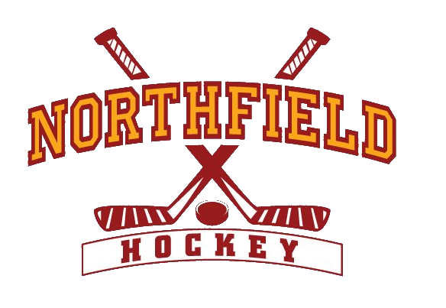
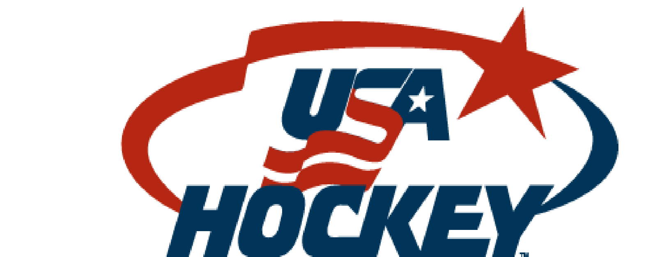
NHA prohibits all types of physical abuse, sexual abuse, emotional abuse, bullying, threats, harassment and hazing, all as described in the USA Hockey SafeSport Handbook. Participants, employees or volunteers in NHA may be subject to disciplinary action for violation of these locker room policies or for engaging in any misconduct or abuse or that violates the USA Hockey SafeSport Policies. Reports of any actual or suspected violations, you may email the NHA Vice President at vicepresident@northfieldhockey.net

