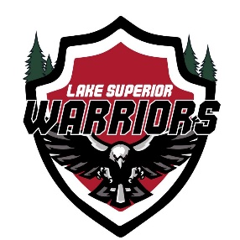

2024 Quarterly Board Meeting

September 22, 2024
VIP Pizza, Superior WI
Call to Order by Shawn Hanson: 1820

Attendees:

Shawn Hanson, Matt Caple, Rhawnie Britton, Kyle Cotrell, John Tobin, Langton Lalor

Agenda:

1) Treasurers Report (Kyle Cotrell)

- Present Current Report
- Approve Report
  - Motioned by Caple
  - Seconded by Hanson
  - Approved Unanimously
- Rental Vehicle Reimbursement to Caple ($1,364.12)
- Remaining Las Vegas Reimbursement to Caple ($3,613.45)
- $2,200 Check to ASHA for Las Vegas Tourney to Be Paid Via Heritage Arena Team Account

2) Upcoming Events/Hockey Ops (Matt Caple)

- Regular Season to Start Soon (Waiting to hear back from SAHA)
- Las Vegas ASHA 2024
- Hockey Day Cloquet (Jan 8th)
- Armed Forces (Mar 20th)
- Others? BLPA? 3rd Line? AHA?

3) Recruiting (Anthony Ostrom – Presented by Matt Caple)

- 42 Paid Members (4 New This Season)
- 7 Returning Members Still Unpaid
- Unknown Status of Over 10 Past Members
- Recruiting and Retention Update

4) Fundraising and Volunteering (Rhawnie Britton)

- Duluth Air Show
- RAGNAR Relay
  - Volunteer Check Should Be Coming Soon
- Minnesota Power Grant Check
  - $2,000 Approved Should be in Mail in 30-60 Days
- LPL Financial
  - $2,500 Grant Approved (Deposited 9/20/24)
- MN Wilderness?
- Bentleyville Volunteer?
- Gun Raffle?
- Cub Foods Grocery Bagging?

5) Technology/Marketing (Mike LaValley – Presented by Matt Caple)

- New Website Update in The Works

6) Equipment (Langston Lalor)

- Jersey Order Update – Expect Jerseys in by Late October Early November

7) Family Advocate (John Tobin)

- 4th of July Party Recap
- Christmas/Thanksgiving Ham/Turkey for Family in Need

8) Open Forum

- General Discussion

Meeting Adjourned
    - Motion by Hanson
    - Seconded By Caple
    - Meeting Adjourned: 1930

