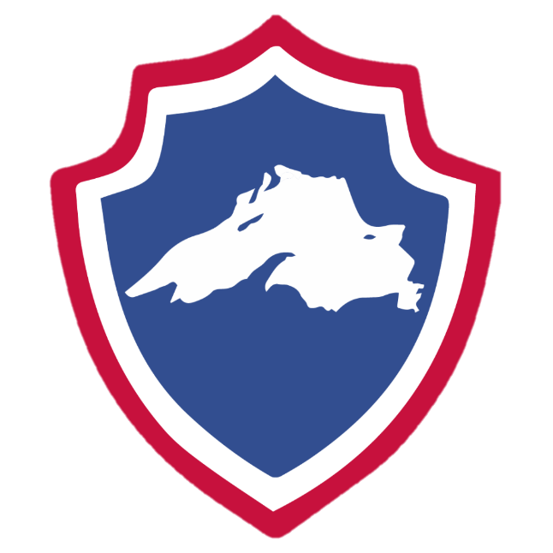

LaKE Superior warriors

Monthly Team Meeting

July 10th, 2019

Cloquet (Northwoods Credit Union Arena)

7:00 PM – 8:00 PM

Attendees: Matt Caple, Mike LaValley, Nate Miller, Jacob Heytens, Pat Russ, Kyle Cotrell, Flash, Sean Leeman, Terry Griffiths, Nick Benjamin, Deanna Benjamin, Jim Rich, Craig Purcell, AJ Spears, Derek Butenhoff, Anthony Ostrom, John Tobin, Mark Pyrzynski.
Item #1 | Copyright Infringement Allegations with MNWIH  Team was informed of notice received from Amy Kottke (attorney representing MNWIH) regarding copyright infringement allegations. LaValley and Caple to ensure future publishing to social media or the website will be free of MNWIH related material, but will not be relinquishing control of lakesuperiorwarriors.com domain to the MNWIH.
Item #2 | Lake Superior Warriors USA Hockey Affiliate  Three options for team affiliation were discussed.  MNWIH / WAHA Region 1 / Independent.  Team discussed the pros and cons for each option, and a unanimous decision via membership vote was reached to pursue WAHA Region 1 with remaining independent being a fallback option.
Item #3 | Lake Superior Warriors Non-Profit Intentions  State and federal applications to be submitted once WAHA approval has been confirmed.  LaValley has already begun writing the bylaws and after a future team revisit of the bylaws and other articles of incorporation, the 501(c)3 paperwork will be submitted.
Item #4 | Potential Exhibition Games for 2019-2020 Season  Hoyt Lakes (MN Iron Rangers) have moved to Spooner, WI. Caple to begin discussion with team reps for possible event.  Silver Bay possibility.  Ely (Rusty Blades) possibility.  Eveleth Rich has indicated that he will be the POC for this event. More information to follow at later dates.  Warriors showcase prior to Wilderness game. Vs St Cloud or Duluth possibilities.
Item #5 | Team Discussion on Dual Rostering with MNWIH/DWIH  Caple made mention that while the team itself does not currently have any issues with Lake Superior Warriors playing for the other MNWIH teams (TC, St Cloud, Duluth), more information will need to be gathered from WAHA to determine if this will be allowed.
Item #6 | Membership Dues / Team Volunteerism  Team discussion regarding membership dues to help offset expenses and to potentially alleviate animosity that develops from core volunteer/fundraising group vs others who are either incapable of assisting due to work, or are generally not interested in volunteer work.  Team came to a unanimous decision via membership vote that the 2019-2020 season will require all members to pay $150 membership dues. Future dues will be dependent on team financial status at the end of the season, and individual volunteerism throughout the season.  Anonymous individual has offered to pay for the membership dues for two individuals that have financial difficulties this season.
Item #7 | Air Show  Caple gave brief recap of July 10th event, and requested more volunteers for the weekend of the air show. All volunteer dates and times have been added to the website.
Item #8 | Louis Karsnia Funeral  DAV (Flash) provided gas card to assist Warriors to get to Fergus Falls for the funeral. Caple and Russ to attend.
Item #9 | Jersey Quotes  Stewarts; Duluth ($135 – Two Jerseys, One Set of Socks)  JFX; California ($149 – Two Jerseys, Two Sets of Socks, 1 Shell)  Tough Jersey; St Paul, MN ($90 – One Jersey, One Set of Socks, 1 Shell. Second Jersey for $50, Second Set of Socks for $15)  Shirts Unlimited; Superior, WI ($100 per set of two jerseys and socks)  Screen Graphics; Superior, WI (Unknown)  Team discussed the intent of the team to stay local, and decided to go with the Superior based companies. Deanna to continue working possible sponsorship deal with Screen Graphics.  Membership vote tabled
Item #10 | Open Discussion / Sponsorships / Volunteer Ideas / Family Events  Once team details are finalized, begin working on inaugural family day and team event to kick off the season.

