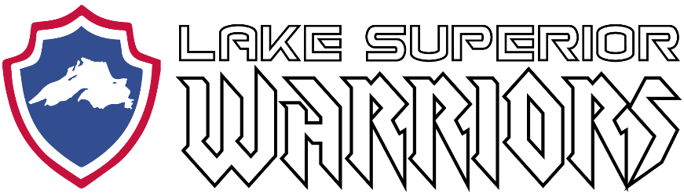

Monthly Team Meeting/Minutes:

August 28th, 2019
Hermantown Arena
6:00 PM – 7:00 PM

Attendees:

Matt Caple, Mike LaValley, Flash, Aaron Newberry, Anthony Ostrom, Brett Metzer, Justin Stokke, Dan Lilya, Rhawnie Britton, Kyle Cotrell, Terry Griffiths, Patrick Russ, John Tobin

Agenda:

1) Treasurers Report

BEGINNING BALANCE (JULY 10, 2019) $737.00

INCOME (Deposits)

Date Description Amount

EXPENSES (Invoices Paid)

Date Description Amount
7/10/19 Nick Benjamin Skates $200
7/11/19 Louis Karsnia Funeral Donation $160
8/28/19 501(c)3 Application Fee $275

ENDING BALANCE (AUGUST 28, 2019) $102.00

ANTICIPATED INCOME (Pending Deposits)

Date Description Amount
??? Duluth Air Show $715
??? Ragnar Relay Donation $750
??? Ragnar Cash Donation $67
??? MPECU Sponsorship $200
??? DAV Partnership (Aug) $320
??? Northwoods Credit Union Donation $1,000

ANTICIPATED EXPENSES (Future Invoices)

Date Description Amount
??? Hermantown Ice $480
??? Game Jerseys $4,000

PROJECTED SEPTEMBER ENDING BALANCE $-1,326

2) Lake Superior Warriors USA Disabled Hockey Status

- Application submitted to join MNWIH was reviewed by the MNWIH board and voted to decline our request to affiliate with them based on the following criteria:
  - Already a Duluth-based team
  - Lake Superior Warriors allow non-disabled veterans to skate and play with them
  - Continued allegations of misappropriation and illegal use of trademarks and copyrighted images
- Request submitted to join WAHA Region 1 and was reviewed and accepted, but LSW has declined to join based on the following criteria:
  - Lake Superior Warriors roster not currently at 50% threshold for Wisconsin residents
- Decisions from both parties were formally appealed to MN Disabled Hockey, reviewed and declined based on following criteria:
  - MN Disabled Hockey is satisfied with current single association per program (sled, warrior, special)
- MN Disabled Hockey decision has option to be appealed to MN Hockey ($200)
- MN Disabled Hockey decision has been appealed to USA Warriors Hockey Rep Mike Vaccaro.
- Recommendation from USA Hockey is to register as an Adult Hockey program with Minnesota Hockey. Players eligible to participate in Warrior Classic and National Disabled Festival will be allowed to go as a team under LSW banner.
- Currently operating as an independent team not recognized by USA Hockey.

3) Upcoming Events

- (Oct 18-20, 2019) AHA Duluth Classic
- (Nov 30, 2019) Iron Range Area Guns and Hoses Game
- (Jan 24-26, 2020) Great Lakes Pond Hockey
- (Feb 21-23, 2020) Hendrickson National Hockey Festival (Unlikely)
- (Mar 13-14, 2020) Lawmen Tournament
- (Mar 20-22, 2020) MN Armed Forces Hockey Tournament
- (Mar 26-29, 2020) National Disabled Festival

- Eveleth, Silver Bay, Ely, St Cloud?
- Volunteer events, Fundraising ideas?

4) Membership Dues

- $150 Membership due immediately for those that have not paid
- Financial Assistance
- Future on-ice event for non-members will be treated as “pay to play”

5) Jerseys

- Final review of jersey design

6) Board of Directors 2019-2020 Season Announcement

- President (Thomas Flaschberger)
- Secretary (Deanna Benjamin)
- Treasurer (Kyle Cotrell)
- Volunteer/Fundraising Coordinator (Nick Benjamin)
- Marketing Director (Aaron Newberry)
- Family Advocate (John Tobin)
- Technology Director (Mike LaValley)
- Director of Hockey Ops (Matt Caple)
- Recruitment Director (Craig Purcell)
- Equipment Manager (Pat Russ)
- Team Captain (Matt Caple)

