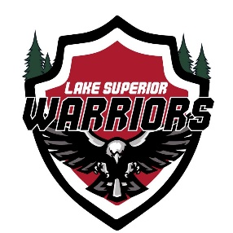

2026 Winter General/BoD Meeting

January 25th, 2026
VIP Pizza, Superior WI
Call to Order by Shawn Hanson: 13:10

Attendees:

Shawn Hanson, Matt Caple, Rhawnie Britton, John Tobin, Langston Lalor, Mike LaValley, Derek Butenhoff

Agenda:

1) Secretary Report (Jacob Talarico – not present)

- Approve Meeting Minutes from October Quarterly Meeting
  - Tabled to February Meeting

2) Treasurers Report (Kyle Cotrell)

- Present Current Treasurers Report
  - Current Balance as of January 25th, 2026 - $5,307.80
- Approve Report
  - Motioned by: RB
  - Seconded by: ML
  - Approved by: ALL
- Upcoming Expenses/Income
  - Jersey Order in January (Andrew Chammings added to early January order)
  - Expecting payment from RAGNAR
  - Reimbursement for hotels to Matt Caple - $8,842 (Approved)
- 501c3 Status Update and Fee – KC Registered with IRS/State, $60 payment

3) Hockey Operations (Matt Caple)

- Las Vegas Recap
- Armed Forces 2026 – 2 Teams Being Sent – Rosters Have Been Set
- Hendy 2026 – 1 Team Being Sent – Rosters Have Yet to Be Set

3) Recruiting (Anthony Ostrom – not present)

- Membership updates over the last 3 months – 6 New Fully Registered Players

4) Fundraising and Volunteering (Rhawnie Britton)

  - Denfeld Hockey Game Recap - $495 Raised and Expecting Additional Payment Later From Booster Club
  - Raffle/End of Season Party Update – March 14th – 4-7PM - Log Cabin Tavern
  - Golf Scramble – Erikson and Krunkkala Need To Provide Update by Next Meeting

5) Technology/Marketing (Mike LaValley)

- Motion Made to Use Crossbar as the New Website and Player App Tool
  - Discussion
  - Cost - $495
  - Motioned by: RB
  - Seconded by: ML
  - Approved by: ALL

6) Equipment (Langston Lalor)

- Jersey Order Update

7) Family Advocate (John Tobin)

- General Discussion
  - Continue Culture of Drama Free Environment – Issues Should Be Brought Up Immediately

8) Open Forum

- Golf Scramble Update – Tabled to February

Meeting Adjourned
    - Motion by: MC
    - Seconded by: JT
    - Meeting Adjourned: Shawn Hanson: 14:49

