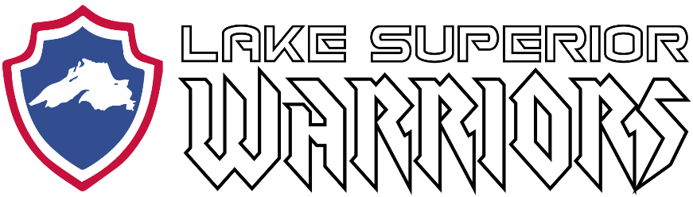

Monthly Team Meeting/Minutes:

September 18th, 2019
Hermantown Arena
6:15 PM

Attendees:

(Names)

Agenda:

1) Treasurers Report

BEGINNING BALANCE (August 28, 2019) $102.00

INCOME (Deposits)

Date Description Amount
8/28/19 Ragnar Relay Cash Donation $67
8/28/19 Membership Dues (Cotrell Deposit) $150
8/28/19 Practice Non-Member Fees $40
8/29/19 Duluth Air Show $715
8/31/19 Krenzen Donation $500
9/3/19 MPECU Donation $200
9/4/19 Northwoods Credit Union Donation $1,000
9/4/19 Practice Non-Member Fees $70
9/18/19 Membership Dues (Caple Deposit) $4,150

EXPENSES (Invoices Paid)

Date Description Amount

ENDING BALANCE (AUGUST 28, 2019) $6,994.00

ANTICIPATED INCOME (Pending Deposits)

Date Description Amount
??? DAV Partnership (Aug) $400
??? Membership Dues $850
??? Heritage Window and Door $550
??? B&B Market Sponsorship $200

ANTICIPATED EXPENSES (Future Invoices)

Date Description Amount
??? Hermantown Ice $480
??? Game Jerseys $4,095

PROJECTED SEPTEMBER ENDING BALANCE $4,419

2) Lake Superior Warriors USA Disabled Hockey Status

- Still waiting on answer from USA Warrior Hockey Rep (Mike Vaccarro) and USA Disabled Hockey

3) Upcoming Events/Hockey Ops

- (Sep 21, 2019) UMD Football Game
- (Oct 18-20, 2019) AHA Duluth Classic
- (Oct 26, 2019) Graybeards Exhibition Game
- (Nov 30, 2019) Iron Range Area Guns and Hoses Game

4) Recruiting

- Ideas moving forward
5) Marketing

- Trifold updates
- Banner and Tablecloth discussion/photoshoot

7) Fundraising and Volunteering

- Report

8) Family Advocate

- Preseason party ideas

9) Technology

- Website improvements, updates, suggestions

10) Equipment

- Report on True and Bauer equipment sponsorship

11) Open Forum

