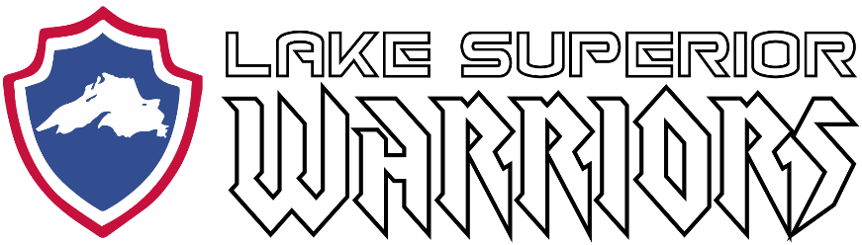

Team Meeting:

November 29th, 2020
Virtual Meeting (Zoom)
Call to Order: 7:00PM

Attendees:
Trent Harris, Matt Caple, Shawn Hanson, Travis Jonns, John Tobin, Shane Lawry

Agenda:

1) Review/Approve September, 2020 Meeting Minutes

- Britton not in attendance
  - No quorum, will review at later date

2) Treasurers Report

- Presented by Kyle Cotrell
  - $14,183.04 total in bank account
  - Anticipated upcoming expenses to be paid
    - NTX Jerseys - $1,155
  - Anticipated income
    - Savage Spartan Apparel - $300
    - Minnesota Power Grant was declined
  - No quorum, will review at later date

3) Upcoming Events/Hockey Ops

- Presented by Matt Caple
  - Current COVID-19 restrictions and lack of ice have focused shifting of efforts to support membership and veteran community as a whole
  - Toy drive will be conducted in partnership with DAV Chapter 6
  - Volunteers needed to help move a disabled veteran and his family to Sartell, MN on December 11th
    - Board members in attendance approve of gas, food, and per diem amount to be reimbursed

4) Recruiting

- Purcell not present

5) Fundraising and Volunteering

- Antilla not present
  - Firearms have been purchased for end of year gun raffle
  - Trent Harris securing golf scramble for next summer

6) Technology

- LaValley not present

7) Equipment

- Russ not present

8) Open Forum

- General discussion

Meeting Adjourned @ 07:35 PM

