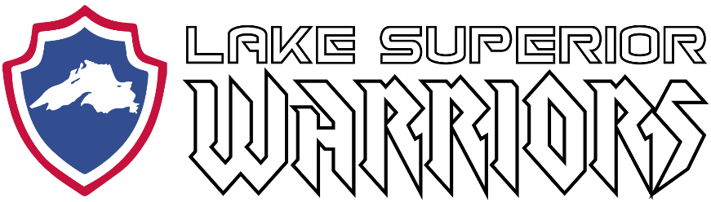

Monthly Team Meeting/Minutes:

October 25th, 2019
Fryberger Arena
Call to Order: 5:35 PM (Flash)

Attendees:

Flash, Matt Caple, Mike LaValley, Pat Russ, Craig Purcell, Aaron Newberry, Terry Griffiths, Kyle Cotrell, John Tobin, Shane Lawry, Hazen Elmgren, Derek Butenhoff, Dan Lilya.

Agenda:

1) Treasurers Report

- Attachment
- Caple motioned to accept treasurers report, Newberry seconded, passed.

2) Lake Superior Warriors USA Hockey / Non-Profit Status

- Independent non-USA Hockey program currently
- 501(c)3 approved
- Board agrees to pursue adult classification within USA Hockey, and for players to become USA Hockey members if they wish to participate in sanctioned events

3) Upcoming Events/Hockey Ops

- (Oct 25, 2019) Cloquet JG Scrimmage
- (Oct 26, 2019) Graybeards Exhibition Game
- (Nov 30, 2019) Iron Range Area Guns and Hoses Game
  - Need DAV transportation
  - Housing available
- (Jan 1, 2020) Buffalo Beauts vs MN Whitecaps
  - Need DAV transportation

4) Recruiting

- Purcell report on new players recruited since last meeting acknowledged

5) Marketing

- Trifold and flyer updates
- Newberry has procured acrylic donation box and has helmet and vehicle decals ready
- Banner has been procured / Tablecloth to be procured once final designs have been made

7) Fundraising and Volunteering

- Benjamin absent

8) Family Advocate

- Cedar Lounge / Earth Rider Recap
- No other information to report

9) Technology

- Website improvements being made, Caple requested e-mail functionality.

10) Equipment

- True equipment sponsorship update. Caple working on team purchase agreement with True rep
- Conex at DAV Property (Solway Rd) now has spare equipment for new members
- Gear for members’ kids has been procured by Purcell
- Jackets to be purchased using Minnesota Power Grant money

11) Open Forum

- Flash update on DAV partnership. Push to boost DAV membership within the LSW ranks.
- Caple presented “LSW Jersey Tracker” form, shared on google drive, to be updated by board members.
- Cotrell presented Russ with custom goalie helmet “wrapped”

Caple motioned to adjourn, Tobin seconded, adjourned at 6:17 PM.

