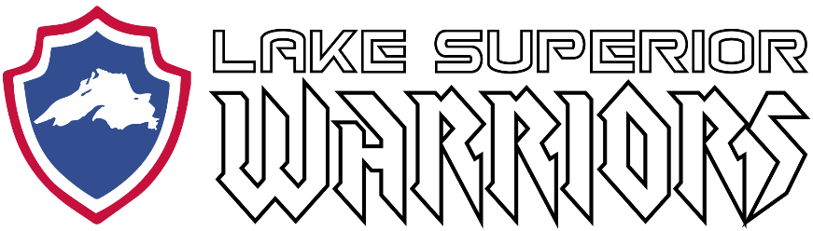

Annual Team Meeting:

September 7th, 2020
Virtual Meeting (Zoom)
Call to Order: 7:00PM

Attendees:

Agenda:

1) Review/Approve November, 2019 Meeting Minutes

- N/A

2) Treasurers Report

- Presented by Kyle Cotrell

3) Upcoming Events/Hockey Ops

- Armed Forces Regional Tournament
  - Cancelled (Tourney fee to be used next year)
- Armed Services Hockey Association National Tournament
  - Cancelled, discussion of moving it to Spring and Fall 2021 (Tourney fee not paid)
- Military Appreciation Game (MN Wilderness)
  - Postponed to 2020-2021 Season
  - Discussions with GM of team partnership
- Hermantown League / Other Options?

4) Recruiting

- Welcome new members

5) Fundraising and Volunteering

- Gun Feed and Spaghetti Raffle
  - $3,737 generated in profit
  - Thanks again to everyone who helped put it together, and to Rhawnie (Neptune Rising) for the great live band performance.
- Membership dues, if any, will be determined by incoming board

6) Technology

- Report by Mike LaValley

7) Equipment

- Jackets purchased and delivered to all members at time of order. Future jacket procurement will be decision of incoming officers
- Current gear location, future plans (DAV site)
- Sponsorship potential through TRUE, BAUER, CCM, etc.

8) Board of Directors Election Results

- President – Trent Harris
- Treasurer – Kyle Cotrell
- Secretary – Rhawnie Britton
- Family Advocate – Nate Miller
- Volunteer/Fundraising Coordinator – Bill Antilla
- Recruitment Director – Craig Purcell
- Marketing Director – Shawn Hanson
- Technology Officer – Michael LaValley
- Equipment Manager – Pat Russ
- Director of Hockey Operations / Team Captain – Matt Caple

9) Open Forum

- General discussion

