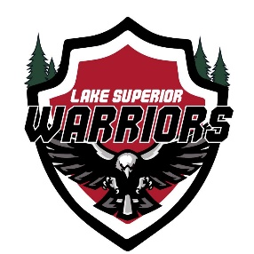

2025 Fall General/BoD Meeting

October 19th, 2025
VIP Pizza, Superior WI
Call to Order by Shawn Hanson: 13:05

Attendees:

Shawn Hanson, Matt Caple, Rhawnie Britton, John Tobin, Langston Lalor

Agenda:

1) Secretary Report (Jacob Talarico)

- Approve Meeting Minutes from April Quarterly Meeting
  - Motioned by Rhawnie Britton
  - Seconded by Matt Caple
  - Approved by All
- Open discussion

2) Treasurers Report (Kyle Cotrell)

- Present Current Treasurers Report
  - Current Balance as of October 19th, 2025
- Approve Report
  - Motioned by John Tobin
  - Seconded by Langston Lalor
  - Approved by All
- Upcoming Expenses/Income
  - Jersey Orders
  - Expecting payment from RAGNAR
  - Ranger Panties
- 501c3 Status to be Worked on By Kyle Cotrell

3) Hockey Operations (Matt Caple)

- AHA Duluth Classic Recap
- Las Vegas ASHA 2025
- Armed Forces 2025

3) Recruiting (Anthony Ostrom)

- Membership updates over the summer

4) Fundraising and Volunteering (Rhawnie Britton)

  - Ragnar Relay recap
  - Planning for Spring Party/Raffle

5) Technology/Marketing (Mike LaValley)

- New Website Update in The Works by Mike LaValley
- Team Schedule and Stat Tracking Migrating to BenchApp, with Possible Integration into New Web Platform After Finished

6) Equipment (Langston Lalor)

- Jersey Order Update
- Ranger Panties
- Vendor Gear Site

7) Family Advocate (John Tobin)

- General Discussion

8) Open Forum

- Golf Scramble – Did not happen this year, start discussion with Dusty Wilson

Meeting Adjourned
    - Motion by Matt Caple
    - Seconded by Rhawnie Briton
    - Meeting Adjourned: 14:35

