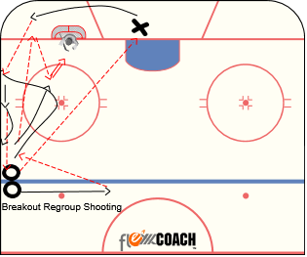
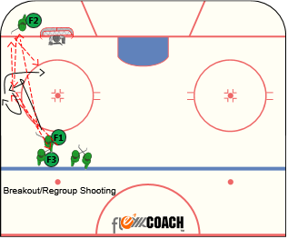
Breakout/Regroup shooting:

Player O in line passes to player X at the goal crease. X wheels the net and makes a breakout pass to O who sprints down and pivots to open up at the boards. O then passes to the player at the blueline who catches the pass, walks the line and passes back to O who has opened back up towards the boards. When O receives that pass he passes to X for a give and go and a one timer on net. X can play the rebound coming out of the corner. O then becomes X.
Works on: passing, receiving, breakouts, shooting, scoring
https://www.youtube.com/watch?v=yKDw6o3kzEg

Quad passing:

Player 1 passes to player 2 who passes back to 1 and 1 passes back to 2. 2 then passes to 3 who passes to 2 who has rotated around the circle. 2 passes to 4 and gets to the back of the line. 1 becomes 3 and 3 becomes 2. 4 becomes 1.
Works on: passing, receiving, give and go’s

https://www.youtube.com/watch?v=UHOgiA1F9f0&list=UUtpq8N-UTX6RTxP_mmmHgNw&index=36

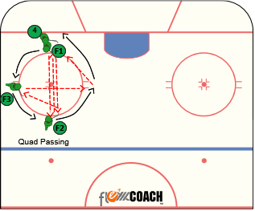

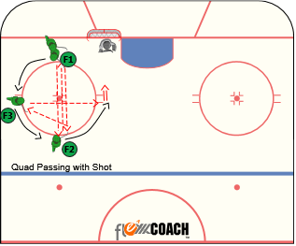
Quad passing with shot:

Player 1 passes to player 2 who passes back to 1 and 1 passes back to 2. 2 then passes to 3 who passes to 2 who catches and shoots (or one times) without stickhandling.
Works on: passing, receiving, give and go’s, team play, cycling, shooting, scoring

https://www.youtube.com/watch?v=9ABHYXJTmtE

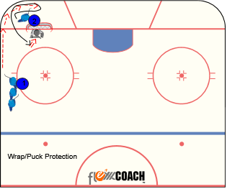
Wrap/Puck Protection Progression:

Part 1 -Player 1 wraps the puck to player 2 behind the net. Player 2 skates with the puck and picks it off the wall with his stick. When player 2 gains possession he cuts back to the corner facing the wall and attacks, the net for a jam or reverse jam attempt.
Part 2 –Player 1 wraps the puck to player 2 behind the net, player 2 protects the puck, cuts back to the corner looks to hit player 1 for a one timer off the post or in the slot.
Works on: puck protection, breakouts, wraps, passing, shooting, scoring, team play.

https://www.youtube.com/watch?v=y2IIfnJFUgA&list=UUtpq8N-UTX6RTxP_mmmHgNw&index=26

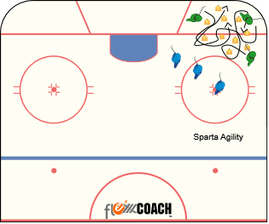
Sparta agility skating:

Players skate as fast as they can in a small area around obstacles. Progression-no pucks, with pucks, only one puck with players passing it as often as possible. Shifts should be :30 on/:30off.
Works on: skating, puck handling, passing, receiving, give and go, spatial awareness

https://www.youtube.com/watch?v=4h8m1I44OpE&index=35&list=UUtpq8N-UTX6RTxP_mmmHgNw

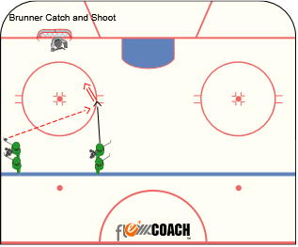
Brunner catch and shoot:

Player takes off towards the net on their strong side (right shot on right, left on left) and they receive a pass from the opposite line. Without breaking stride they catch and shoot without stickhandling.
Works on: passing, receiving, underhandling, shooting, scoring

https://www.youtube.com/watch?v=bYqxn9aKrGE&list=UUtpq8N-UTX6RTxP_mmmHgNw

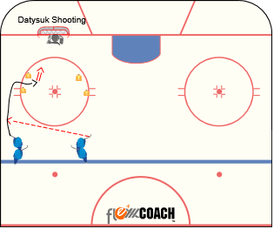
Datsyuk shooting:

Player takes a pass and attacks the first cone. At the cone he pulls the puck inside the next cone and shoots on the opposite hand that he just was. Example, if they drive on their backhand they pull puck to forehand for quick release, if on forehand, they pull to backhand.
Works on: passing, receiving, underhandling, shooting, scoring

https://www.youtube.com/watch?v=_S_fOEl1i-Y&index=15&list=UUtpq8N-UTX6RTxP_mmmHgNw

Two touch shooting:

Player 1 underhandles the puck through the cones and makes a pass to the board side D(2) who catches the pass and makes a pass to his partner D(3). The middle point (D3) can only can only touch the puck twice; Once to stop it, once to shoot it. Player 1 who made the pass looks to go to the net for a rebound while player 4 is already net front to set a screen/tip the shot. Rotation is as follows, player one becomes D2 (have an extra in line there to speed up reps), D2 becomes D3, D3 becomes player 4. Player 4 goes back to line.
Works on: Underhandling, passing, shooting, o/z play, tips, screens, scoring
https://www.youtube.com/watch?v=84z9OfqFmcc

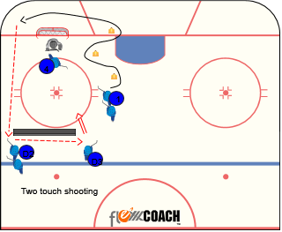

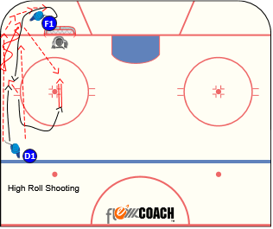
High Roll Shooting

D1 rims a puck to player F1 behind the net. F1 picks it off the runner properly with his/her stick and protects the puck and cuts back to the corner. F1 continues up the wall with the puck at which point D1 moves down the wall. F1 stays to the inside and exchanges it with D1. D1 carries it to the goal line extended and hits F1 in the high slot for a scoring attempt. Have players go at both positions, have a line for each positions as well.
Works on: passing, receiving, taking wraps, scoring, offensive zone play
https://www.youtube.com/watch?v=Z2Y7hs8Pglo
https://www.youtube.com/watch?v=h-e3ND-O594&feature=youtu.be

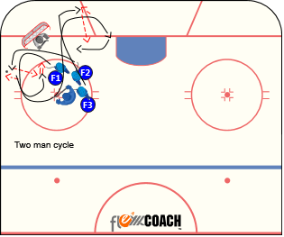
Two player cycle:

Coach spots a puck off to the side of the net and F1 and goes up the wall away from the net, F2 fills in behind to receive a bank pass from F1. F2 then hits F1 with a pass in the high slot for a shot. Coach then spots a puck on the other side of the net and player F2 picks it up with F3 (next in line) filling in behind him. F2 banks to F3 and F3 hits F2 for a shot. Drill continues back and forth from side to side.
Works on: cycling, passing, shooting, scoring, puckhandling, offensive zone play.

https://www.youtube.com/watch?v=7NjoSNU5eJ0&list=UUtpq8N-UTX6RTxP_mmmHgNw&index=47

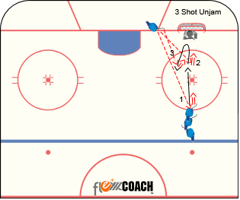
3 Shot Unjam

The player next to the net passes (1) to the player at the top of the circle who shoots by two touching the puck. That player then attacks the net and receives a second pass (2) for a one time shot. After the one time shot, the player taps the goalies pads and backs out into the high slot for a third pass (3) and shot (one timer or catch and shoot). The shooting player becomes the passer and the passer goes back to the line.
Works on: passing, receiving, team play, shooting, scoring, offensive zone play

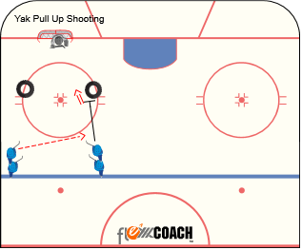
Yak Pull Up Shooting
Players are in line by which way they shoot. Righty’s are in the left line and lefty’s are in the line to the right. Player from the opposite line passes to a player on their backhand and they drive at the tire in front of them. As they near the tire, they put the brakes on, pull up and get a quick shot off by going from backhand to forehand as quickly as possible.
Works on: passing, receiving, zone entry, shooting, scoring

https://www.youtube.com/watch?v=1AnxJOtIy9E&list=UUtpq8N-UTX6RTxP_mmmHgNw

https://www.youtube.com/watch?v=miLfpIiulUo&list=UUtpq8N-UTX6RTxP_mmmHgNw

BDS Passing/Shooting (backcheck,dish,score)

Puck starts with player 1 on the half wall. 1 passes to 2 in the corner. 2 sprints behind the net who hits 1 closing in the slot. 2 now sprints to the half wall (backchecks) to retrieve a loose puck. While 2 is sprinting to the loose puck, 3 skates to the corner (2 becomes 1, 3 becomes 2) and the drill continues. Emphasize sprinting back to the loose puck. BDS stands for backcheck, dish, and score. Variation, have the pass to the corner be a wrap.
Works on: passing, receiving, taking wraps, scoring, offensive zone play, backchecking
https://youtu.be/RAeyuHMixfk

1 Time/Quick Hands shooting

Players line up facing the far post. Players attack the net with speed and receive a pass from coach (or player) and they one time the puck. Second progression is they receive the pass and pull it to the opposite hand for a quick shot (if they catch on forehand, pull to backhand and shoot; if they receive on backhand, pull to forehand and shoot).
Works on: passing, receiving, puck handling, shooting, scoring

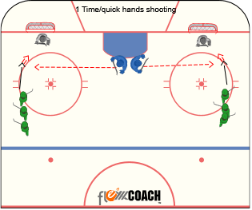

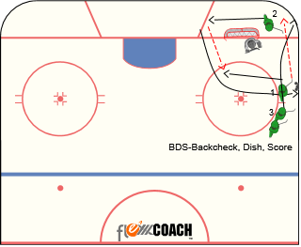

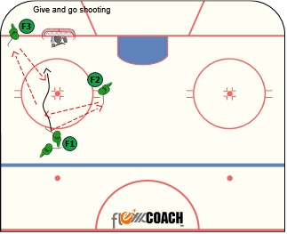
Give and Go Shooting

Player 1 passes to player 2 who passes back to 1. Player 1 then passes to player 3 who gives it back to 1 for a 1 timer on net. 1 becomes 3, 3 becomes 2, 2 goes back to line.
Works on: passing, receiving, give and gos

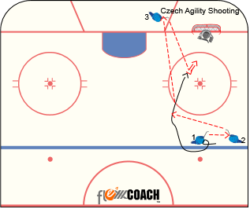
Zone Entry Drives

Player 1 passes to player 2 who drives hard down the wall. Player 1 drives hard to the net, player 3 buys time and becomes the late man. Player 2 can either shoot, pass to player 1 driving the net for a tip, or delay/escape to find player 3. Player 2 can’t escape until below the hash marks.
Works on: passing, receiving, zone entries, offensive concepts, shooting, scoring

Czech Agility Shooting

Player1 pulls puck across blue line and passes back to player2 in line, player1 pivots to outside and gets pass back from player2. Player1 now passes to player3 for a quick give and go. Player1 one times it on net. 1 becomes 3, 3 goes to line, 2 becomes 1
Works on: passing, receiving, shooting, skating, puck handling, scoring, offensive play

https://www.youtube.com/watch?v=aewBtgYsFak

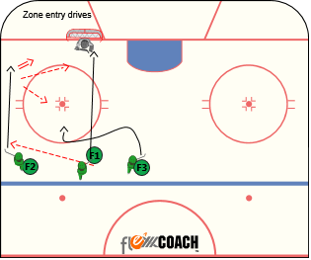

Criss Cross Drop Passing

Player 1 passes to player 2 before the first border. In between the first two borders, player 2 makes a drop pass to player 1, between the next two borders, 1 drops it back to 2 then when around the last border 2 passes back to 1 for a one time shot.
Works on: puck handling, passing, receiving, shooting, scoring, attacking the net

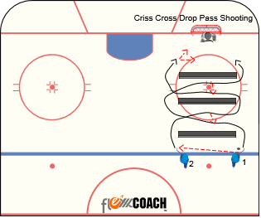

Johnny Phone Booth:

Player flips a puck over the barrier then escapes towards the blue line then back towards the goal line turning towards boards to protect puck. After second escape, they stickhandle through obstacles, around cone then attack the net/barrier. Players feet go on one side of barrier and puck on the other for a shot on net.
Works on: puck protection, edges, puck handling, underhandling, shooting, release, scoring
https://www.youtube.com/watch?v=_25JMt9YhkQ https://www.youtube.com/watch?v=gOs9upakl0E

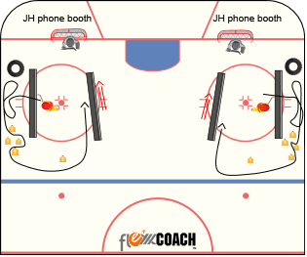

4 corner Passing progression https://youtu.be/CFpiIDZlgyE
Players are in 4 lines, and 4 players enter the middle area with pucks and move and pass to any line (progression: coaches can add pressure in space). Keep shifts to 30 seconds. Next 4 in line go in middle and Os leave middle to get in line.

Teaching Points: Present a good target, communicate; face puck & move feet direction going

2nd progression – players play keep away and can use their lines as well to make it a 4v2 https://youtu.be/FvWLGH84Gac

Concepts: Puck handling, Puck support, passing, receiving, transition, puck possession

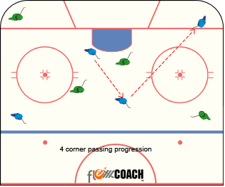

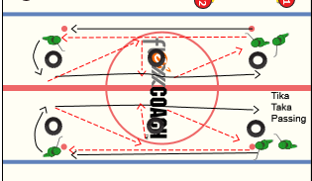
Tika taka passing

Player 1 passes to player 2, player two opens up around the tire and passes to player 1 who has skated to the middle tire, they perform and give and go and player 2 passes to player 3. 1 becomes 2, 3 becomes 1 and drill is continuous.
Concepts: passing, skating, puck handling, team play, break outs

https://www.youtube.com/watch?v=e-CETEagzjw

Oolu shooting

Player 1 and 2 perform a give an go, player 1 skates into the zone and makes a back diagonal to player 2 who has skated the top of the circle to get open and player 2 shoots, player 1 after making the back diagonal comes back towards player 3 for a give and go and player 3 enters the zone, while player 1 comes back up top for a shot. Drill then moves continuously.
Works on: passing, o/zone play, shooting, scoring, team play.

https://www.youtube.com/watch?v=idN3N0yKsT0

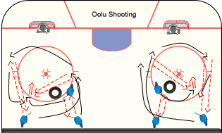

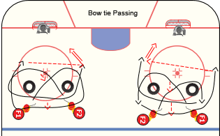
Bow Tie Shooting

Player 1 crosses in front of player 2 and drops it to him. Player 2 then exchanges with player 1. Player 1 then passes to player 2 who catches and shoots without stickhandling. Player 1 looks for a rebound.
Works on: passing, receiving, scissoring, Underhandling, shooting, scoring

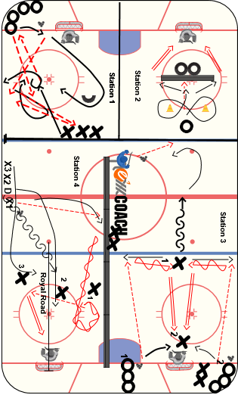
Underhandling with pass off bumper

Players skate a figure 8 pattern around cones keeping the puck on their forehand, pass puck off bumper and collect puck on forehand, Push or Pull around bumper executing a quick release shot-follow for rebound.
Can progress to same as above but players skate a Russian figure 8 pattern (always facing the goalie).
Concepts: Underhandling puck, hands away from body, quick release shooting, deception
https://vimeo.com/93537607

https://youtu.be/mriLvMkYIvU

Blue Line REPS

1) Player X chips puck into corner, skates to RETRIEVE puck, shoulder checks, surrounds puck when retrieving, skates behind net & ESCAPES back toward corner. After escape, player X PASSES to player X at the blue line, who pushes or pulls the puck around the stick for a quick SHOT. Player X who made the pass looks to go to the net for a screen/tip.
2) Player O chips second puck on net, goalie plays puck behind net and O RETRIEVES, ESCAPES, & PASSES to X at the blue line for second shot.
Progressions: 1. Blue Line player can fake stick, and pull/push to the other side for quick shot 2. Add a second X at blue line and D-D pass
Concepts: Puck Retrieval, puck protection, passing, receiving, underhandling, blue line movement, shooting, tips, screens

https://www.youtube.com/watch?v=5egb1Uz1S2A&list=PLkVqE1VRe5DfbxfibRb2FKqUhFOXNNL7d&index=6

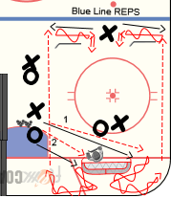

Cornell Underhandling

Players go around the cones with a puck without stickhandling. The puck must always remain on the forehand side of the blade. Emphasize proper technique over speed. After the last tire, players should move their feet while taking their shot.
Works on: skating, edgework, stick handling, shooting, scoring, release, underhandling

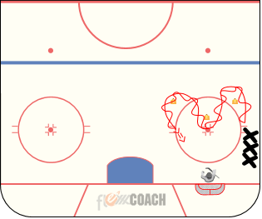

Net Drive Read and React 2v0 (8 mins)

Player X1 stands in the middle of the tires and receives a pass from either O on the goal line and pulls or pushes the puck outside the tire on forehand, at the same time, player X2 reads X1 and reacts by sprinting around opposite tire to receive a quick pass and shot. X2 should receive puck on forehand on strong side and should work on displaying a target and receiving puck on both forehand and backhand on weak side.
Concepts: Push and pull to shot, Puckhandling, One-Touch Shooting, Transition Skating, One-touch Passing, backhand puck reception and shooting, displaying a passing target
https://youtu.be/lFLhKxaTi1o (progression is later in video)

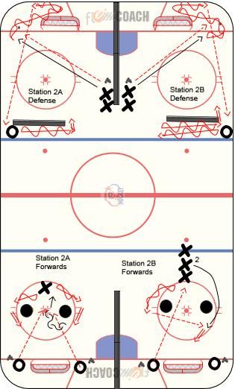

Puck Protect Scissor Exchange

Forward at the top of the circle throws a soft rim to the player below the goal line. The player collecting the rim, skates with the puck, protects it for a second then comes up the wall to create a scissor play with the other forward. The forward who gets the puck on the exchange going down the wall must skate past the line drawn from the edge of the net to the end boards and throw a misdirection pass back to the other forward for an off angle one timer.

Concepts: Puck protection, o/z play, underhandling, goal scoring
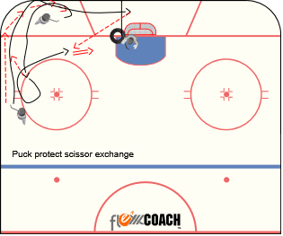

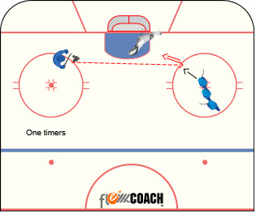
Back Door One Timers

Players line up on the dot. Goalie lays down in a two pad stack formation. One by one, players attack the net and receive a pass that they attempt to one time over the sprawled out goaltender.
Concepts: Underhandling, goal scoring

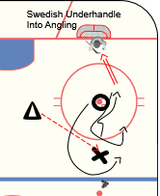
Swedish Pass and Shoot Underhandle

Player x receives a pass and attacks a stationary defender O. X performs a pull push move (underhandling) and shoots on net as he goes by the defender.
Progression: As X shoots the puck, O picks a puck up at the blue line, X gaps back up by angling and they play a 1v1.
Works on: passing, receiving, underhandling, shooting, scoring, angling, body contact
http://www.swehockey.se/Hockeyakademin/Nyheter1/nyheterfranhockeyakademin/malskytteskolan/malskytteskolandel7-ovningforattlaradiggrundernainomindragningsskott/

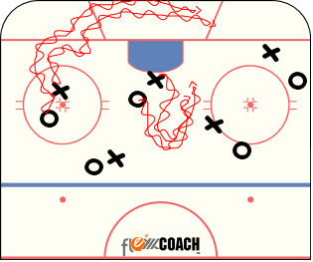
Trucks and Trailers

Players will partner up. One player will be the truck and other is a trailer. The truck will skate around the ice staying inside the designated area while the trailer will try to follow. Both players will have pucks. After 20-25 seconds, switch positions. Add more players to create more confusion, while keeping the environment safe
Works on: Skating, Stick Handling, Finding open ice, Agility

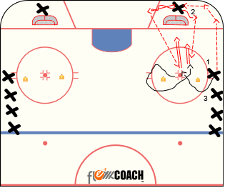
2 shot quick release

X1 will wrap puck around wall to X2. X2 will pick puck off wall under handle and make pass to X1 in slot. After shot X1 will continue around second cone always facing play. During that time another puck with be wrapped by X3. X2 will pick up second puck and hit X1 in slot for second shot. X2 will go to end of line and X1 will go behind the net.
Works on: Picking puck off wall, Timing, passing, quick release

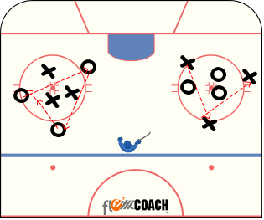
Passing Circle Chaos

Player inside circle each have a puck and will stickhandle around trying to avoid each other. Players on the outside have one puck that they are passing through the circle to each other trying not have the puck intercepted by players in middle. Players in middle may only block puck with feet while trying to maintain possession of their own puck. Rotate every 20-25 seconds

Works on: Stick Handling, Passing, Decision Making

Activities below may have very little contact. Promote stick on puck and active stick and not allow body contact to adhere to the social distancing guidelines if required

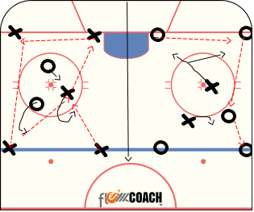
5V2 Keep away (no contact)

There are two 5 V 2 keep away games going on each side of ice. Players on outside stay stagnant and play keep away. Players on outside can utilize teammate in the middle, who can move inside box to support puck. The two defenders pressure and try to steal puck. Defenders are not allowed to make contact and just look to steal puck using stick on puck.

Works on: attacking defender, passing, Puck support.

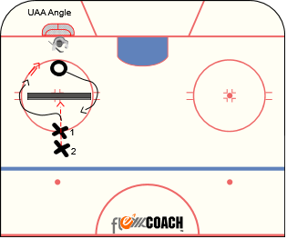
UAA Angle
https://youtu.be/a-zZB5XogrI

X2 starts by passing puck between X1s feet off barrier. As X1 picks up the puck, player O angles around barrier (pick either side) as X1 reads where the open side is and attacks net. O continues to pursue X1 until one of three things. 1-X1 scores, 2-goalie covers the puck, 3-O gains possessions and skates puck past the barrier. O limit contact and focus stick on puck
Works on: angling, underhandling, goal scoring, loose puck battles, OZ play, DZ play, scoring, body contact

DS Keep Away

Play 5 on 5 keep away in the zone. 2 players on each team must stay on their half of the ice. Object is to bring the puck to your side to create a 5v3 keep away. Team that is on defense is looking to steal the puck and pass to there side to create the man advantage. Play 30-45 second shifts then change all players. Focus on moving without the puck and finding passing lanes. No body contact and focus on stick on puck.
Works on: Passing, Puck Support, Stick on puck, Hockey sense
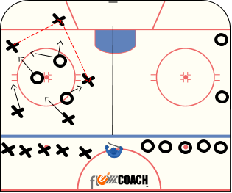

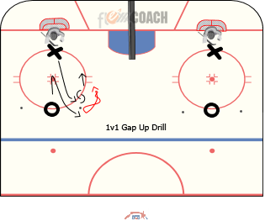
Grillo Gap Up

Coach sets up two pucks on opposite sides of the top of circle. O1 starts on top of circle and skates to dot, stops, and grabs one of the pucks from either side of the tops of the circle and attacks X1 1v1. When O1 starts, X1 gaps up and plays O1 1v1. Make sure X1 gaps up stick on puck, body on body, giving O1 as little time and space as possible. Play quick 1v1 until coach yells “second puck” and O1 goes to opposite puck, X1 gaps up and they play 1v1 until X1 scores, goalie covers puck, or X1 steals puck and makes pass to next player in line.
Concepts: COMPETE & PUCK POSSESSION, taking away time & space defensively, stick on puck
https://youtu.be/kyN_s4NHuRE

