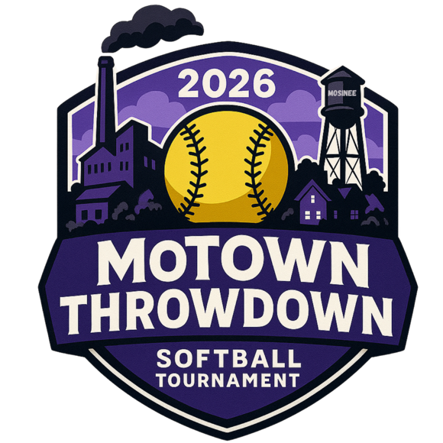
14U Tournament Rules – 2026

- No new inning started after 1 hour 15 minutes. Championship game is 6 innings – no time limit. Run rules apply to Championship game also. International tie breaker will be used in case of a tie during bracket play. Last official batter of prior inning will be placed on 2nd base with no outs, no strikes, no balls. Each inning as needed after (if needed) will follow this format.

- All games will be 6 innings max with a 15 run rule after 3 innings, 12 run rule after 4 and 10 run rule after 5. Pool games CAN end in a tie.

- No limit to number of players on team roster; awards will be limited to 15. All players must be 14 or under as of August 31st, 2025.

- Absolutely NO metal spikes, gum, seeds, or tobacco on the Turf Field. Metal spikes will be allowed at City Field and Dessert Park.

- Any of the following line-ups are acceptable (must be communicated to opposing coach and umpires prior to the start of each game):
    - Standard 9 player line-up.
    - DP/Flex (Flex plays the field but does not bat). DP is placed in batting order.
    - Bat entire roster. If a player is injured during a game and that player cannot bat, an automatic out will be charged in that batter’s spot.
    - A game may be started or continued with a minimum of 8 players.

- NO fake bunt and swinging (automatic out).

- A courtesy runner is allowed for the pitcher and catcher. Courtesy runner must be one of your extra players not in the line-up or the last recorded out.

- Dropped third strike rule in effect. Infield fly rule will be enforced.

- Final team roster must be turned into concession stand 1/2 hour before 1st game. No changes will be made to roster after that time. Proof of age needs to be available should a question arise. It is the responsibility of the coach to provide this information should they be asked. Line-ups should be shared with opposing team 10 minutes before game time.

- Home team is decided by a coin flip during pool play. In bracket play, home team will be best seed and use 3rd base dugout, visiting team will use 1st base dugout. Home team is official scorebook. Visiting team will control scoreboard.

- Aside from the above exceptions, refer to most current USA Softball rule book.

- Profanity or harassment by a team member, coach or fans toward an opposing team, umpire or official of the tournament will NOT be tolerated. This type of activity can lead to ejection of said team member, coach or fan, without warning, by a tournament official or umpire.

- The tournament director reserves the right to change any of the rules previously listed.

- Seeding tie breakers:

    - Head to head competition
    - Run differential (runs scored – runs allowed, 10 run per game max)
    - Runs allowed.
    - Runs scored. (teams will only be credited with a maximum of 10 runs more than they gave up for tiebreaker purposes)
    - Coin flip.

