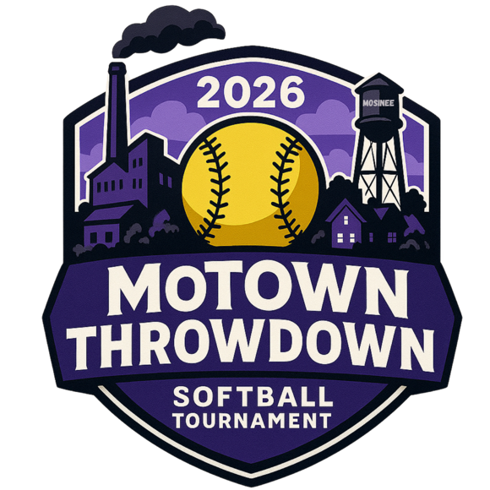
12U Tournament Rules – 2026

- No new inning started after 1 hour 15 minutes. Championship game is 7 innings – no time limit. Run rules in (2) will apply. International tie breaker will be used in bracket games. Pool games can end in a tie.

- All games will be 7 innings max with a 15 run rule after 3 innings, 12 run rule after 4 innings and 10 run rule after 5. International tie-breaker rule: Last official batter of prior inning will be placed on 2nd base with no outs, no strikes, no balls. Each inning as needed after (if needed) will follow this format.

- No limit to number of players on team roster; awards will be limited to 15. All players must be 12 or under as of August 31st, 2025.

- Shoes with metal spikes are not allowed. Absolutely NO gum, seeds, or tobacco on Field Turf!!

- Teams will bat entire roster. If a player is injured during a game and that player cannot bat, no penalty will be assigned for missing that spot in the order.

- A game may be started or continued with a minimum of 8 players.

- Bunting is allowed. NO fake bunt and swinging (automatic out).

- Runners may steal any base. Runners may leave the base once the pitcher releases the ball. Runners leaving early will be called out. A courtesy runner is allowed for the pitcher and catcher. If a courtesy runner is needed, the courtesy runner will be the player who made the last out or substitute who is not in batting lineup.

- Dropped third strike rule in effect. Infield fly rule will be enforced.

- Final team roster must be turned into tournament director or concession stand 1/2 hour before 1st game. No changes will be made to roster after that time. Proof of age needs to be available should a question arise. It is the responsibility of the coach to provide this information should they be asked. Line-ups should be shared with opposing team 10 minutes before game time.

- Home team is decided by a coin flip in pool play. Home team is official scorebook. In bracket play, team with best seed # will be home team.

- Visiting team will control the scoreboard.

- Pitchers will pitch from 40’ and use 12” ball. Game ball used will be Dudley SB12.

- Aside from the above exceptions, refer to most current USA rule book.

- Profanity or harassment by a team member, coach or fans toward an opposing team, umpire or official of the tournament will NOT be tolerated. This type of activity can lead to ejection of said team member, coach or fan, without warning, by a tournament official or umpire.

- The tournament director reserves the right to change any of the rules previously listed.

17) Seeding tie breakers as follows:
    - Head to head competition
    - Runs allowed.
    - Run differential (runs scored – runs allowed, 10 run per game max)
    - Runs scored. (teams will only be credited with a maximum of 10 runs more than they gave up for tiebreaker purposes)
    - Coin flip.

