USA Rugby Registration
PLEASE NOTE! Just because there is a USA ID# doesn’t mean you are registered with a team! You must go through the entire registration process!
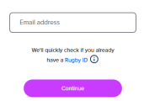
1. Go to https://myaccount.rugbyxplorer.com.au/. Enter the email address you or your player used to register before.
2. You may get the message “We have found some profiles that might be you.” if you think that the profile is yours, select it, and skip to direction # 9. Otherwise choose Create New Profile,
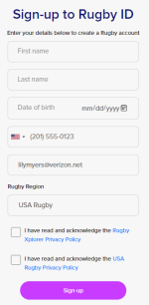

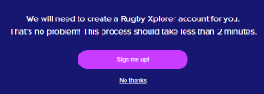
If your account is not found, you will see this:

3. Enter your player’s information on this screen.

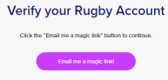
5. Verify Your Rugby Account through your email.


6. Tap the link in the email sent to you to confirm your email address.
7. Reset your password.

8. Sign in again and update any personal
details under my profile.
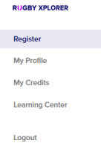
9. Select register in the upper left-hand corner.

10. Under Participate in Rugby, choose find a club.
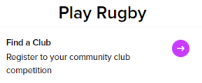
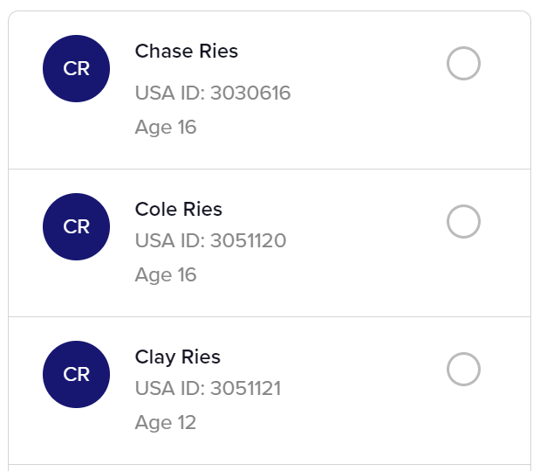
11. Select a person to register.
12. Type in the name of the club you would like
to register for the correct level of play.
NOT FLAG OR ROOKIE RUGBY!

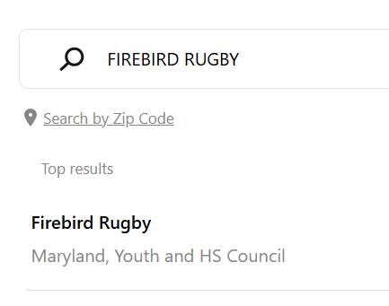

13. Select role, registration type
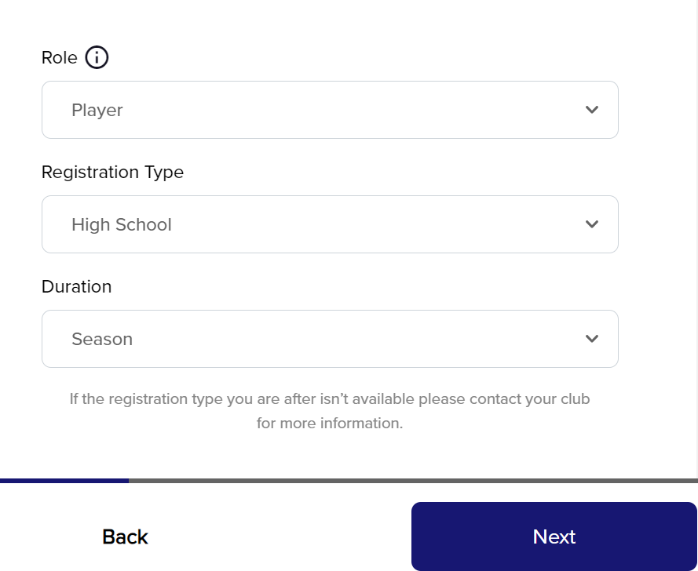
and duration. Choose high school or youth NOT FLAG!

14. Verify your personal details.
15. Accept the waivers.
16. Pay for your membership.
17. Write down your Rugby ID.
Birth Date Verification
This is a new addition to the registration process. An email will be sent to the address listed on the account after registration is complete with the process on how to upload proof of birth date.
It will NOT be an immediate email. It may take several days or weeks to receive. With this being new to RugbyXplorer we are expecting some hiccups to work through. We will keep you updated with directions as the process is rolled out.

