Rich Sobilo
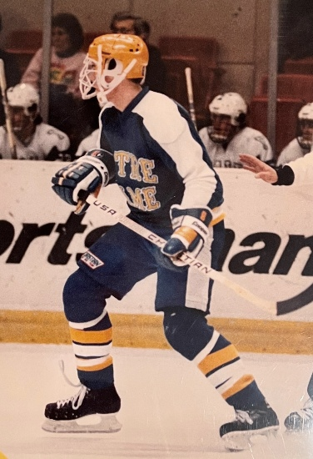
Rich currently serves as the Hockey Director for the Mohawks and Head Coach of Bishop Noll Institute. Rich has been coaching youth and high school sports for over 35 years. He has coached hockey at various levels. He has also run skills and skating sessions, camps and clinics for different Organizations throughout the past 30 years.
Rich is a graduate of the University of Notre Dame with a degree in Mechanical Engineering. Transferring in, Rich lettered three years with the Fighting Irish, leading the team in season highs in Game Winning Goals, Short-Handed Goals and Plus-Minus his junior year. Rich started his career at St. Mary’s College (now University) in Winona, MN. At St. Mary’s Rich led the Junior Varsity Team in scoring his freshmen year, moving up to the Varsity mid-way through the season. In college Rich played for legendary coaches Lefty Smith and Don Olson. In high school, Rich played football, hockey, baseball and even one year of basketball. In football, he was MVP, All-Area and All-Conference his senior year. In hockey he was the leading scorer, MVP, a League All-Star and Academic All-State for multiple years.
Rich’s teams have won numerous youth and high school tournaments and league championships. He was named Coach of the Year numerous times in his hockey coaching career for the Maniax, Blackbirds and the Illiana League. In 1994 Rich served as an assistant for Team Indiana. He has coached Team Illiana for several years.
Currently eight of Rich’s former players are participating at the junior or college level. Over the years, Rich has coached more than thirty (30) hockey players that have played beyond high school. Many of his hockey players have also played a different college sport than hockey.
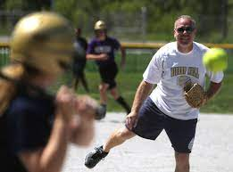
In addition to hockey, Rich has coached high school football and softball. In 1989, he was an assistant coach on Bishop Noll’s 3A State Championship Team. Rich coached football at the high school level for five years. In four years as the Head Coach in softball, Rich’s overall winning percentage was over 70% with an 81-34 record including one Conference Championship, two Sectional titles and one Regional title. He was named the Northwest Indiana Times Softball Coach of the Year in 2015, when his team finished 25-3 with wins over Munster, Lake Central, Andrean, Hanover Central and other Region powerhouses.
Bishop Noll Hockey has had success in Rich’s twenty (20) years as head coach. He is most proud of their Academic Achievement and commitment to the community and school. Seven Bishop Noll Hockey players have been awarded State-Wide Scholarship Awards. The Team Average GPA has consistently been in the Top Ten in the State and has led the Illiana League. Over 70% of the possible Academic All-State Warriors (Seniors only) have garnered the prestigious honor. Amongst the Bishop Noll Hockey Alumni, we boast doctors, lawyers, engineers, scientists, IT professionals, teachers, health professionals, administrators, craftspeople, construction professionals, management professionals and even some coaches. In fact, over half of the current coaching staff are BNI Hockey alumni.
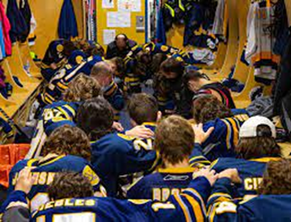
On the ice, success has been just as common and abundant. Several Northern Illiana League Championships and Runner’s Up in the 1990’s, culminating in an ISHSHA 2A State Runner’s Up in 1999, finishing 10th in the State, the highest finish by a Region Team at that time. After restarting the program in 2016, the successes have come even more regularly. One year away from a three-win Varsity season, the 2016-17 Warriors captured the ISHSHA A Championship in South Bend. Three years later, the Warriors captured the 2A at Midwest, in our backyard. Then two Roper Cup Championships and a 2023 3A State Championship. Three State Championships in a six-year period. Consistently near the Top Ten in the State and towards the top of the Illiana League, the program has become one of the premiere high school programs in the State.
Rich was acknowledged by his hometown in 2023 by being named to the East Chicago Athletic Hall of Fame, sitting aside legends like Kenny Lofton, Tim Stoddard, Angel Manfredy, LaTanya Pollard, Mary Verbish, Stacey Zurek and Pete Piskol.
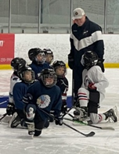
Rich gives full credit to all his Coaches, Managers, School Administrators, Athletic Directors, fellow coaches, parents and players throughout the years. Without their support, there would be no success. Additionally, this group has supported his select goal of assisting, in some small way, the development of outstanding young adults into the world. However, the most credit does to his wife and family for their support and encouragement.
Rich is still active as a player as well. After nearly twenty years in Johnny’s Icehouse Elite League, including a Championship and numerous All-Star Game appearances, Rich continues to play at Johnny’s and the Kube, earning numerous Championships throughout the years. He also has won two State Championships and has been invited to play in numerous USA Hockey National Championships.
Rich supports BP’s global portfolio as a senior mechanical engineer. He also is involved with several industry groups. He moved to BP after being the Director of Engineering at Union Tank Car Company. He is a Professional Engineer in the State of Indiana and has numerous other certifications. Rich is married to his wife of 31 years, Cathy. She has always been supportive of Rich and the kids. They have two children, Elena and Alex, both of whom excelled as athletes at BNI. But Alex always kids that he has a State Championship - the 2017 ISHSHA Class A State Championship. To her credit, Elena has six Conference Championships, seven Sectional Championships, two Regional Championships and one Semi-State Championship, losing in the State Finals in Volleyball in 2013.
Rich looks forward to continuing to assist the development of the South Shore’s next set of elite hockey players.

