Support Buffalo-Hanover Baseball Association
HANGING FLOWER BASKET FUNDRAISER
ALL BASKETS $35.00 ― Checks payable to BHBA
Plant colors maybe vary

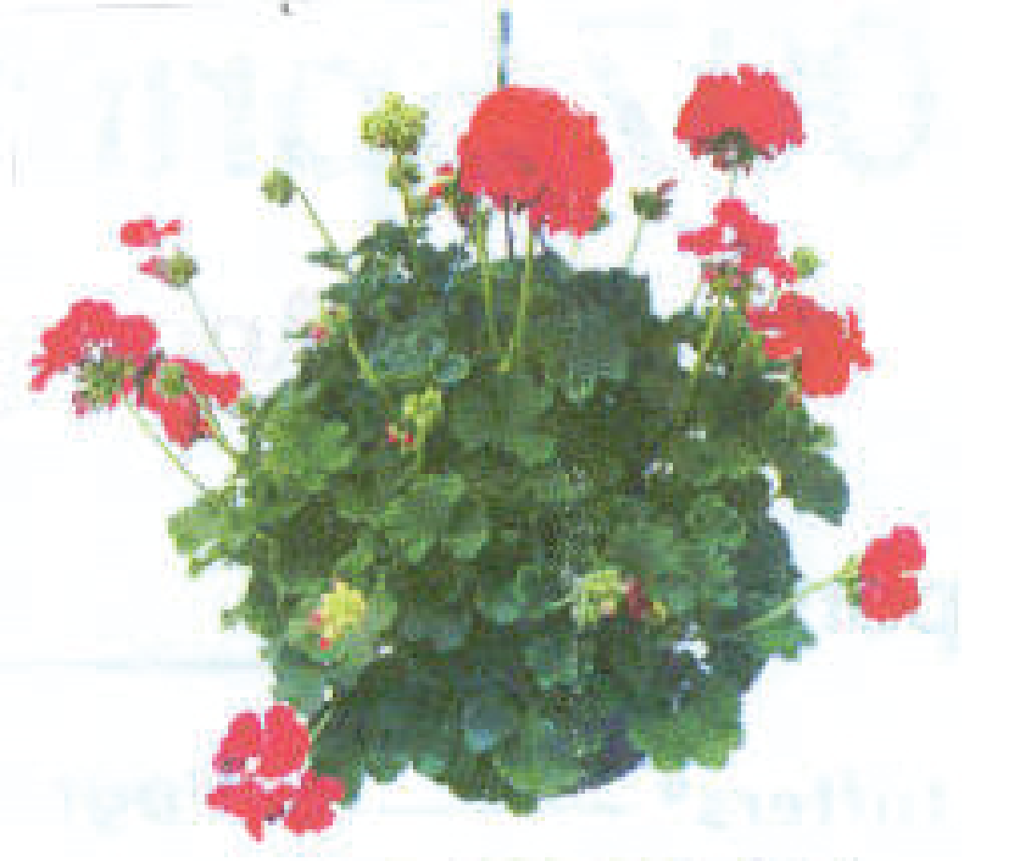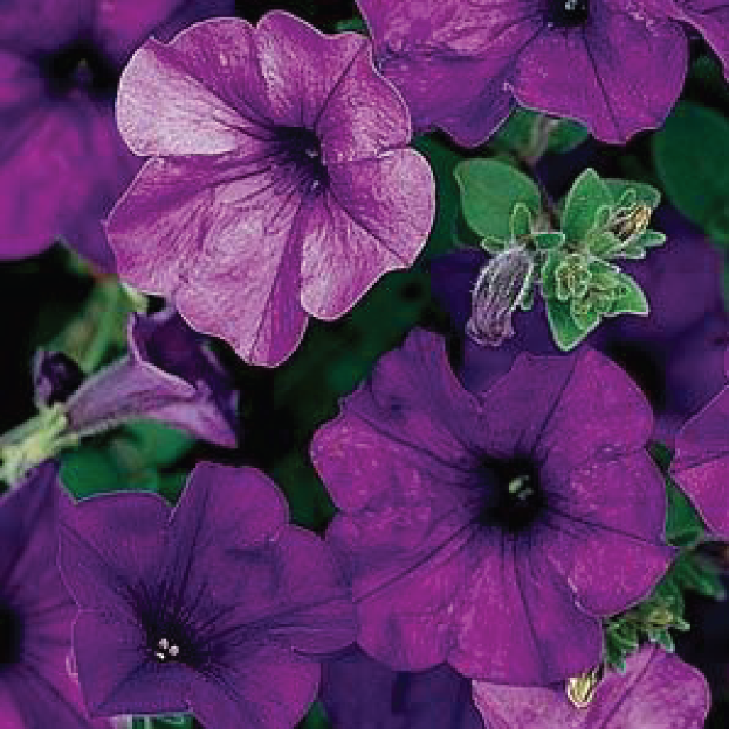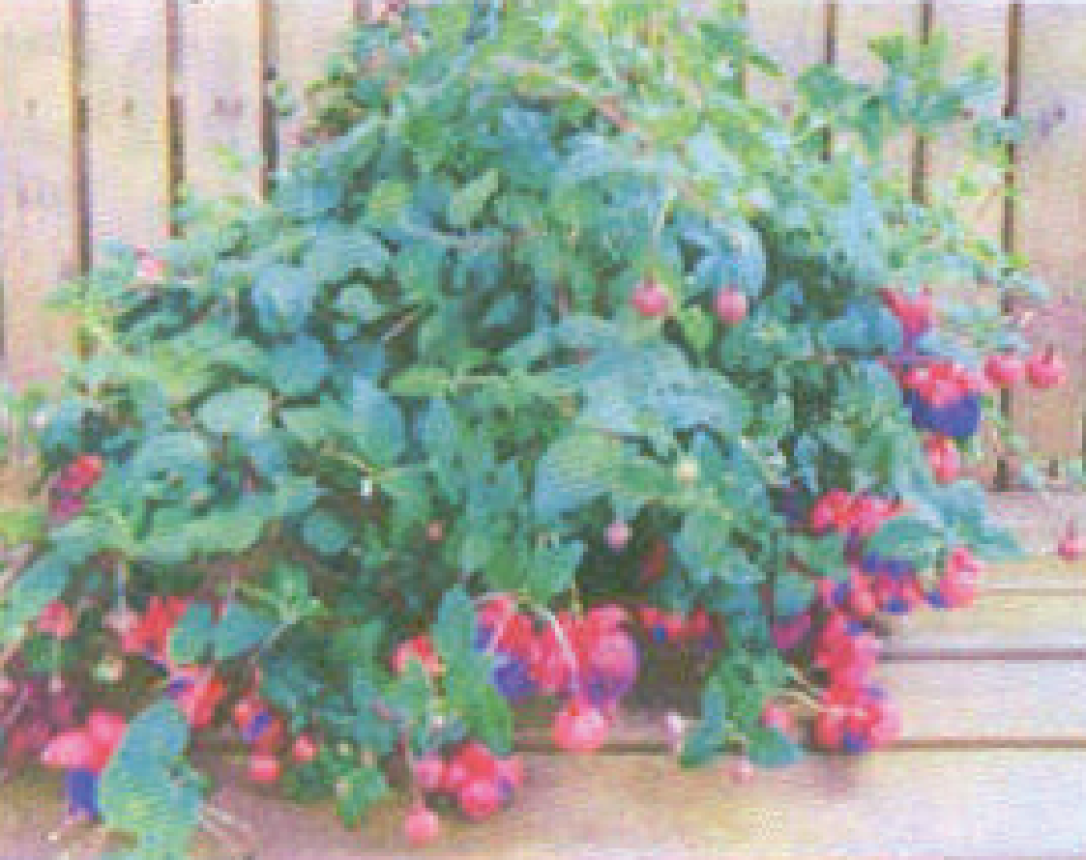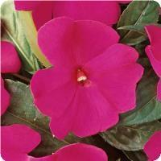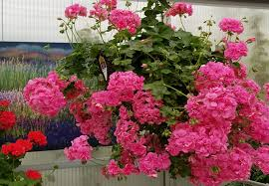
Red Geranium

Wave Petunia (Blue)
Sunshine
Fuchsia (Purple)
Shade

Impatiens
(Divine Violet)
Shade

Pink Ivy Geranium

Player:____________________ Player Phone:______________________

Coach:____________________ Age/Level/Team: ___________________

Total # of Baskets Sold: __________________
ORDERS DUE TO YOUR COACH BY APRIL 10th, 2026
Each player is required to sell a minimum of 5 baskets, which is equivalent to the deposit of $175.00 paid at Tryouts. This deposit will be shredded once the order form is returned. If the order is not returned with a 5 basket minimum order your check will be cashed. If you Prefer your check cashed, please Note that on your order form.

Prizes Awarded to top Sellers!!

Flower Pick up on Friday, May 8th 2026
12:00PM-6:00pm at Bentfield Main Parking Lot.

Player:_________________ Age/Level __________________ Coach_________________________

NAME / PHONE | Red Geranium | Wave Petunia | Fuchsia | Impatiens (Divine) | Pink Geranium  (Ivy) | TOTAL Baskets | TOTAL $  (QTY x $35)
TOTALS

