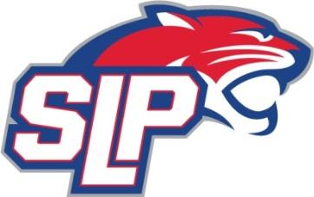
SLP Panther Basketball Club
May 3 - Atlantic Aviation Board Room - 6:30

May Meeting began at 6:24 PM
Attendance: Ben Fehrenbacher, Sarah Lee, Josh Davison, Joelle Lipa, Eric Kessel, Tyler Dahlgren, Yasmin Ma’alin, Jennifer Barnes, Sam Doran, Amir Hameed, Dan Davidson, Jimmy Whitehead
Absent: Amjad Wadi
Guests: Ollie Major (HS Boys Basketball Coach)
Minutes:
- Approval of May Agenda
  - Motion to approve by Tyler Dahlgren, second by Eric Kessel

- Approval of Minutes from March 2026
- Motion to approve by Jeff Baskin, second by Josh Davison

- Treasurer’s Report
  - Detailed report on financial activities provided by Eric Sanks. Summary of income/expenses for the season in travel and rec.
  - Setting the budget for the coming season and our yearly expenses we already know.

- Tournament Updates - ran through facility needs/possible changes for our tournaments, needs on concessions
  - Boys Tourney - December 5-6
  - Girls Tourney - December 19-20
  - Motion to approve concession equipment purchase by Jeff Baskin, second by Josh Davison

- Rec Updates
  - Discussion on the future of Rec: continuing discussions on options for 2nd-4th and 5th-8th.

- Travel Updates
  - Tournament registration begins to open in July. Begin to look at reciprocities

- Communications
  - Planned Comms for Summer and looking at key dates for Fall.

- Program Development
  - Jeff Baskin gave a presentation on a Junior Panther K-3 Program
  - Jeff Baskin presented an opportunity to host a 3-day camp led by Concordia University-St. Paul’s men’s basketball coaching staff.
    - Hosted at SLP Panther Gym, Limited spots available
    - Geared toward high level rec and travel players
    - Voted unanimously to move forward to commit and put communication together
  - August 3v3 - SLP High School
    - Concessions - all board members register for one timeslot - Ben Fehrenbacher will email out

- Miscellaneous / Open Discussion
  - Joelle Lipa presented the uniform mockups
  - Motion to approve purchase of higher quality basketballs by Erick Sanks, seconded by Jeff Baskin
  - Next Board Meeting – Sun, June 7th at 6:30pm

Next Board Meeting – Sunday, June 7 at 6:30 location TBD
Motion to adjourn by Jeff Baskin, second by Josh Davison. Meeting ending at 8:30

