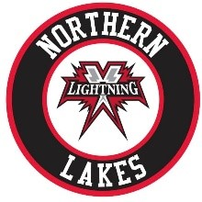

2026 Northern Lakes Youth Hockey Association Board of Directors Application

Name of Applicant:

1. Your reasons for applying to be on the NLYHA board.

2. Do you have any previous Board of Directors or Non-Profit organization experience?

.

3. How do you plan on helping with the betterment and longevity of the Association?

4. How do you plan on helping with the financial growth and stability of the Association?

5. Do you have the time to devote to attending the board meetings on a consistent basis? We meet as a board at least once per month and sometimes twice per month during the busier times of the year. You are also expected to be active in other sub-committees that support the association.

6. Provide information about yourself/hockey experience.

Please Return This Application to northernlakeslightning@gmail.com by: APRIL 1, 2026

