OUR STORY & GROWTH OF WFSC  2026–2027 Sponsorship Opportunities | 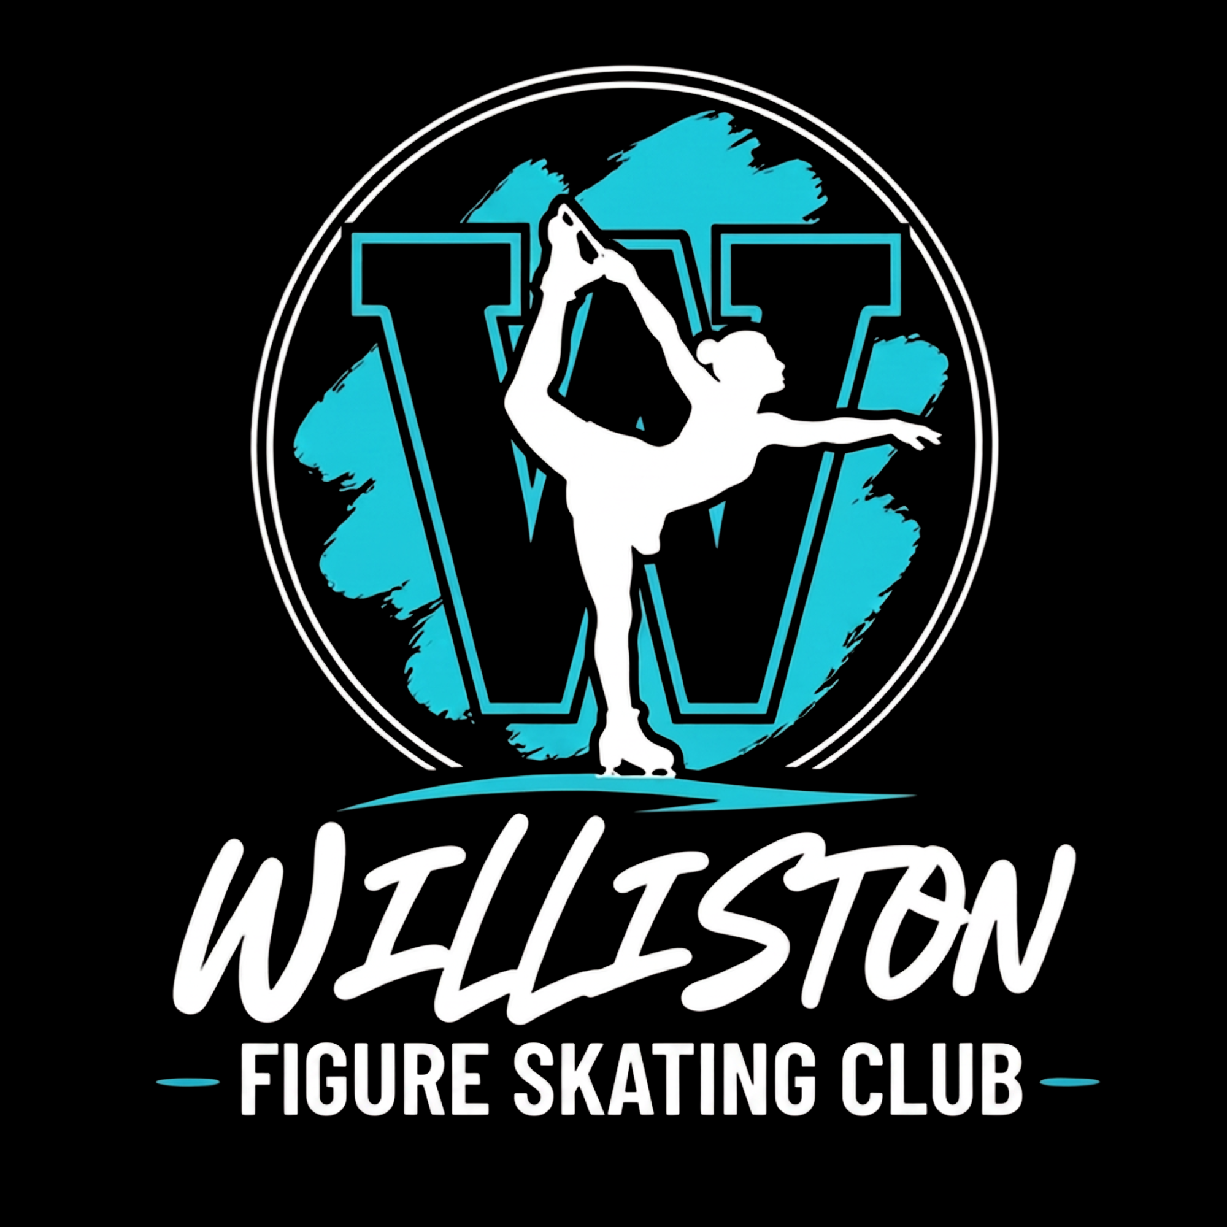
OUR STORY HIGHLIGHTS
What began with 25 skaters has grown into a thriving organization serving 96 athletes and their families. WFSC provides affordable, high-quality skating opportunities in western North Dakota through Learn to Skate, Aspire, competitive figure skating, hockey skating development, testing, competitions, and special events.
82  ATHLETES | 4  COACHES |  | 17  SPONSORS |  | 27  USFS TESTS |  | 4  COMPETITIONS
PROGRAMS & SERVICES  WFSC offers Learn to Skate programs, Aspire Development, Hockey Power & Edge Dynamics, after-school figure skating and hockey programs, USFS testing tracks, and affordable access to sport for all skill levels. |  |  |  | LOOKING AHEAD  WFSC plans to host additional Team USA athletes and national coaches, purchase a professional off-ice training harness, expand testing and regional competition support, develop WFSC-sanctioned competitions in Williston, and create affordable access to elite coaching for every skater.
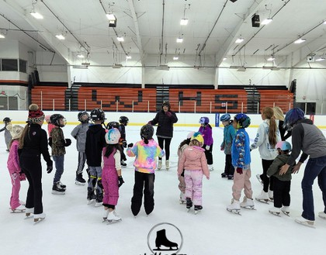 |  | 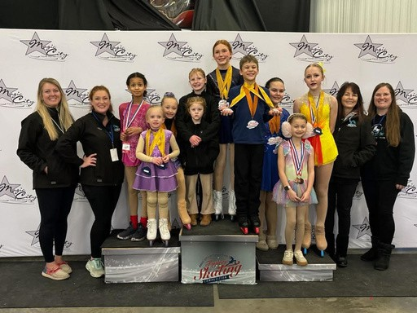 |  |  |  | 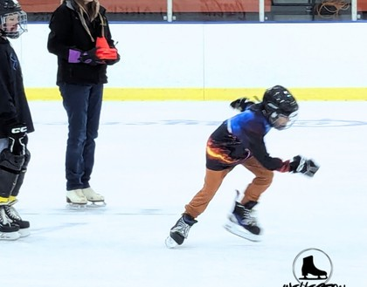
HOW YOUR SUPPORT MAKES A DIFFERENCE
Keep Skating Affordable  Scholarships reduce financial barriers so every child can participate. | Develop Athletes  Professional coaching helps skaters reach their full potential.
Train Safely  A skating harness supports advanced-jump training with reduced injury risk. | Bring Elite Opportunities  Sponsors help bring Team USA athletes and national coaches to Williston.
Expand Competition Access  Testing, competitions, and Aspire programming create next-level pathways. | Strengthen Community  Skating builds confidence, leadership, discipline, and lifelong friendships.
YOUR PARTNERSHIP BUILDS CONFIDENCE ON THE ICE—AND OPPORTUNITY BEYOND IT.

INVESTING IN ACCESS
Team USA & Elite Opportunities
In April 2026, the Williston Figure Skating Club made history by hosting Team USA Junior World Champions Leah Neset and Artem Markelov for our inaugural ice show and regional training camp.
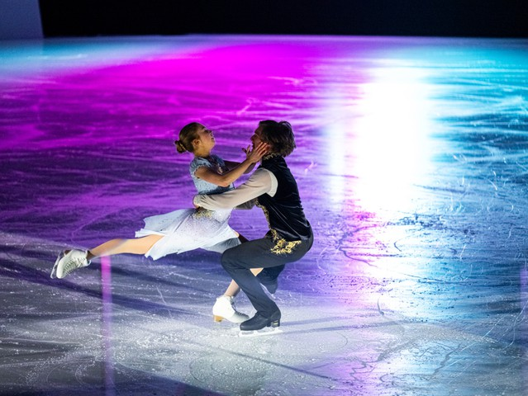 | 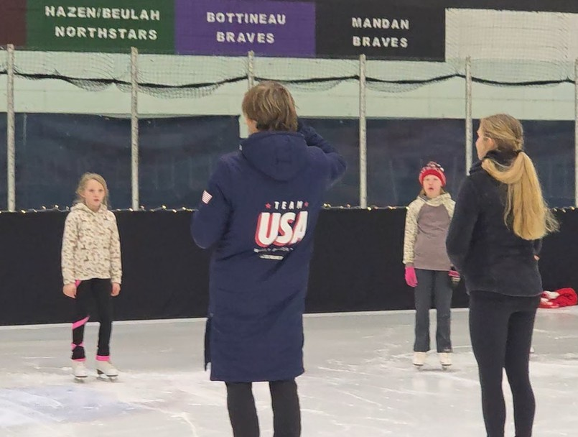
Skaters from Williston and Watford City participated in this extraordinary experience, receiving hands-on instruction from internationally recognized athletes without having to travel hundreds of miles to larger metropolitan training centers. For many participants, it was their first opportunity to learn directly from world-class competitors and witness elite-level skating up close.
This event demonstrated what is possible when rural communities invest in youth development and athletic excellence. Opportunities like these are typically reserved for athletes in major skating markets, yet WFSC is committed to bringing those same experiences to western North Dakota.
SPONSOR IMPACT
Your sponsorship helps ensure local athletes have access to the same developmental opportunities available in larger cities—without leaving home. Together, we are building a program that develops confident leaders, supports athletic excellence, and establishes Williston as a growing hub for figure skating in western North Dakota.
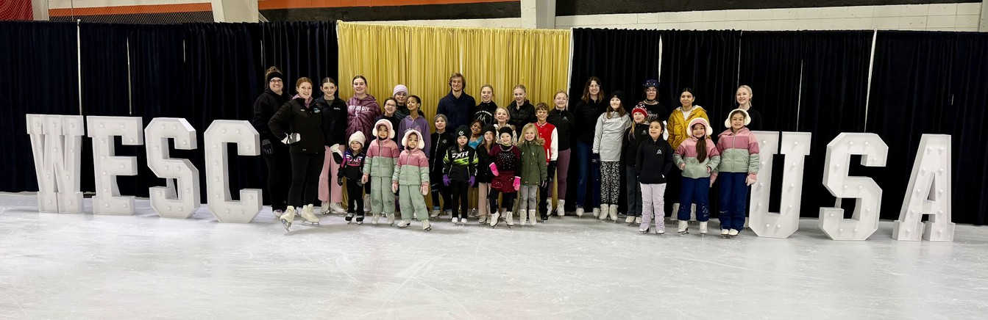

PARTNER WITH WFSC
2026–2027 Sponsorship Levels
Champion Partner | $5,000+  Our highest level of partnership provides premier, season-long recognition throughout WFSC programs, special events and digital communications.  - Embroidered company logo on WFSC competition-team jackets  - Company logo displayed on the rink boards at the Agri Sports Complex  - Recognition as a sponsor of the Team USA Training Camp held in conjunction with the Annual Ice Show  - Premier logo placement on the WFSC website and major event materials  - Full-page advertisement in the Annual Ice Show program  - Recognition during the Annual Ice Show and other major club events  - Dedicated social media sponsor spotlight  - First opportunity to renew at the Champion level for the following season | Gold Medal Partner | $2,500–$4,999  Gold Medal Partners receive prominent season-long visibility while supporting WFSC programs, events and athlete development.  - Logo placement on a designated WFSC event and apparel sponsor banner displayed on the wall at the Agri rink  - Large logo placement on the WFSC website  - Half-page advertisement in the Annual Ice Show program  - Recognition during major club events  - Dedicated social media sponsor feature  - Logo included on selected event and promotional materials

Silver Medal Partner | $1,000–$2,499  - Medium logo on sponsor signage  - Medium logo on the WFSC website  - Quarter-page advertisement in the Annual Ice Show program  - Social media recognition  - Recognition in selected club communications  - Recognition on selected event materials | Bronze Medal Partner | $500–$999  - Logo on sponsor signage  - Logo on the WFSC website  - Business-card-size advertisement in the Annual Ice Show program  - Social media thank-you  - Recognition in the Annual Ice Show program

Community Partner | $250–$499
- Business name or small logo on the WFSC website | - Inclusion on the WFSC sponsor listing
- Recognition in the Annual Ice Show program | - Inclusion in a community sponsor thank-you post

Jacket embroidery, rink-board placement and banner recognition are subject to sponsorship deadlines, final artwork approval and facility authorization.
READY TO PARTNER? COMPLETE THE COMMITMENT FORM OR CONTACT ADMIN@WILLISTONFSC.COM.

THANK YOU FOR SUPPORTING LOCAL SKATERS
Sponsorship Commitment Form
BUSINESS / ORGANIZATION NAME  _____________________________________________________________ | CONTACT PERSON  _____________________________________________________________
PHONE  _____________________________________________________________ | EMAIL  _____________________________________________________________
MAILING ADDRESS  ________________________________________________________________ | CITY / STATE / ZIP  ________________________________________________________________
WFSC MEMBER REFERRAL NAME (IF APPLICABLE)  ________________________________________________________________ | BUSINESS WEBSITE / SOCIAL HANDLE  ________________________________________________________________
SELECT A SPONSORSHIP LEVEL
☐ Champion Partner — $5,000+ | ☐ Gold Medal Partner — $2,500–$4,999
☐ Silver Medal Partner — $1,000–$2,499 | ☐ Bronze Medal Partner — $500–$999
☐ Community Partner — $250–$499 | ☐ Other Amount: $________________
PAYMENT & AUTHORIZATION
Payment Method: ☐ Check ☐ Online  _______________________________________________________ | Artwork / Logo Contact or Email  _______________________________________________________
Authorized Signature  _______________________________________________________ | Date  _______________________________________________________
MAIL CHECKS TO  Williston Figure Skating Club  P.O. Box 7063 • Williston, ND 58801  701-651-4590 • admin@willistonfsc.com • www.willistonfsc.com | TAX REFERENCE  EIN 33-4625654  Williston Figure Skating Club  501(c)(3) nonprofit organization

