1
18 HOLE-4 PERSON BEST SHOT
GOLF TOURNAMENT
LIVE / SILENT AUCTION AND RAFFLE
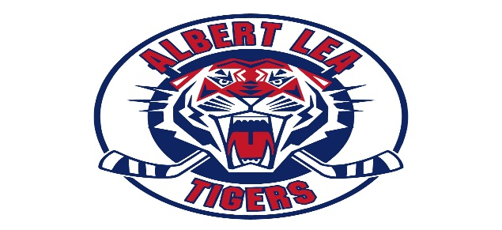
Reserve a Foursome On-Line. (www.albertleahockey.org)

Checks Payable To: ALHA
(Tax Deductible). Credit / Debit Card Transactions are an option (Square Reader) prior or the day of the event.

Questions:
Rachel Miller
507-383-6415
Rjaspersen6415@gmail.com

Kim Erickson
952-237-1667
Kimberly_knott@hotmail.com

Brad Loch
507-363-2916
bradsueloch@gmail.com

PLAYER 4
FEES (golf, dinner and gift)
PAYMENT DAY OF EVENT IS AN OPTION
Cart 1 Yes No
Cart 2 Yes No
PLAYER 2
PRIZES
1st & 26th (For 2026) Places
Player (Skins Included) $100
Cart $25/player
Team & 2 Carts $500
Team & 1 Cart $450
Team w/ No Carts $400
CONTEST
Longest Drive, Closest to Pin, Longest Putt,
Skins, Greenies & Hockey Net Challenges
Green Lea Golf Course, Albert Lea, MN
Saturday, August 29, 2026
10:00 am Registration, 11:00 am Shotgun Start
PLAYER 1
REGISTRATION

