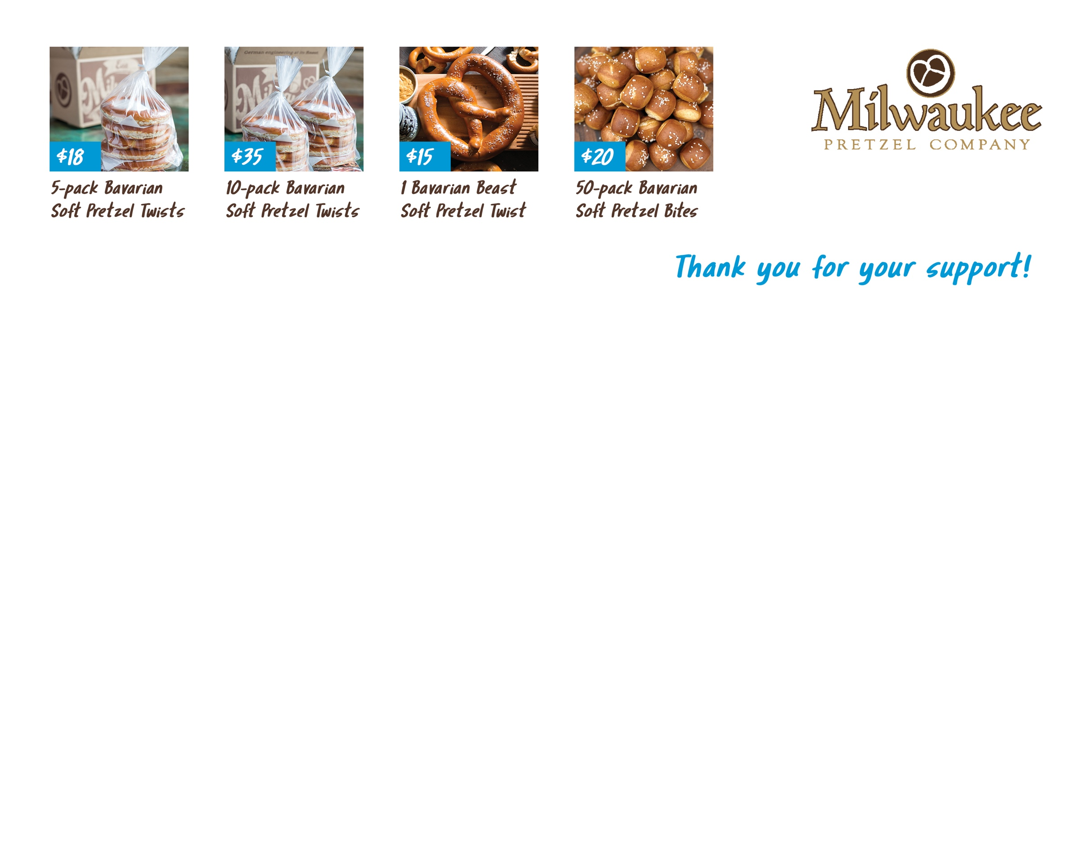

WCYHA
PRETZEL FUNDRAISER
PLEASE ADD $10.00 PER ORDER IF THE CUSTOMER WOULD LIKE TO HAVE THEIR PRODUCT SHIPPED DIRECTLY TO THEM.
CUSTOMER | ADDRESS | PHONE | 5  PACK | 10 PACK | BEAST | BITES | SHIPPING | TOTAL | PAID | DUE
SELLER’S NAME: |  | PAGE TOTALS:

