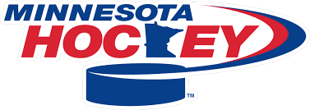
District 12 Meeting Agenda
April 30th 2025, 6-8pm
Iron Trail Motors Event Center
- Introductions
D12 Girls Coord Sara Drees
D12 Secretary Shawnna Rude

2. D12 Position Needs

3. D12 Finances

4. House Keeping
Affiliate Agreements (Need by Fall Meeting)
Board Rosters with USA Hockey #’s (Need when board id finalized)
Team Declarations (Form on D12 website)
13U waivers (Form on D12 website)

5. District Tournament Draw Dates Feb 13th-15th District Teams
Greenway Bantam AA Squirt A
Hibbing Bantam A Squirt B
I’ Falls Bantam B 10UB
Grand Rapids PeeWee AA
Rock Ridge PeeWee B
Ely 12UA
Mesabi East 12Ub

6. Region Tournament Draw Region Dates Feb27- March1st Region Levels
Hibbing 15A- Duluth
Rock Ridge 15B
Mesabi East 12UA
Ely 12UB
Grand Rapids
I’Falls
Greenway

7. State Tournament Dates. March 13-17th
8. Referee Updates (Kavanaugh)
9. Tournaments (Burt)
10. Girls Coordinator (Drees)

11. Spring Meeting Notes
D12 Bylaws (District Director term)
Mite Summit
Intermediate nets Mites. Squirts? D2 running pilot program
GameSheet
Junior Gold 2yr pilot program for team level placement
World Jr’s
Hearing procedures
Membership Committee Report (D12 needs a member to sit on that Committee)
MN Hockey Annual Banquet
12. Member input

