Tolland Youth Football and Cheer, Inc.

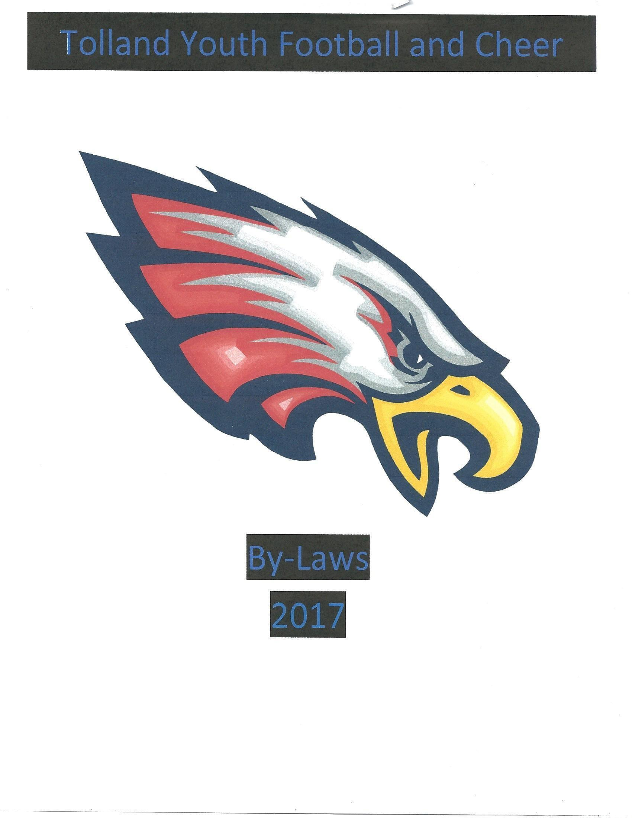

Organization By-Laws
Adopted May 5th, 2026
ARTICLE I
1.1 Name and Location: The name and location shall be, “Tolland Youth Football and Cheer, Inc.” and shall be in the town of Tolland, Connecticut.

1.2 Purposes: The purpose of Tolland Youth Football and Cheer, Inc. (hereinafter, “TYFC”) is set forth the Certificate of Incorporation and exists to provide the youth of Tolland and surrounding communities participating in the Tolland program the principles Family, School, Football and Cheerleading. Using the ideologies of good citizenship, sportsmanship, honesty, loyalty, courage, and respect through association with the competitive sports of football & cheerleading, to instill self-esteem in the children participating in the program, and to instruct them in the fundamentals of football and cheerleading.

ARTICLE II
2.1 No Members: TYFC shall have no members. TYFC should be governed by its Board of Directors (“Directors”), which should be self-perpetuating.

2.2 Affiliation: TYFC is affiliated with the Southern New England Youth Football Conference (“SNEYFC”) and shall comply with the SNEYFC bylaws and rules, as may be amended from time to time.

ARTICLE III
Executive Officers
3.1 General Powers: The Board of Directors shall also include Executive Officers (“Officers”), and they shall have the general authority to conduct the affairs of TYFC in a manner consistent with Article I of these by-laws. Such authority should include, but is not limited to, the following powers:
a) to administer the organization, develop and execute the policies of TYFC, and to appoint all personnel;
b) to enter into agreements and contracts, make purchases, enter into leases, and buy and sell property;
c) to implement all personnel, fiscal and program policies;
d) to ensure compliance with all applicable program policies, conditions or grants and contributions;
e) to take other actions as are necessary and appropriate to carry out the purposes of TYFC.

3.2 Executive Officers: The Officers of TYFC shall be a President, Vice-President, Secretary, and Treasurer, each of whom shall be elected by the Board of Directors in accordance with the provisions of this article. The Board may elect or appoint such additional Officers, including one or more Assistant Secretaries and Assistant Treasurers as it deems desirable. Such Officers shall have the authority and perform the duties prescribed by the Board from time to time. All Officers of TYFC should be elected or appointed by the Directors of the Board of TYFC.

No individual should simultaneously hold more than one of the following offices: President, Vice President, Secretary, or Treasurer. Other offices may be held concurrently, as determined by the Board. Notwithstanding the foregoing, an Officer may also serve in a Head Coaching role if elected or appointed to such position.

3.3 Election and Term of Office: The Officers of TYFC shall be elected annually by the Directors at the annual meeting after nomination by the Nomination Committee. All Officers of TYFC must be chosen from the members of the Board of TYFC.

3.4 Vacancies: Any vacancy occurring in the Executive Officer shall be given urgent priority and to be filled by a majority vote as soon as feasible by those Directors remaining in office. A Director elected to fill a vacancy shall hold office for the unexpired term of his/her predecessor.

3.5 Executive Officer Duties:
a) President: The President shall be the principal executive officer of the corporation and shall supervise and control all the business affairs and be the custodian of the records of TYFC. He/she shall preside at all meetings of the Board of Directors. He/she may sign, with the proper Officer of TYFC authorized by the Board, any deed, mortgages, bond, contracts, or other instruments which the Board of Directors has authorized to be executed, except in cases where the signing and execution thereof should be expressly delegated by the Board of Directors or by these By-laws or by statute to some other officer or agent of TYFC; and in general he/she should perform all duties incident to the office of President and such other duties as may be set forth by the Board from time to time, including the appointment of the Chair of and members of all committees as may be needed. All such appointments shall be approved by a majority vote of the Board.

b) Vice President: In the absence of the President or in the event of his/her inability or refusal to act, the Vice President shall perform the duties of the President, and when so acting shall have all the powers of and be subject to all the restrictions upon the President. Any Vice-President shall perform such other duties as from time to time may be assigned to him/her by the President or by the Board of Directors.

c) Treasurer: The Treasurer shall have charge and custody of and be responsible for all funds and securities of TYFC; receive and give receipts for moneys due and payable to TYFC from any source whatsoever, and deposit all such moneys in the name of TYFC in such banks, trust companies or their depositories as shall be selected in accordance with the provisions of Article VII of these By-laws; will be ultimately responsible for all accounting duties, documenting and/or registering TYFC as a 501(c)3 entity, annual tax returns and in general perform all the duties incident to the Office of Treasurer and such other duties as from time to time may be assigned to him/her by the President or by the Board of Directors.

d) Secretary/Communications: The Secretary shall keep the minutes of the meetings of the Board of Directors in one or more books provided for that purpose, see that all notices are duly given in accordance with the provisions of these By-laws or as required by law, keep a register of the permanent address and post office address of each Director (which shall be furnished to the Secretary by such Director), and in general perform all duties incident to the office of Secretary and such other duties as from time to time may be assigned to him/her by the President or by the Board of Directors. Maintain website on a regular basis throughout the season. Send Board Member emails (as requested by the President and other Directors of the Board). Send league wide/team wide emails (as requested by the President and other Directors). Respond to emails and/or forward emails to appropriate Directors.

3.6 Regular Meetings: The annual meeting of the Board of Directors should be held in February of each fiscal year. Regular meetings of the Board should be held on the first Tuesday of each month unless otherwise determined by the Board.

The Officers may, by resolution, establish the date, time, and place of the annual and regular meetings of the Board without other notice than such resolution. The Secretary shall provide notice to each director of the date, time, and place of each meeting at least five (5) days in advance; provided, however, that shorter notice may be given when reasonably necessary. An agenda for each regular meeting should be prepared in accordance with these bylaws and distributed to directors at least twenty-four (24) hours prior to the meeting based on the previous meeting and Director input.

3.7 Special Meetings: Special meetings of the Board of Directors may be called by the President or by any three (3) Directors. The person or persons calling such special meeting shall designate the date, time, and place of the meeting, which should be within the Town of Tolland. Notice of special meetings shall be given in accordance with Section 3.6 of these by-laws.

3.8 Notice: All notices of any special meeting of the Board should be given to Directors at least two (2) days prior or when feasible to the date of such meeting. Such notice shall be delivered by email or other reasonable means and shall include the date, time, place, and purpose of the meeting. Any Director may waive notice of any meeting before or after the meeting. The business to be transacted as a special meeting of the Board must be specified in the notice or waiver of notice of such meeting.

3.9 Compensation: Directors and Executive Officers as such shall serve without compensation for their services. Nothing contained herein shall be construed to prohibit a Director from serving TYFC in any other capacity and receiving compensation for such services.

ARTICLE IV
Board of Directors
4.1 Special Powers: In addition to all other powers granted under these by-laws, the Board of Directors shall have the right to suspend or remove any participants in any programs sponsored by TYFC, including but not limited to, players, coaches, assistant coaches, referees, and team parents or guardians. The Directors may delegate this authority in accordance with any rules, policies and/or any procedures that may be established by the Board.

4.2 Quorum: A majority of the Board shall constitute a quorum for the transaction of business at any meeting of the Board of Directors; if less than a majority of the Directors are present at said meeting, no business shall be conducted until a quorum is present.

4.3 Manner of Acting: The act of the majority of Directors present at any meeting at which a quorum is present shall be the act of the Board of Directors, unless the act of a greater number is required by law or by these by-laws.

4.4 Absence as Resignation: Absence from three (3) consecutive meetings of the Board of Directors without previous notification shall be considered a resignation. The President shall “excuse” or “not excuse” an absence during the roll call of Directors during such months. The Board of Directors in attendance shall have the right to vote on any absence if it is felt that an excused absence is not warranted. Exceptions can be made at the Board’s discretion if extenuating circumstances exist.

4.5 Election, Number, and Tenure: Directors shall be nominated by a Nominating Committee in January and elected by the Board of Directors at the annual meeting. The number of directors should not be fewer than nine (9) nor more than twenty-five (25). Directors will be elected to a one-year (1) term.

4.6 Board of Director Duties:
a) Registration: Assist families with registrations of their children in the online registration system. Continually maintain and update participants on the correct squad/team. Collect, verify, and file all required forms for all participants. Organize all required paperwork by squad/team before football weigh-ins and cheerleader verification dates. Communicate with all squad/team head coaches regarding registration and required paperwork. Provide requested registration reports to head coaches, TYFC board as requested, or when necessary. Maintain confidentiality regarding registered participants.

b) Volunteer Coordinator: Initiate volunteer opportunities for all registered families and create sign-up pages for all volunteer needs throughout the season. Verify all families have completed required volunteer commitments. Act as main point of contact for volunteers during home games, provide game day sign-in sheets, and communicate as needed with participants. Collect, count, and deliver to the Treasurer the money acquired during the 50/50 raffles held at our home games.

c) Equipment Manager: Maintain and monitor all equipment owned and distributed by TYFC. This is inclusive of both football and cheerleading divisions. Coordinate purchasing, discarding, distribution, and return of equipment, except in the case of cheer uniform distribution which shall be the responsibility of the Cheer Coordinator. Maintain a current list of equipment and needs. Maintain AED along with records and certifications.

d) Fundraising: Organize fundraisers that will help TYFC grow as a league and at the same time earn funds to support our expenses. Coordinate with each team and assist them in any way necessary.

e) Sponsors: Work closely with the community to increase funds for sponsorship. Maintain a running list of those contacted and those businesses that have sponsored and their amount. Ensure proper sponsor signage at the home games and announced during the game.

f) Novelties: Responsible for the creation, cost, sales and/or delivery of all TYFC merchandise. Includes pay out to our novelties vendors as well as collect and deliver funds acquired from novelties to the Treasurer.

g) Cheer Coordinator: Attend monthly SNEYFC cheer coordinator meetings. Participate in the planning and execution of the SNEYFC cheer competition. Ensure all cheer coaches have completed NYSCA and concussion certifications and at least one coach/representative be AACCA certified by August 1 of the playing season. Coordinate with the head cheer coaches to check that all coaches have completed background checks by August 1 of the playing season. Organize uniform distribution and collection. Collect and count all uniform parts and pom poms. Responsible for ordering of uniform parts (middy, shorts, socks, sneakers, bows, warm-up jackets, etc.) as determined with each head coach. Secure practice locations and submit necessary building use forms. Step in as head coach on any squad that doesn’t have a head coach until one can be assigned.

h) Ethics Committee Head: Coordinates By-law meetings as needed or directed by the Board. Makes recommendations to the Board for changes, adoptions, or redactions to TYFC By-laws. Has a clear understanding of the Roberts Rule of Order and contents of TYFC adopted By-laws. By-laws are to be reviewed every 2 years but can be changed outside of the timeline in accordance with Article 6.2. Tasked to oversee all disciplinary issues at all TYFC levels (make judgements, validate issues, hand down penalties when necessary) when the President feels such an issue is deemed appropriate for committee review. Responsible for the correction and/or guidance of issues presented.

i) Concessions: Maintains the operations of concessions. Organizes the purchase of concession products. Responsible for the management of concession sales at league and non-league events. Works closely with the volunteer coordinator to have the proper number of volunteers for each event. Collects and reviews concession related offers, discounts, and bulk purchasing opportunities to get the maximum profit. Organizes, tallies, and keeps record of all concessions sales and purchases. Responsible for having a Director to operate the cash register at any time. Responsible for counting drawers and preparing deposits after each event.

j) Associate Concessions (non-voting position): Partners with Concessions Manager in order to fulfill the duties of the position.

k) Cheer Head Coach: Teaches sideline cheers. Responsible for halftime routine/competition routines. Works with the cheer coordinator on responsibilities for SNEYFC. Attend any cheer meetings. Ensure a safe environment where all cheerleaders are treated equally and expected to work to their potential. Create a “cheer family” which includes excellent attendance at games and practices.

l) Football Head Coach: Organizes and coordinates communication to the team and coaches. Is solely responsible for every member of the team of coaches, players and families. Creates a safe learning environment and family atmosphere, instills “Family, School, Football and Cheerleading” moto into the team. Teaches the game of football to all athletes. Maximizes every athlete’s potential regardless of skill level.

m) Football Coordinator: Act as Head Coach to any team that does not have a coach. Attend monthly SNEYFC meetings and communicate league decisions, dates, and other relevant updates to the TYFC Board. Responsible for Game Day Coordination and adherence to SNEYFC regulations.

n) Recruitment Coordinator: Responsible for the outreach to local approved towns in order to advertise the TYFC organization by utilizing various channels such as schools, community events, and online platforms. Initiate and maintain communication with the prospective players’ families to keep them informed of the process as needed.

o) (2) Associate Directors (non-voting position): Assists Directors as needed to achieve the duties of said Director’s position.

ARTICLE V
Removal of Officers and Directors
5.1 Any Officer or Director elected or appointed by the Board of Directors may be removed by the Board whenever, in its judgment, the best interests of TYFC would be served thereby, provided that a majority of all of the Directors are present and that two-thirds (2/3) of those present voted in favor of removal, but such removal of such officer or director should be without prejudice to the contract rights, if any, of the person so removed.

ARTICLE VI
6.1 Nominating Committee and Judge of Election: The President shall appoint a Judge of Election (must be a non-voting participant of the organization) to lead the election of the new board. The Judge of Election and at least 2 current Directors of the Board will comprise the Nominating Committee. The Nominating Committee will be appointed no later than the November meeting. The Nominating Committee should present a single slate of Officers and Directors to be elected one month prior to the annual meeting, provided that this provision shall not limit the right of the members of the Board to offer nominations from the floor at the annual meeting. Any Director leaving for the following year, shall submit in writing before the November meeting so a clear list of positions is ready for voting.

6.2 By-law Committee: A by-law committee made up of three (3) Directors shall be appointed by the President at the Annual Meeting. They will be tasked to oversee the TYFC By- Laws, solicit Board of Director input, make recommendations to revise and or adopt as they see fit. Any changes to the TYFC by-laws shall be ratified by the Board of Directors using a super majority vote (2/3). Changes to the By-Laws outside of the bi-annual timeline may be submitted by Director petition with five (5) additional Director signatures to the Board of Directors for approval. Such approval shall be ratified by super majority vote (2/3).

6.3 Auditing Committee: Should there be an audit request, the Board of Directors shall appoint an Auditing Committee consisting of two (2) Directors. The Officers (President, Vice President, Treasurer, and Secretary) of TYFC are NOT eligible. The committee will review the TYFC financial records annually (no later than the December meeting) and report at the January meeting. They shall attach a statement of their findings to the annual financial statement of the president and/or Treasurer; or may, if voted by super majority by the Directors, secure the services of a Certified Public Accountant to accomplish such review.

ARTICLE VII
7.1 Conflict of Interest: TYFC may enter into a transaction or arrangement with any entity or individual in which a Director or Officer has a financial or other interest, provided that the material facts of such interest are disclosed to the Board of Directors and the transaction is approved by the Board. Any Director or Officer having a conflict of interest shall disclose the existence and nature of such interest prior to the Board’s consideration of the proposed transaction.
A Director with a conflict of interest shall not be counted for purposes of determining a quorum with respect to the matter and shall not participate in discussion or vote on the transaction.

ARTICLE VIII
Contracts, Checks, Deposits and Funds
8.1 Contracts: The Board of Directors may authorize any officer or officers, agent, or agents of TYFC, in addition to the officers so authorized by these By-laws, to enter any contract or execute and deliver any instrument in the name of and on behalf of TYFC, and such authority may be general or confined to specific instances.

8.2 Checks, Drafts, etc.: ALL checks, drafts or orders for the payment of money, notes or other evidence of indebtedness issued in the name of TYFC, shall be signed by such officer or officers, agent or agents of TYFC and in such manner as shall from time to time be determined by resolution of the Board. In the absence of such determination by the Board, such instruments should be signed by the President and/or the Treasurer.

8.3 Deposits: All funds of TYFC shall be deposited from time to time to the credit of TYFC in such banks, trust companies or other depositories as the Board may select.

8.4 Gifts: The Board of Directors may accept on behalf of TYFC any contribution, gift, bequest, or device for the general purposes or for any special purposes of TYFC.

ARTICLE IX
9.1 Fiscal Year: The fiscal year of this corporation should commence on February 1.

ARTICLE X
10.1 Robert’s Rules of Order: The latest revisions of Robert’s Rules of Order should govern the proceedings of TYFC, unless contrary provisions appear in the Certificate of Incorporation or these by-laws.

10.2 Oversite: Tolland Youth Football shall comply with USA Football’s regulatory bodies and/or rules that govern practice procedures and game play quality as its operational procedure unless such regulatory bodies are overruled by the SNEYFC by-laws. Football Coordinator will perform such duties as but not limited to:
a) Register TYFC for Heads Up Football
b) Take the PSC training course through USA Football
c) Oversee all training for ALL Coaches
d) Administer HUF program and oversee compliance as such.

10.3 Regulation of Play: TYFC shall comply with SNEYFC By-laws according to Article VI (6), except in the regulation of squad size and minimum play/substitution as determined in section 10.4.

10.4 Squad Size and Substitutions:
Squad Size:
a) Senior, Junior, Micro and PeeWee Football squads may not exceed 40 eligible players in uniform per squad.
b) Senior, Junior, Micro, and Mini Cheer squads may not exceed 25 members in uniform per squad.

Substitutions: There will be no minimum plays on Senior, Junior, or Micro football teams. PeeWee teams that roster thirty (30) athletes or more, there shall be a four (4) play minimum per athlete per game. PeeWee teams rostering twenty-nine (29) athletes or less, shall include six (6) minimum plays per athlete per game. Acceptable exclusions from this would be: missed practice attendance, player refusal to participate, safety concerns, or behavior considerations.

When plays are not followed by the head coach and documentation not provided, the discipline will go as follows:
- First Offense is a warning
- Second Offense is a 1 game suspension
- Third Offense is Head Coach will be removed

10.5 Playing up: In the case of athletes playing up, all athletes are required to be registered with their designated team. Any conversation(s) about such need will be special circumstances only and shall happen only once the season begins AND shall be evaluated by Head Coach, Football Coordinator, and President based on: Team size, safety, and skill—in that order.

ARTICLE XI
11.1 Amendment: The Certificate of Incorporation may be amended, altered or repealed by a two-thirds vote of the Directors, and these By-laws may be amended, altered or repealed by a two-thirds vote of the Directors, at any annual, regular or special meeting called for that purpose, provided that notice of the nature of the proposed changes should be included in the notice of such meeting.

ARTICLE XE
12.1 Dissolution: If, in the opinion of two-thirds (2/3) of all the Directors of the Board, it becomes necessary or desirable to dissolve TYFC, the assets of TYFC should be applied and distributed as follows, so long as consistent with the Certificate of Incorporation:
a) All liabilities and obligations of TYFC shall be paid, satisfied, and discharged, or adequate provision should be made thereof.
b) Assets held by TYFC under conditions requiring return, transfer, or conveyance, which condition occurs by reason of the dissolution shall be returned, transferred, or conveyed in accordance with such requirements.
c) All other assets shall be transferred to corporations, persons, groups, or organizations engaged in activities which conduct the purpose of TYFC, as stated in its
Certificate of Incorporation and By-laws (and which are exempt from taxation under Section 501(c)(3) of the Internal Revenue Code of 1954, or successor provisions thereto).

ARTICLE XIII
Indemnification of Directors and Officers
13.1 Indemnification: Any person (and their heirs, executors, and administrators of such person) made or threatened to be made a party to any action, suit or proceedings by reason of the fact that he or she is or was a Director or Officer of TYFC shall be indemnified by TYFC against any and all liability and the reasonable expenses, including attorney’s fees and disbursements, incurred by him or her (or by his or her heirs, executors, or administrators) in connection with the defense or settlement of such action, suit or proceeding, or in connection with any appearance therein, except in relation to matters as to which it should be adjudged in such action, suit, or proceeding that such Director or Officer violated a law or is liable of gross negligence or willful misconduct in the performance of his or her duties. Such right of indemnification should not be deemed exclusive of any other rights to which such Director or Officer (or such heirs, executors, or administrators) may be entitled apart from this Article.

Amended on this 5th day of May, 2026 in Tolland, Connecticut.
Present, Tolland Youth Football and Cheer, Inc. Board of Director signatures.

