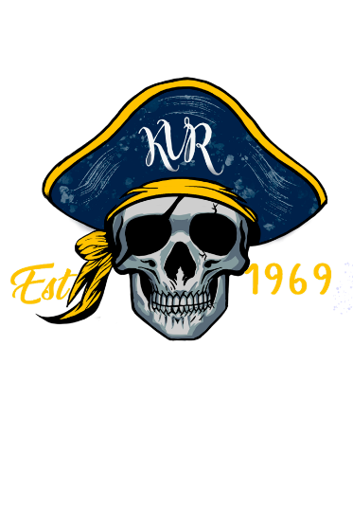

Kernersville Raiders Rules and Policies

- Only players and authorized personnel are allowed pass the ropes at all times.
- Any siblings not participating as a football player or cheerleader are prohibited from being on the field during practices and games.
- NO weapons of ANY kind or anything that can be perceived as a weapon,
- NO fighting or verbal altercations will be tolerated.
- NO animals, except certified service animals.
- NO tobacco use of any kind, including vapes.
- NO drugs of any kind allowed.
- NO alcohol beverages allowed.
- All parents or guardians MUST attend practice. If you cannot attend and do not have someone responsible present for your child, please let a Coach, Team Parent, or Board Member must be made aware.
- Only authorized personnel behind any building (concessions, trailer, bathroom, etc.) unless otherwise stated.
- Parents are responsible for their child and their behavior on the playground.
- Trash must be cleaned up around your area before leaving practices or games.

