2023
BPBA
Handbook Rev 001123
11/29/2023
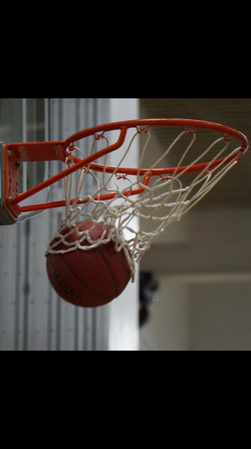
Belle Plaine Basketball Association
Table of contents
1. Mission Statement 4
2. Player Eligibility 4
3. Level of Commitment 5
4. Registration 7
5. Costs 7
6. Player Evaluations 8
7. Families with Multiples 10
8. Team Size and Name 10
9. Tournaments 10
10. Fundraising 11
11. Other ResponsibILIties 11
12. Uniforms 11
13. Adult Supervision /Medical Attention 11
14. Coaching 12
15. Diversity, Equality, and Inclusion 14
16. Conflict Resolution 15
17. Codes of Conduct 16
18. Board of Directors 17
19. Contact Information 17
20. Revision Control 17
Registration Form (This is done online) 19

Every effort has been made to ensure that this handbook is accurate as of the date of printing/posting. As the year progresses, the Board may have to change a policy in response to changing circumstances. Please consult the Documents section on the Association’s website for the most recent version.

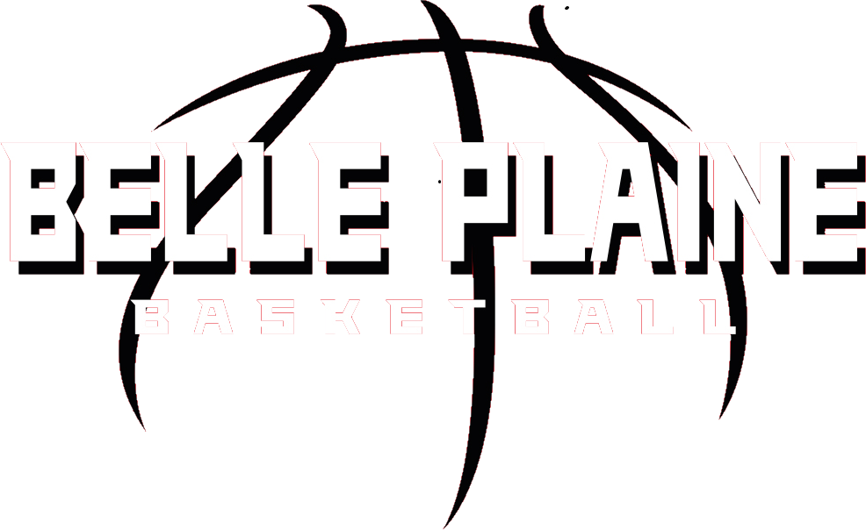

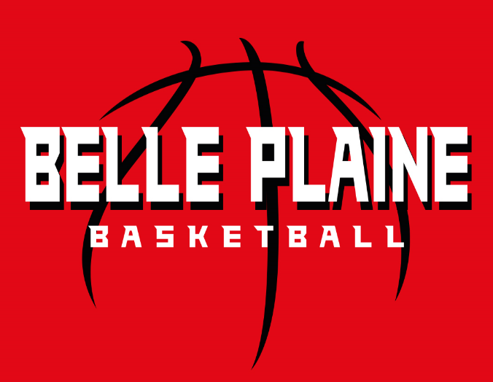
1. Mission Statement
Mission: The mission of the Belle Plaine Basketball Association (BPBA) is to provide all the youth in 4th through 8th grade who live in the Belle Plaine School District (ISD 716) attendance area the opportunity to gain experience and enjoy the game of basketball at their best competitive level.
Focus: Our coaches, assistants, and board members donate their time and talents to help provide athletic opportunities for the children participating in our basketball programs. We all focus on teaching basketball fundamentals, promoting team play, improving individual skills, and having fun to foster a life-long enjoyment of basketball.
Goal: We demand a high degree of ethical conduct by all its coaches, players, volunteers, and guardians to provide an excellent example for the community, the opponents, and its participants, thus helping their growth to adulthood.
Expectations: The BPBA strives to create a positive environment through positive reinforcement of fundamental skills and a competitive team atmosphere by following values and qualities that align with the Minnesota Youth Basketball Alliance (MYAB).

2. Player Eligibility
2.1 Residence requirement

All student-athletes in grades 4-8 who are residents of the Belle Plaine school district (716) are encouraged to try out for the Belle Plaine Basketball Traveling program. They must live in the area served by Belle Plaine School District 716 (the "BPBA Area"). Students who attend a private school or homeschool are encouraged to participate in the Belle Plaine Basketball Traveling program so far as the student lives within the boundaries of District 716. Student-athletes who are not in the geographic area of District 716 as determined by the school will only be allowed to participate under the following conditions:
- The family plans on moving into the BPBA area by the first scheduled tournament.
- It does not displace a traveling, capable, willing student who desires to play at that grade level and lives within the defined District 716 boundaries.
- Other children may apply to the Board for permission to play on a BPBA team by following the Minnesota Youth Athletic Services Player Transfer Request Form guidelines.
- BPBA will handle any unique situations on a case-by-case basis.
2.2 Age and Grade Requirements
Players must be enrolled in 4th through 8th grade and should play in their grade division. You must finish as one of the top 3 players at the advanced grade level to qualify for playing up. Qualifying does not guarantee player movement. Particular circumstances may warrant the BPBA to have limited player movement if the grade level the player would vacate would lose an entire team due to insufficient players. BPBA will manage all player movement.
2.3 Other Eligibility Rules
The BPBA follows all rules and regulations of the MSHSL, District 716, and MYAS regarding players' eligibility to participate in traveling basketball. These rules and regulations are not limited to behavioral, substance abuse policies, attendance, and academic situations. If a player is deemed by the MSHSL or Belle Plaine schools to sit out a period due to any of these violations, then the same will be required as a BPBA traveling basketball organization participant. As required by the MYAS guidelines and the MSHSL, a child who plays for the Belle Plaine Tigers varsity, junior varsity, or 10th-grade team is ineligible to play for BPBA.
2.4 Moving away during the season
A player who makes a traveling team, moves out of the BPBA area, or leaves a Belle Plaine school mid-year may finish the season with their team.
2.5 Multi-Household Families
Suppose a child lives in a multi-household family. In that case, the child may elect to participate in either the traveling program appropriate to the primary guardian residence or the athletic program applicable to the secondary guardian residence.
2.6 Joining after the registration deadline
Student-athletes may only join a team after the registration deadline with the Board and the coach’s permission.
2.7 Transfer Requests
Non-District 716 student-athletes may apply to the Board for clearance to be evaluated for a BPBA team if they first obtain a transfer form filled out from their home basketball association. For transfer forms and criteria, please see the Minnesota Youth Athletic Association's (MYAS) website. Transfer form requests will be reviewed on a case-by-case basis by the Board. Once the Board has approved an incoming transfer form request to enter the BPBA program, the student-athletes are treated as BPBA players. Players must still obtain the annual MYAS transfer form signed by their home Association(s). Players with approved transfer forms are considered part of the BPBA in subsequent years.
District 716 youth who do not earn a spot on a team at evaluations and there are no other BPBA teams to play on may request a transfer form to play with another association.

3. Level of Commitment
3.1 Responsibilities
The Association has high expectations for its coaches, teams, players, and guardians. Here is what to expect:
• BPBA will schedule evaluations in the early September timeframe.
• The practice season starts in late October, and tournaments begin in November and end in March.
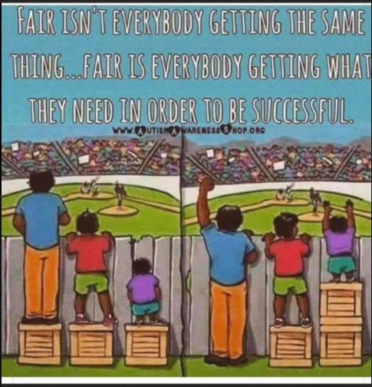
• Practices are generally scheduled two nights per week for 1.5 hours, between 6 and 9:30 p.m. Competitions are commonly held two to three weekends per month.
• Most tournaments that we attend are one-day events with multiple games. Generally, teams play at least three games.
• Saturday evening and Sunday morning games are likely.
• BPBA will host tournaments on the 3rd weekend in December and January, where a guardian or a family representative must volunteer.
• Every effort is made to provide the guardian with a schedule of practices and games early in the season. The guardian is expected to eliminate most scheduling conflicts if given adequate time to adjust. The goal should be to attend every practice and game. If a scheduling conflict does exist, it is the guardian's responsibility to inform the coaching staff as soon as possible.
3.2 Playing time
Every player is a contributing member of a team. The BPBA realizes that all team participants share the same expenses as part of the traveling program. However, the ability to pay does not guarantee the ability to play. Players are challenged in practice sessions and given opportunities to display their basketball skills in game situations. All players get playing time, but some may get more playing time than others.
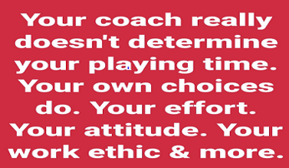
Playing time is determined by several things, including:
• Basketball skill/knowledge • Foul trouble
• Match-ups • Attitude
• Attendance • Hustle at practice and games
• Work ethic • Team Chemistry
For 4th and 5th graders, the basketball experience will primarily focus on teaching and developing players' skills within the "team" concept. The minimum expected time to play for
Players should average about 6 minutes per game throughout a tournament, allowing coaches more flexibility. For grades 6th-8th, increased emphasis will be placed on the players and the team performing at a higher competitive level, and playing time is at the coach's discretion. At this level, however, the expectation is that all players should receive playing time in each half of most games. Modifications to playing time are allowed due to injury, foul trouble, practice/game attendance issues, or other disciplinary reasons.
Coaches should provide players and guardians with communication if playing time falls below the minimum for disciplinary reasons. Coaches should communicate clearly with players and guardians about expected playing time to manage expectations. Coaches shall have the flexibility to reduce playing time for those players who do not attend practices regularly. The coach will give the player and guardians a verbal warning if practice time absence will affect playing time.
Please do not forget that coaches are volunteers – respect their decisions. If the guardians have questions about their child, discuss them privately with the coach. The Association recommends that guardians arrange their conversations with the coach at least one day after a game – not on game day. Also, seeking advice from a director is always very helpful to obtain.
It is the intention of the Belle Plaine Basketball Traveling program that academics come first. Therefore, if a player is deemed by the MSHSL or Belle Plaine schools to sit out a period due to any violation (behavioral, substance abuse policies, attendance, and academic situations), then the same will be required as a BPBA traveling basketball organization participant.
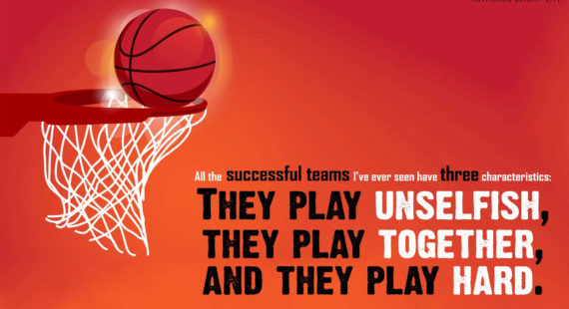

4. Registration
4.1 Registration Process
The BPBA will only accept registration up to the scheduled evaluation or a posted deadline on the BPBA website.

5. Costs
5.1 Tournament/Facility Fees
Please visit the team tab on the BPBA website and look for registration information to find the current season's fee structure. BPBA collects every player's tournament/facility fees through an invoice sent from Sports Engine after team assignments are complete. It will be the responsibility of BPBA to collect all fees for each student/athlete in a timely matter. BPBA will give guardians ten days to complete payment.
BPBA will issue all checks for each team's tournaments and cover all facility rent for practices so that the coaches are not funding these events. Players will not participate in team activities until their fees are paid—no pay, no play and may risk removal from the roster.
5.2 Volunteer Deposit
The Association's primary income source is the BPBA tournaments, usually held in mid-December and January. As the BPBA could not exist without fundraising during these tournaments, everyone involved expects that the players' families will donate their time to the BPBA at no cost. Without successful home tournaments, player registration fees would be much higher. Holding a successful event requires a substantial commitment of time and energy by volunteers. Each family must provide a check at evaluations held as a deposit on that commitment (visit the team tab on the BPBA website and look for registration info to find the amount).
BPBA will shred the check after the family meets the volunteer commitment: 6 hours per child, with a family max of 12 hours for each family. BPBA will cash the full volunteer deposit check for families contributing less than the yearly requirement hours. BPBA will then refund a prorated amount if a family partially fulfills the volunteer requirements. The donated work duties include admissions, concessions, scorekeeping, and general set-up or clean-up duties. In their third year of coaching, coaches receive full volunteer credit for their coaching time and will have their volunteer check shredded after the season.
5.3 Financial Assistance
If a family needs help meeting the financial commitment, they must speak to the President or Director of Operations to set up a fee schedule (periodic payments).
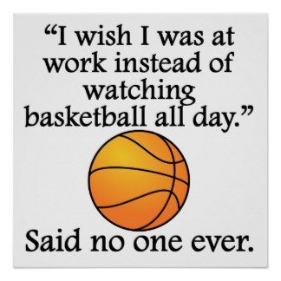
Scholarship opportunities for families that need them are available through The Feast. Families can apply for partial or complete financial assistance. Please talk to a board officer about requesting this offer; they can guide you through this process.)
5.4 Refunds
Traveling teams depend on every player to keep up their commitment. Each team has a very tight budget; if a player leaves during the season, another child may have lost an opportunity to play at that level. The BPBA also incurs expenses relating to each player that may not be recoverable if a child quits. For these reasons, BPBA will not refund any part of a player's registration. The exception is if a participant is moved up to the varsity or jr. varsity team after the season has started, BPBA may prorate the refund. All exceptions to this refund policy are subject to BPBA Board approval. In addition, BPBA will destroy all checks received from students who are not assigned a team.
5.5 Other Costs
(a) Evaluation Fee
The Board and Belle Plaine High School coaching staff volunteer their time to reduce these costs passed onto the athletes' families. In addition, BPBA will pay for all supplies and rent of the facilities for that day. The evaluation fee is included in the registration fee.
(b) Admission to Tournaments
Some smaller traveling basketball organizations, including BPBA, charge an admission fee for spectators. Therefore, families should anticipate a per-day entry fee at traveling tournaments (usually $5-10/adult, $3-6/child).
(c) Team Apparel
BPBA periodically offers sweatshirts, t-shirts, and other apparel items for sale online, with a small portion of the proceeds going back to BPBA for our Dollars for Scholars scholarships.
5.6 Association Expenses
Annual expenses include:

• Building rental charges
• Scheduling Fees
• Insurance
• Background checks
• Equipment
• Coaches' and player shirts
• Website Costs
• MYBA Membership Fees
• Postage and printing
• Other material
• Storage Costs
• Evaluations
• Training and clinics

6. Player Evaluations
6.1 Purpose
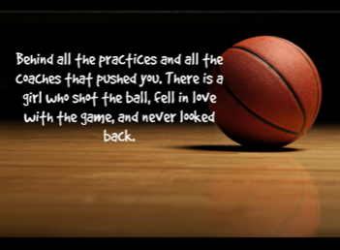
The purpose of evaluations is to assign players to teams based on an objective assessment of skills and abilities. Therefore, evaluations rely on many independent evaluators to assess players' skills and talents as they perform drills and scrimmages. BPBA has established a consistent process and criteria to ensure that each player is allowed a fair and just opportunity to demonstrate their ability. These guidelines further promote the selection process's integrity by requiring the Board to be accountable for their decisions.
Guardians and players must understand that the evaluators are looking for the players who will make up the best basketball teams and not just the tallest players, the fastest players, or the players who have the best shots. A successful basketball team includes players who can rebound, play defense, pass the ball, and are willing to play within a team framework with maximum effort and a positive attitude. Guardians should encourage their athletes to attempt to demonstrate all of their basketball skills during evaluations. Players demonstrating abilities in all facets of the game and who demonstrate the ability and willingness to play as a team member and not as an individual will be more highly rated in the evaluations than players concerned only with shooting the ball on every touch.
6.2 Required for all Players & Teams
Evaluations are required, but depending on numbers, available coaching, and individual player ability, only some potential players may be placed on a team.
6.3 Injury or Absence from Evaluations
Don't hesitate to contact the Board of Directors for scheduling conflicts that may prevent a player from attending one or both evaluation days/sessions before the scheduled date.
Suppose an injury or absence cannot be avoided, resulting in missing both evaluation days/sessions. In that case, a player will be considered for a team based on prior evaluations, seasons, and coach's feedback from previous teams. Generally, a player in this situation would be considered for the same or lower level of competition as last year.
When making an alternative plan, the Board must approve it before the evaluation date ends to consider the athlete for a team.
6.4 Choosing teams per grade level
If 16 or more students/athletes register and have the skills to play for that grade level, two teams will be created (subject to coach availability). There will be an A team for higher-skill players and a B for intermediate players using skill-grading.
6.5 Scheduling
The Board will determine the dates, times, and locations for evaluations. Evaluations will be early in September. Check the BPBA website for schedule details.
6.6 Evaluation Rules
(a) General rules
BPBA will complete required evaluations on all students registered in the program regardless of the number trying out. Grade levels will conduct evaluations independently; each typically runs for one to two hours. BPBA will judge each player's skill levels based on drills agreed upon by the BPBA, High School Coaches, or their designee. How much weight each skill will carry will be predetermined before evaluations by the BPBA. 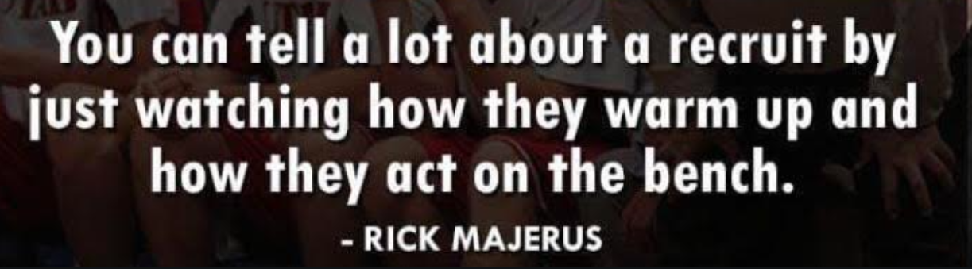Evaluators are chosen based on their knowledge and experience of the game. This assessment will be an unbiased evaluation of a player's skill level. Directors do not evaluate their players or their children's grades. The evaluator should have a general lack of familiarity with the players trying out for a team. Coaches will not be assigned to evaluate players for their teams. Players will receive a jersey with a pre-assigned evaluation number for evaluations. The skill level shall be the only basis that determines placement. Evaluations are closed to guardians, and only players, evaluators, and Board members (if their child is not participating) are allowed in the gyms.
A player may request to be evaluated with a different grade due to a scheduling conflict if the player notifies BPBA at least 48 hours before evaluations. In this case, the player will be allowed to participate in another grade's assessment, and their score will be used as-is. The player will be ranked as if they tried out with their class and would be subject to rules described in section (d) Player Assignments, along with all other players from that grade. In these cases where a player is trying out with a different age group, there is no way to ensure they receive the same score they tried out with their class. BPBA will not consider modifications to a player's evaluation score. The player and family choose an evaluation with a different age group/time to assume that scoring could impact overall player placement on a team.
(b) Scoring
The players will have the opportunity to run through the drills section twice, where BPBA will add the best score with their score from their scrimmage session to follow. Finally, the assessments will be combined to generate a total score to establish a ranking. All evaluators' scores are final and not open to debate. The evaluators' final scores and rankings are reviewed only by the Basketball Operations Committee. This committee reviews "player readiness" and total grade roster sizes to determine additional needs for additional teams and coaches. For complete breakdowns of the scoring of the evaluations, refer to the assessment- Evaluation Manual.
(c)Team Size
The maximum number of players on a team is usually ten (10) unless the Board approves another amount. In general, team sizes are 8-10 players per team. The number of players who register is a significant factor in this decision. (also see section 8)
(d) Number of Teams
Due to limited practice space, the Board is committed to filling one team with enough players at each grade level. Adding a second team in any grade will be evaluated based on the number of athletes trying out and the availability of practice space.
(f) Announcement of results
The Board will post the results of evaluations using the player's first name and last initial on the website. Rosters are posted for all teams, even if BPBA has not identified a head coach. Teams without a head coach at the specified deadline on the results website will be cut and receive a refund. Once BPBA establishes a team roster, adjustments, such as adding or moving players, will only be made with the Board's approval. When on the BPBA website, the guardians must ensure they are on the team's tab, not a previous year's team roster.

7. Families with Multiples
When a family has multiple players at the same age level (twins), the family has two options. The family may opt to evaluate their players as individuals with the understanding that one may make the team and the other may not. Alternatively, they can elect to have both players handled the same. If both players are dealt with the same way, both players will receive the lowest score at the end of the evaluation process. Both players will then be ranked at their grade level, and all other players will make or fail to make the team according to that lowest score. The families must predetermine their preferences before evaluations.

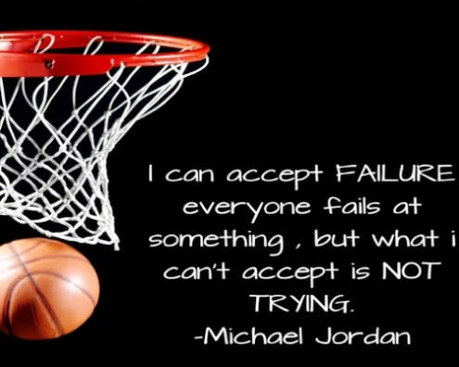
8. Team Size and Name
The maximum number of players on a team is ten (10) unless the Board approves another team size. Generally, the number of registered players is a significant factor in team sizes of 8-10 players.
The team name structure:
Example: Belle Plaine G7 Red
- Team Name (Belle Plaine)
- Gender Initial (G)
- Grade (7)
- Color or Number (Must be unique to each team) (Red)

9. Tournaments
9.1 Tournament Scheduling
Annually, the BPBA Board will predetermine the suggested number of tournaments teams will participate in throughout the season. Historically, one less than the grade number is scheduled. In 2022, the junior high program started a reduced schedule; BPBA now plans and organizes seven tournaments for 7th and 8th grades. In 2023, the Community Ed program requirements were adjusted, and BPBA plans and schedules seven tournaments for 6th grade and six for 5th grade.
The BPBA Board determines the number of tournaments that BPBA will host.
The BPBA Board may choose tournament locations, give coaches a small list of organizations considered friends of our program, or encourage the head coach to organize tournaments that best fit their team. If there are additional tournaments that a team wants to play in, the guardians can cover those tournaments' costs. This cost is above and beyond the pre-season tournament/facility fee. Coaches can manage those options; this may include Great State. and tournament venues in which BPBA
9.2 Travel to Tournaments with Winter Weather
BPBA's first concern is the safety of its players and association members' (guardians) families. When the National Weather Service has issued a winter storm watch, it is up to the coach's discretion if the team should make the trip. When the National Weather Service has issued a winter storm warning, it is up to the coach and a majority vote of the guardians (a family, not voting equals a no vote, in the eyes of BPBA). When the Minnesota Department of Transportation (MnDOT) has a no-travel advisory on highways in the direction families must attend for a BPBA-scheduled tournament, the coach will call off the contest and notify their team and those tournament officials per BPBA requirements. If the games are missed due to inclement weather, a team may have fewer tournaments that season if a replacement cannot be found.

10. Fundraising
Teams may only carry out fundraising activities or seek sponsorships with Board permission. The Board may grant permission if, in its opinion, the money raised will be spent for a purpose consistent with the Association's mission.

11. Other ResponsibILIties
BPBA requires seventh and eighth graders to play basketball for the high school program. Receiving more court time will develop the skill levels and confidence of the entire seventh and eighth-grade teams.

12. Uniforms
We take great pride in our organization and hope coaches, guardians, and players share that same pride. One of the ways to support the organization is by wearing a uniform. Guardians can also show their support by wearing team apparel. When playing on a BPBA team, players may only wear Uniforms authorized by the Association. The use of uniforms may only be at games approved by the Association through the winter season. Prior permission from the Board to use uniforms at other events is required.
All players will receive a warm-up shirt that each player will get to keep at the end of the season. All head coaches are equipped with a BPBA shirt at the start of their assignment. Head coaches are asked to wear BPBA apparel to each tournament as a program representative.
Due to the increasing cost of uniforms and the burden of storing them, BPBA has decided that players must buy their uniforms starting in the 2021-22 season. BPBA will negotiate/strive to keep these costs reasonable but will be at the manufacturer's mercy.
All coaches are given a voucher to purchase BPBA apparel at the start of the season. As a representative of the BPBA, coaches are expected to wear BPBA apparel to each tournament.

13. Adult Supervision /Medical Attention
The BPBA emphasizes providing our players with an experience that balances fun, safety, and learning. Given these priorities, we’ve developed a policy requiring at least two adults to always be present at practices and events.
13.1 Adult Supervision
Travel Players in Grades 3-6 must always have a supervisor (or designated adult) at the school. Guardians, please always be aware of the scheduled time that practice or games should finish. Our coaches, assistants, and board members donate their time and talents. We do not want them burdened with spending more time waiting for the last child to be picked up.
Travel Players in Grades 7-12 are not required to always have a parent (or designated adult) supervisor at the school. However, they should still have their unsupervised time very limited.
Guardians should advise their children of actions to take in case of injury, sickness, inclement weather, and early or unexpected cancellation of basketball games or practice. If this includes a cell phone call and pick-up, then guardians should ensure they can return to the school within 15 minutes of the call. After each game or practice, coaches should remain attentive to ensure all players have a ride or planned transportation home.
13.2 Injuries and Medical Attention
Guardians should know that if their child is injured and the guardian is absent, BPBA coaches will seek appropriate medical attention, including calling 911. All costs for this medical treatment and transport will be the responsibility of the child’s legal guardian. Coaches and board members of the BPBA are authorized to contact emergency personnel at no personal civil liability under Minnesota’s Good Samaritan Law.

14. Coaching
14.1 Coach Selection
The Basketball Operations team will select coaches for each group. Prospective coaches should submit an application found on the website. The Board makes coach selections based on:
• Previous experience
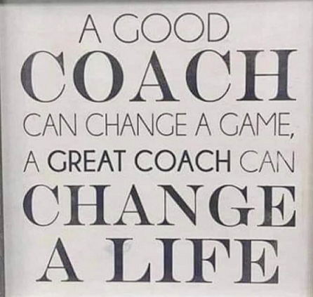
• Knowledge of basketball
• Player and guardian evaluations from former years
• Commitment to the mission of the BPBA
• Discussions with past players, coaches, or guardians
The Basketball Operations team will make final coach recommendations at a future Board meeting for the Board's approval. If someone else applies for a specific grade level, the Board will post that opening on the Association website and do its best to find a coach. There will only be a team if BPBA can secure a coach by the published deadline. Head coaches will choose an assistant coach after evaluations. The Association reserves the right to assign or remove any coach without reasoning.
14.2 Trusted Coaches
All head and assistant coaches must complete Trusted Coaches for a Nationwide Criminal Background Check, Child Safety Training, and Concussion Certification. There are no exceptions. Failure to complete the required Trusted Coaches certifications will result in the removal of the respective coach.
14.3 Coach's Code of Conduct
The head and assistant coaches must sign the Coach's Code of Conduct (form in the back of this manual)
14.4 Coach Development
Various online resources exist for coach development, and the Association works to ensure coaches have development opportunities. At the end of the season, the three objectives for each child in our sports program are:
1. Did the child have fun?
2. Did the child learn and progress?
3. Do they want to come back and play again?
14.5 Coach-Board Relationships
The program can only exist with good coaches. Therefore, the Board is always eager to assist coaches in any possible way.
(a) Board LiaisonBPBA will assign Basketball Operations Committee members to each grade as a Board Liaison. The Board Liaison will meet with the team guardians at the beginning of the season and may attend team games or practices occasionally. The Board Liaison should be the guardians and coach's first contact for any questions or concerns. The committee member cannot be a guardian of a player in that grade.
(b) Attendance at Board Meetings
Directors may invite coaches to attend Board meetings during the season. These meetings encourage dialog between coaches and the Board and discuss any concerns or questions the coaches have about the program. Board meetings are always an open forum, and coaches are welcome to attend regularly (monthly) scheduled Board meetings throughout the year.
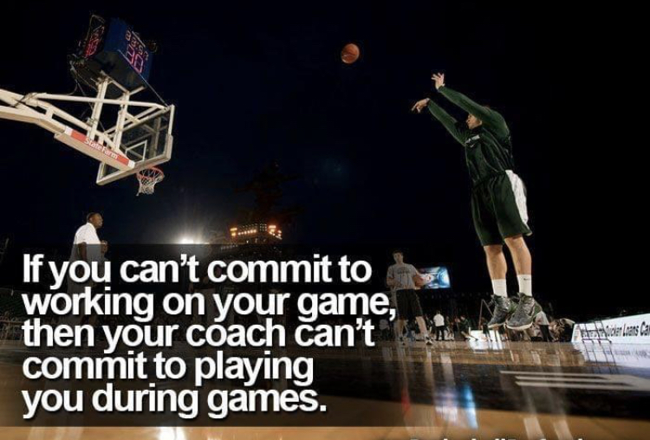
14.6 Coach-Guardian Relationships
Coaches and guardians must work together to create the best possible experience for the children on the team. Children learn what we teach them, but they also learn from what they see, including how their coaches and guardians behave and interact. Sometimes, a guardian will disagree with a coach's decisions or be unhappy with their child's treatment. When these situations arise, it is best to discuss them with the coach – but not when the coach or guardian may still be under the incident's stress. The guardian's Code of Conduct describes the Association's expectations of guardians and includes:
• Guardians will respect coaches and their authority during practices and games, will never question, discuss, or confront coaches at a game, and will take the time to speak with coaches at an agreed-upon time and place.
Here are some additional suggestions for working out disagreements:
• Remember that coaches genuinely try to do the best thing for the team and each child. Traveling basketball is competitive, and coaches will make player substitutions and assignments to give the team the best chance to win in a given situation. That may mean some players do not get as much court time.
• Please wait until the day after an incident before mentioning it to the coach. Sometimes, "sleeping on it" will give you a better perspective.
• The guardian can disagree with a coach's decision without attacking the coach personally. However, the guardian and the coach must treat each other respectfully, even if they disagree.
• Conversations between a coach and a guardian should remain private. Neither the coach nor the guardian should discuss their disagreement with other guardians or players. To do so can easily lead to feelings of "ganging up" and make it more challenging to resolve the problem.
• If the discovery of a resolution for the problem is unreachable after the initial conversation, the guardian and the coach should ask the Board for help. The Board will arrange for a Board member to meet with the guardian and the coach to discuss the issue.
• If the issue cannot be resolved, the guardian can initiate a formal complaint. Formal complaints are very infrequent. The complaint process will always produce a decision, but it may be a decision neither the coach nor the guardian likes. Individuals can usually find a better result if they work things out themselves.
• Don't involve the children. The disagreement with the coach is for the guardian and the coach to work out. Kids see, listen, and talk. Keep them out of it.
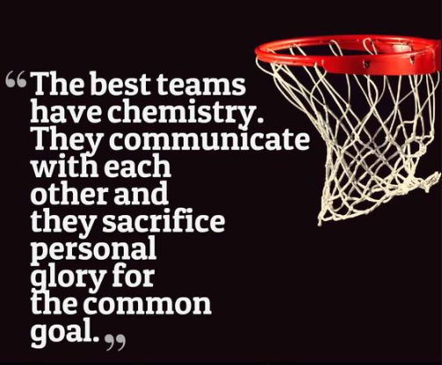
• Never use email to complain to a coach. Email is a great communication tool, but does not work well when emotions kick in. There is a tendency for people to put things in emails that they would never say to someone's face. It is also easy to misunderstand an email and read it as a personal attack when no attack was intended. Each angry response leads to another in rapid succession. Finally, emails are too easy to pass along to others. Disagreements between a guardian and a coach are private matters. It will destroy trust between the parties completely and immediately if one side broadcasts their version of things to the world." Remember: if a guardian cannot work things out privately, bring in a Board member for help.
14.7 Team meetings
The Association encourages coaches to conduct a team meeting at the beginning of the season to set expectations and review schedules and other housekeeping items. Coaches may also meet with team guardians during the season if needed.
14.8 Coaches Supplies
BPBA will provide each coach with a traveling basketball bag with adequate basketballs to practice before a game. In addition, a stocked first-aid kit, ice packs, scorebooks, and dry-erase board with enough supplies to meet the traveling season will be provided to each coach. In addition, BPBA will supply every coach with an adequate number of reversible practice jerseys.

15. Diversity, Equality, and Inclusion
15.1 Diversity, Equality, and Inclusion
BPBA is committed to fostering a welcoming environment by building a diverse, equitable, and inclusive program. We support any teammate, coach, or fan who brings heart, energy, and passion to the gym. We seek to establish and maintain an inclusive culture that fosters equitable participation for student-athletes and opportunities for coaches and directors from diverse backgrounds. Meaningful action can positively affect necessary change in our sport and carry over to our everyday lives.
15.2 Anti-Bullying / Hazing
According to the U.S. Department of Health & Human Services and the Stop Bullying program, “Bullying is unwanted, aggressive behavior among school-aged children that involves a real or perceived power imbalance. The behavior is repeated or has the potential to be repeated over time. Bullying can take many forms. Verbal bullying includes teasing, name-calling, taunting, or threatening to cause harm. Physical bullying includes hitting, kicking, pinching, spitting, tripping, pushing, taking or breaking someone’s things, or making mean or rude hand gestures. Finally, bullying can be social, frequently called ‘relational bullying,’ when someone is left out on purpose, when someone tells kids not to be friends with someone, when a child spreads rumors about another kid, or when a child intentionally embarrasses another child in public. Hazing is taking these same activities of harassment, abuse, or humiliation and using them as a way of initiating a person into a group or a team.
Below are the steps BPBA will use to handle a Bullying / Hazing accusation:
1. The coach of the team and a board liaison will assess any claims against bullying.
2. The accused player and guardians must appear before the BPBA Board if a claim is warranted.
3. A player accused of bullying/hazing is NOT allowed at any BPBA scheduled events (practice, games, tournaments, clinics, etc.) until the resolution is deemed resolved by the Association Board.
4. The board shall react promptly to any allegations and expedite a meeting to resolve the conflict.
Discipline from such actions can include:
1. Suspensions of a given amount of time.
2. Removal of the player from the team and Association for the remainder of a season (without refund).
3. A permanent ban from the Belle Plaine Basketball Association.
15.3 Social Media Guideline:
BPBA desires a positive environment for all its members and players, including off-the-court areas like social media. Please use these bullet points as guidance!
(A) Think before you post anything (text or photo) online. Once you post, it is available and viewable to anyone, anytime, in the world, and the content is no longer yours, no matter how private your accounts may be. Before posting, ask yourself if what you’re about to post is something you’d want your mother, father, grandparents, college recruiter, or future employer to see.
(B) Freedom of Speech is not unlimited; there are things you cannot and should not say or write online. There are consequences for your actions and speech.
(C) Strive for accuracy. Please get your facts straight before posting them on social media sites. Don’t start rumors or post anything you are not 100% sure of.
(D) Be constantly aware of liability. You are responsible for what you post on your site and the sites of others. You can be held liable for anything deemed copyright infringement, defamatory, propriety, libel, or obscene (as defined by the courts). Be sure what you post today does not come back to haunt you tomorrow.
(E) Correct Mistakes. If you make a mistake when posting, admit it. Be upfront and be quick with your corrections; don’t wait three days to correct something. Also, monitor your teammates. If you see a post that is very close to violating this policy, encourage them to delete it.
(F) Coaches and guardians. Make smart choices when friending a player, sending photos, comments, etc., that anyone can see. Young and impressionable players look up to their coaches and team guardians.

16. Conflict Resolution
Disputes between guardians, coaches, or Board members are subject to an identical complaint procedure:
• The individuals should try to work things out privately (see section 13.6 for suggestions).
• If the problem remains, an independent Board member will attempt to mediate the dispute.
• If the problem is unresolved, either party may file a written complaint
• Following the schedule in the complaint form, the Board will allow responding in writing.
• The Board will convene a Hearing Committee of three Board members and announce a date for hearing the complaint.
• At the hearing, both parties will have an opportunity to argue their case and present letters from others who have personal knowledge of the events giving rise to the complaint. Outsiders will not be permitted to attend the hearing.
• The purpose of the hearing is to resolve the dispute, and the Hearing Committee will encourage the parties to do so. If the parties cannot agree, the Hearing Committee will render a written report within 72 hours of the hearing's conclusion.
• The Hearing Committee report will include a summary of the facts, an explanation of how those facts constituted a violation of the relevant code of conduct, and a recommendation for any sanctions or other consequences they consider appropriate.
• The Board will meet within seven days of the Hearing Committee's report to decide on the appropriate sanction. The Board may not change the Hearing Committee's findings of fact but may decide on different sanctions.
• If the final sanctions include removal as a coach, the Board will call a meeting of the team's guardians and coaches. At the meeting, participants may express their views on the coach's suitability, general character, or any other matter they think might help the Board make a final decision. After the meeting, the Board will meet privately to render a final decision.
• Within seven days of the Board's decision, either party may appeal the decision by notifying the President in writing of the reasons for the appeal. The President will allow the other party to respond in writing. Within seven days of the notice of appeal, the Board will convene an Appeal Hearing. The entire Board will hear the appeal.
• At the Appeal Hearing, the parties may argue why the decision should be changed but may not say that the Hearing Committee misunderstood the facts. After the hearing, the Board will privately meet and announce their decision.

17. Codes of Conduct
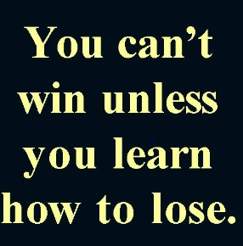
Every Board member, coach, player, and guardian must read and sign a yearly Code of Conduct form. Forms are distributed via guardians or team meetings and are available on the Association website. Violations of the Code of Conduct may result in a warning, suspension from participation for a definite or indefinite time, removal from a coaching position, or removal from the Association. BPBA believes the example we set for our kids- How to act when things do not go our way- is much more important than the rules we establish for them.
The Association wants to ensure that games are fair, festive, and enjoyable for all parties involved. Therefore, a basketball game should be friendly and unifying - a spirited social and athletic occasion for players, coaches, referees, and spectators.
17.1 Player's Code of Conduct
Players agree to abide by the Players Code of Conduct. Players that violate these rules may forfeit their gameplay for the next game. In addition, chronic infractions by any player may result in the player's dismissal from the team. Each player will be expected to sign the Players' Code of Conduct.
Please see Appendix D for this Form
17.2 Player Removal/Violation Process
Players, coaches, or guardians acting in any way contrary to this program's philosophy will be asked to explain their behavior. Coaches will communicate with the player's guardians in person or by phone but follow up with a written follow-up to be signed by both parties to ensure players and guardians understand the violation and consequence(s). Coaches must also notify their Board representative and, if possible, can have board members present for meetings with guardians.
The matter will be brought to the Board of Directors for review and action if a violation warrants. Penalties for such behavior can range from a verbal/written reprimand to suspension or expulsion from the program. For example, a traveling basketball team represents its community in tournaments. How everyone acts at these tournaments reflects directly on the team and the organizations they represent.
17.3 Team Expectations & Facility Considerations
Please see Appendix E for this Form
17.4 Coach's Code of Conduct
Coaches will treat all players equally with no preferential treatment to any player. Coaches will not be physically or verbally abusive to any player. Coaches found violating will be asked to resign from their positions. The BPBA desires that all players will have the opportunity to succeed in a non-hostile environment. Each Coach will be expected to sign a Coaches Code of Conduct if it becomes necessary for an assistant coach to assume the coaching responsibility due to conflicts, moving, or illness. Any change should be made with the recommendation of the respective Coach Coordinator and the Board. Guardians are encouraged to inform the Board when BPBA coaching staff members commit behaviors detrimental to our code of conduct.
Please see Appendix F for this Form
17.5 Guardian's Code of Conduct
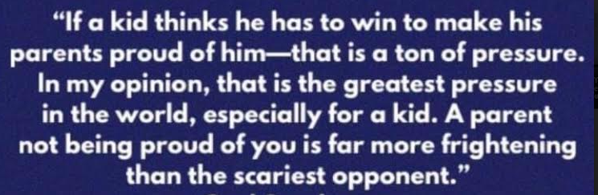
The BPBA strongly urges all guardians to attend the mandatory meeting before evaluations (Held every other year). Any guardian of a BPBA player may be asked to leave the game by a BPBA Board of Directors member or coach if that guardian is unruly to officials, coaches, players, or other team member guardians. Suppose a guardian refuses to leave the premises where the tournament is being conducted. The violating guardian player will not be allowed to play in the next scheduled set of games. Should this happen a second time, the BPBA Board of Directors will ask the player not to return for the remainder of the season. In addition, each guardian will be expected to sign the Guardians Code of Conduct.
Children's sports are supposed to be fun – for children. Unfortunately, many guardians do not realize that their verbal or nonverbal actions can have a lasting emotional effect on children. As a result, too many children leave sports activities because adults unfairly take the fun away. Guardians who follow this simple code can help reinforce what sports are all about, BEING FUN FOR EVERYONE.
Please see Appendix G for this Form
17.6 Directors Code of Conduct
Board members are selected from the membership to carry out the Association's day-to-day operations. Their responsibilities, however, are broader. They are ambassadors of the sport and the Association in their dealings with the community. In addition, they serve as role models for coaches and players. Above all, guardians are entrusted to provide a safe and supportive environment where children can reach their full potential in basketball.
Please see Appendix H for this Form.

18. Board of Directors
18.1 Who are they?
See the Association's website for current Board Members (Directors).
(www.BellePlaineBasketball.com).

19. Contact Information
19.1 Association Email
Contact the Association through their email account at BellePlaineBasketball@gmail.com
19.2 Personal Email
Contact the Association President or any Board members listed on the BPBA website.
19.3 Website
https://www.BellePlaineBasketball.com
19.4 Address
Belle Plaine Basketball Association
PO Box 51,
Belle Plaine, MN 56011

20. Revision Control
20.1 Revision Number
Every effort has been made to ensure this handbook is accurate as of the printing date. However, as the year progresses, the Board may have to make changes at any time in response to changing circumstances. Please consult the Association's website for the most recent version. The BPBA will control this document with a six-digit # system.
- The first digit is any change the updating officer makes.
- The second digit is for any change that must go before the Board for a vote.
- The third digit, though sixth, is the date of full review from the Board. 0912= month Sept, the year 2012.
Example: 460915
Sept = Month 2015 = year of last full review
4 = How many significant changes the updating officer makes
6 = How many times did the total board vote?
20.2 Policy Adjustments
Any Policy or activity not covered in our By-Laws or Handbook will be up to the discretion of the current Board of Directors. The Board of Directors holds the right to adjust any policy in the handbook with a majority vote at any regular scheduled or special meeting with at least a quorum of voters.

Note:
Every effort has been made to ensure that this handbook is accurate as of the date of printing/posting. As the year progresses, the Board may have to change a policy in response to changing circumstances. Please consult the Documents section on the Association’s website for the most recent version.

2023

Mission Statement
Our mission is to provide an opportunity for student-athletes to participate in traveling basketball, and to promote good sportsmanship, academic excellence, and a drug free environment for all the youth in the Belle Plaine High School district.

Highly Committed
The Association has high expectations for its players, teams, coaches, and guardians.

Official Use Only
Registration check:
Yes No Check # ________
Volunteer Deposit: Yes No Check # ________
Uniform Size: (not 4th grade):
Top: _______________
Bottom: ____________
Warm up: ___________

Try-out #:
____________________

Registration Form (This is done online)Tournament
Information Technology Solutions


4th Grade
Registration Fee: $125
Volunteer Deposit: $0

5th Grade
Registration Fee: $360
Volunteer Deposit: $240

6th Grade
Registration Fee: $425
Volunteer Deposit: $240

7th Grade
Registration Fee: $425
Volunteer Deposit: $240

8th Grade
Registration Fee: $425
Volunteer Deposit: $240

Belle Plaine Basketball Association Registration Form

In consideration of accepting this registration form. I, the undersigned, for myself, my executors, administrators and assignees, do here by discharge Belle Plaine Basketball Association and any and all sponsors, organizers and their representatives and successors from all claims of damage, demands, action and cause of action whatsoever, if any matter arises or grows out of my participation in said program. I understand the strenuous nature of competitive basketball. I further attest that my child is physically qualified to participate in the program.

Guardian Signature:

___________________________________

Child Name: ________________________
Grade: _________ Gender: ________
School: ____________________________
Address: ___________________________
Guardian: __________________________
Primary Phone #:____________________
Guardian: __________________________
Secondary Phone #:__________________
Email: ____________________________
Families of Twins may opt to allow their players to be evaluated as individuals or together. Please indicate below to inform
The Association: _________________
Please email the Association if you are interested in coaching.

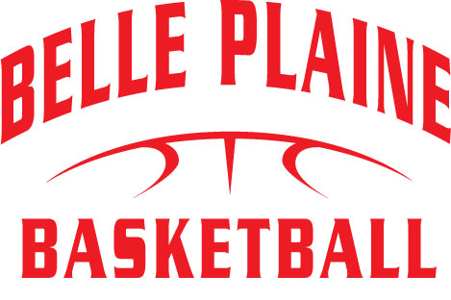
guardians Meeting – 4th,5th & 6th
What is the BPBA Mission? The mission of the Belle Plaine Basketball Association (BPBA) is to provide all the youth who live in the Belle Plaine School District (ISD 716) attendance area the opportunity to gain experience and enjoy the game of basketball at their best competitive level.
- What is the BPBA?
  - We aim to create a fun and structured environment to enhance the skill sets of youth basketball programs.
  - We are a middle ground or gap-filler between Comm. Ed. and the high school programs.
- Leagues and Tournaments
  - Maximum of ten players per team unless BPBA decides otherwise.
  - Waconia League – Saturdays (typically mornings) – back-to-back games – played at various communities.
  - Tournaments – 4th grade (3), 5th grade (4), and 6th grade (5), including a BPBA, hosted the tournament.
  - Practices – Traveling on Thursdays or Sundays at Oak Crest. A schedule will be prepared with all game and practice times subject to change and available online on our website, www.belleplainebasketball.com.
- Volunteer Hours and Players Fees
- Fees cover the cost of practices, tournaments, uniforms, equipment, insurance, and a shooting shirt that players get to keep. In addition, BPBA is being charged a usage fee for gym rentals.
- Each player's guardians, grandparents, or 18 or older designee will be required to provide up to 6 hours of volunteer time at BPBA-hosted tournaments, raffles, open gym supervisor, or other events as assigned.
- Due to the increasing cost of uniforms and storage costs, BPBA has decided that starting in 2021-22, players will be responsible for buying their uniforms. BPBA will no longer own or require that they be handed in at the end of the year.
- Playing Time
  - League Games - coaches will be encouraged to play players equally. However, there will be times during certain games when coaches must use their discretion to put their best team on the court during a given situation.
  - Tournament Games – we are going to tournaments expecting to win games. All players will play, however, not equally. Note: Fair isn’t everyone getting the same thing. Fair is everyone getting what they need to be successful.
  - All players will be worked as evenly as possible to develop all team players during practice times. In addition, players will be encouraged to work on their skills during the season other than practice.
- BPBA – Looking to the future
  - Hopefully, this will be a positive and fun experience for guardians and players. If there are concerns, please do not address them during a game. Feel free to address the coach or member of the BPBA board at practice or at a time that is not disruptive to the players.
  - We ask guardians to work with the BPBA to improve their child's basketball experience.
  - The fees we pay now will help the children throughout their years in the Belle Plaine Basketball program. The team needs equipment, uniforms, coach's clinics, team banquets, student nights, and other miscellaneous items.
  - Codes of Conduct
Questions

guardians Meeting – 7th & 8^{h}
- What is the BPBA Mission? The mission of the Belle Plaine Basketball Association (BPBA) is to provide all the youth who live in the Belle Plaine School District (ISD 716) attendance area the opportunity to gain experience and enjoy the game of basketball at their best competitive level
- What is the BPBA?
  - We aim to create a fun and structured environment to enhance the skill sets of youth basketball programs.
  - We are a middle ground or gap-filler between Comm. Ed. and the high school programs.
- Leagues and Tournaments
  - Maximum of ten players per team unless BPBA decides otherwise.
  - Players are expected to play school ball and on a traveling team.
  - Tournaments – 7th grade (6) and 8th grade (7), including a BPBA, hosted the tournament. The count may vary depending on the season.
  - Practices – These will be flexible as the high school will dictate gym availability.
  - A schedule will be prepared with all game and practice times subject to change and available online at www.belleplainebasketball.com.
- Volunteer Hours and Players Fees
- Fees cover the cost of practices, tournaments, uniforms, equipment, and a shooting shirt that players get to keep. In addition, BPBA is being charged a usage fee for gym rentals.
- Each player's guardians, grandparents, or designees 18 or older must provide 6 hours of volunteer time at BPBA-hosted tournaments, raffles, or other events as assigned.
- Due to the increasing cost of uniforms, BPBA has decided that starting in 2018-19, any damaged or lost uniforms will result in the volunteer check being cashed to cover expenses.
- Playing Time
  - League Games - coaches will be encouraged to play players equally. However, there will be times during certain games coaches will need to use their discretion to put their best team on the court during a given situation.
  - Tournament Games – we are going to tournaments expecting to win games. All players will play, however, not equally. Note: Fair isn’t everyone getting the same thing. Fair is everyone getting what they need to be successful.
  - All players will be worked with as evenly as possible to develop all team players during practice times. In addition, players will be encouraged to work on their skills during the season other than practice.
- BPBA – Looking to the future
  - Hopefully, this will be a positive and fun experience for guardians and players. If there are concerns, please do not address them during a game. Feel free to address the coach or member of the BPBA at practice or at a time that is not disruptive to the players.
  - We ask guardians to work with the BPBA to improve their child's basketball experience.
  - The fees we pay now will help the children throughout their years in the Belle Plaine Basketball program. In addition, the team will need equipment, uniforms, coach's clinics, team banquets, student nights, and other miscellaneous items.
  - Codes of Conduct
Questions
All players, coaches, and guardians involved in the Belle Plaine Basketball Association program must act with good sportsmanship at all functions, whether games or practices. BPBA will not tolerate unsportsmanlike conduct, including physical or verbal abuse of teammates, opponents, or officials. Players, coaches, or guardians acting in any way contrary to this program's philosophy will be asked to explain their behavior. The matter will be brought to the Board of Directors for review and action if a violation warrants. Penalties for such behavior can range from a verbal/written reprimand to suspension or expulsion from the program. In addition, a traveling basketball team represents its community in tournaments. Therefore, how everyone acts at these tournaments reflects directly on the team and the communities they represent.

Players Code of Conduct Form
Mission: The mission of the Belle Plaine Basketball Association (BPBA) is to provide all the youth who live in the Belle Plaine School District (ISD 716) attendance area the opportunity to gain experience and enjoy the game of basketball at their best competitive level.

As a Player in the Belle Plaine Basketball Association program, you must agree to the above mission statement's following principles.
- I will encourage good sportsmanship by supporting all players, coaches, and officials at every game, practice, or youth basketball event.
- I will accept accountability for my behavior and its outcomes.
- I will honor my obligations and promises.
- I will place my teammates' and opponents' emotional and physical well-being ahead of my desire to win.
- I will demand a sports environment free of drugs, tobacco, and alcohol and refrain from their use at all youth basketball events.
- I will try to remember that youth basketball is supposed to be FUN and that winning and losing are part of everyone's experience.
- I will treat other players, coaches, fans, and officials regardless of race, sex, or ability.
- I will not verbally abuse the officials or "trash talk" to my opponent.
- I will not use profanity.
- I will be subject to all the same rules and regulations of the Belle Plaine High School regarding academic or substance abuse violations.

Players Signature

All players, coaches, and guardians involved in the Belle Plaine Basketball Association program must act with good sportsmanship at all functions, whether games or practices. BPBA will not tolerate unsportsmanlike conduct, including physical or verbal abuse of teammates, opponents, or officials. Players, coaches, or guardians acting in any way contrary to this program's philosophy will be asked to explain their behavior. The matter will be brought to the Board of Directors for review and action if a violation warrants. Penalties for such behavior can range from a verbal/written reprimand to suspension or expulsion from the program. In addition, a traveling basketball team represents its community in tournaments. Therefore, how everyone acts at these tournaments reflects directly on the team and the communities they represent.

Team Member’s Code of Conduct Form
Mission: The mission of the Belle Plaine Basketball Association (BPBA) is to provide all the youth who live in the Belle Plaine School District (ISD 716) attendance area the opportunity to gain experience and enjoy the game of basketball at their best competitive level.

As a Team Member in the Belle Plaine Basketball Association program, you must sign and agree to the above mission statement's following principles.
- When practicing in District 716 buildings, no food is allowed in the gyms; all beverage containers must have a cover.
- If your team is the last one to leave the gym on a practice night, ensure the gym is left clean; PLEASE CLEAN UP THE GYMNASIUMS AFTER YOUR PRACTICE.
- Coaches and players should wear different shoes on the gym floor than they wear to and from school.
- No one should arrive more than 10 minutes before team practice.
- If your team is practicing second, do not enter the gym until the other team leaves.
- Coaches: no basketballs should ever be out of the ball bags until a team has entered the gym for a practice or game, so we do not have anyone bouncing basketballs in the hall of any school building in BP or any tournament location.
- Guardians are welcome to all practices; siblings of players are not unless under the guardians' complete supervision, which means they always stay in the gym. Friends of players are never welcome at practice.
- Players are expected to leave the building immediately after practice, so guardians must ensure they pick up their athletes when scheduled to finish. Likewise, the coaches must not leave the gym site until all their players have left the building with their ride home.
- Players found in other school buildings will be suspended from their team for one to two weeks.
- Travel team players must provide transportation to all games, and each player and coach is expected to be at the game/tournament site one-half hour before game time. Non-guardian coaches should not give players rides to tournament games.
- It is essential to be at every practice and game and to make sure you inform your coach of the two excused reasons you may miss a practice or game, which is being ill or a family event. Missing a game or practice for another athletic competition is not an excused absence unless BPBA approves.

Team Signatures
All players, coaches, and guardians involved in the Belle Plaine Basketball Association program must act with good sportsmanship at all functions, whether games or practices. BPBA will not tolerate unsportsmanlike conduct, including physical or verbal abuse of teammates, opponents, or officials. Players, coaches, or guardians acting in any way contrary to this program's philosophy will be asked to explain their behavior. The matter will be brought to the Board of Directors for review and action if a violation warrants. Penalties for such behavior can range from a verbal/written reprimand to suspension or expulsion from the program. In addition, a traveling basketball team represents its community in tournaments. Therefore, how everyone acts at these tournaments reflects directly on the team and the communities they represent.

Coaches Code of Conduct Form
Mission: The mission of the Belle Plaine Basketball Association (BPBA) is to provide all the youth who live in the Belle Plaine School District (ISD 716) attendance area the opportunity to gain experience and enjoy the game of basketball at their best competitive level.

As a Coach in the Belle Plaine Basketball Association, one must sign and agree to the following principles' mission statement.
- I will place the emotional and physical well-being of my players ahead of a personal desire to win.
- I will treat each player as an individual, remembering the full range of emotional and physical development of children in the same age group.
- I will support the BPBA and its Board of Directors and follow their policies and by-laws.
- I will do my best to organize fun and challenging practices for all my players.
- I will know the rules of the game and instruct my athletes in those rules.
- I will provide an environment for my team free of drugs, tobacco, and alcohol, and I will refrain from their use at all youth basketball events.
- I will lead by example by demonstrating fair play and good sportsmanship to all my players.
- I will always be responsible for providing a safe environment for my players, free from harassment on gender, place of origin, color, sexual orientation, religion, political beliefs, economics, and disabilities.
- I will not tolerate profanity or verbal abuse by my players or guardians, regardless if it is directed towards teammates, officials, or opponents.
- I will use coaching techniques appropriate for each skill I teach.
- I will remember that I am a youth basketball coach and that the game is for the children and not the adults.

Coach's Signatures
Coach’s Signature ___________________________________________Date:__________________
All players, coaches, and guardians involved in the Belle Plaine Basketball Association program must act with good sportsmanship at all functions, whether games or practices. BPBA will not tolerate unsportsmanlike conduct, including physical or verbal abuse of teammates, opponents, or officials. Players, coaches, or guardians acting in any way contrary to this program's philosophy will be asked to explain their behavior. The matter will be brought to the Board of Directors for review and action if a violation warrants. Penalties for such behavior can range from a verbal/written reprimand to suspension or expulsion from the program. In addition, a traveling basketball team represents its community in tournaments. Therefore, how everyone acts at these tournaments reflects directly on the team and the communities they represent.

Guardians Code of Conduct Form
Mission: The mission of the Belle Plaine Basketball Association (BPBA) is to provide all the youth who live in the Belle Plaine School District (ISD 716) attendance area the opportunity to gain experience and enjoy the game of basketball at their best competitive level.

As a Guardian, I now agree to provide positive support and encouragement for my child participating in the Belle Plaine Basketball Association program by following these principles in the above mission statement.
- I will encourage good sportsmanship by supporting all players, coaches, and officials at every game, practice, or youth basketball event.
- I will inform the coach of any physical disability or ailment that may affect my child's or others' safety.
- I will place the emotional and physical well-being of my child ahead of a personal desire to win.
- I will support coaches and officials working with my child to encourage a positive and enjoyable experience for all.
- I will demand a sports environment for my child free of drugs, tobacco, and alcohol and refrain from using them at youth basketball events.
- I will remember that the game in this program is for the youth – not for the adults.
- I will do my best to make youth basketball fun for my child.
- I will respect and show appreciation for the volunteers who give their time to basketball for my child.
- I will ask my child to treat other players, coaches, fans, and officials respectfully, regardless of race, sex, or ability.
- I promise to help my child enjoy the youth basketball experience by doing whatever I can, such as being a respectable fan, assisting with coaching, providing transportation, and volunteering my time at BPBA-sponsored tournaments.
- I will communicate all and any concerns regarding inappropriate behavior to the coach or the BPBA representative.
.

GUARDIAN's Signature

All players, coaches, and guardians involved in the Belle Plaine Basketball Association program must act with good sportsmanship at all functions, whether games or practices. BPBA will not tolerate unsportsmanlike conduct, including physical or verbal abuse of teammates, opponents, or officials. Players, coaches, or guardians acting in any way contrary to this program's philosophy will be asked to explain their behavior. The matter will be brought to the Board of Directors for review and action if a violation warrants. Penalties for such behavior can range from a verbal/written reprimand to suspension or expulsion from the program. In addition, a traveling basketball team represents its community in tournaments. Therefore, how everyone acts at these tournaments reflects directly on the team and the communities they represent.

Directors Code of Conduct Form
Mission: The mission of the Belle Plaine Basketball Association (BPBA) is to provide all the youth who live in the Belle Plaine School District (ISD 716) attendance area the opportunity to gain experience and enjoy the game of basketball at their best competitive level.

As a Board Member in the Belle Plaine Basketball Association program, you must sign and agree to the following principles by the above mission statement.
To meet these expectations, Board members must:
- Perform the functions of their office in good faith and honestly.
- Act in the best interests of the Association and take all necessary steps to assist the Association in achieving its objectives without compromising the Association's credibility and integrity.
- Conduct themselves in a manner worthy of their position within the Association.
- Act with due care and diligence in discharging their functions for and on behalf of the Association.
- Disclose to the Association any direct or indirect personal or private business interest that they or their spouses, partners, or business associates may have, which may conflict with the Association's affairs.
Board members may not:
- Engage in conduct, behavior, or practices that may harm the Association's best interests.
- Engage in any conduct, behavior, or practices that may bring the Association or the game into disrepute.
- Disclose confidential information entrusted to them or obtained due to their position as a Board member unless legally obliged.
- Disclose information, unless legally obliged to do so, in a way that may damage the reputation of the Association or the game.
- Use their position or privileges as covered persons for private gain or to benefit another person improperly.
- Commit or be responsible for, or party to, any form of discrimination including, but not limited to, bias concerning race, color, gender, sex, ethnic or social origin, religion, or political persuasion.
- Do anything likely to intimidate, offend, insult, or humiliate anyone based on race, color, gender, sex, ethnic or social origin, religion, or political persuasion.
- Harass any person on any grounds, whether physical, mental, professional, or sexual.
- Accept hospitality, goods, or services that may influence or affect judgment in the Association's affairs.
- Give gifts or perform favors of any kind where it could appear designed to influence theirs improperly or which may influence or affect judgment in the conduct of the Association's affairs.

Board member's Signatures

Board Member Signature ___________________________________________Date:__________________
BPBA Coaching application |  |  |  |  |  |  |  | 
Personal Information
Name: |  |  |  |  |  |  | Phone #"s
Gender: | Male | Female |  | DOB:
Address
Email
Basketball Coaching Experience
Desired Team:  Primary choice first |  |  |  |  |  | Desired Role Head or Assistant Coach:
Are you a returning Head coach? |  |  |  |  | Yes or No or Assistant
Have you ever been a youth-level Traveling Head Basketball coach…if so, how many seasons? (Any sport)
Have you ever been a youth-level Assistant Basketball coach…if so, how many seasons? (Any sport)
Have you ever received a Technical Foul while coaching basketball?
If yes, Explain:
Have you ever been asked to leave an event while coaching or a fan of any sport? |  |  |  |  |  |  |  |  | Yes | No
If yes, Explain:
Are you willing to ask a team member's parent to stop acting disrespectfully at an event? Or even leave?
Yes or No | Thoughts
Please choose your three most important attributes from the list below to teach your team members. (Circle, please)
Willingness to Take Criticism |  |  |  | Respect for Teammates |  |  |  |  | Sense of Belonging
Trust in the Process |  |  |  | Appreciation |  | Optimism |  |  | Inner Desire to Succeed
Strong Sense of Focus |  |  |  | Resiliency and the Ability to Learn from Setbacks

If selected as a Head Coach, I ____________________, agree to represent the Belle Plaine Basketball Association to the best of my ability and will strive to teach the young people in my care and supervision to be the best athletes and human beings each can be. I will guide and lead by my example to them and the words that I say. I understand I must follow any guidance from the BPBA Board of Directors. If actions warrant, I could be suspended or removed as a Coach. I do authorize BPBA to conduct a background check.
Signature of Applicant:_________________________________________________
*If there are any other factors that you would like the Board to consider when reviewing this document, please state them on the rear.

