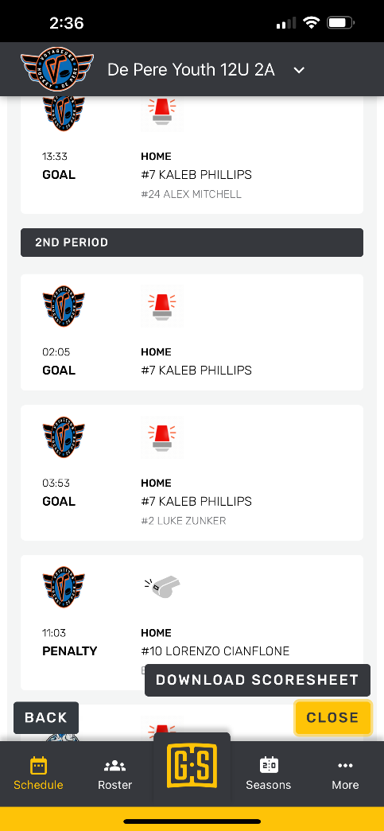
Photo #1: On the game sheet app, choose download scoresheet.

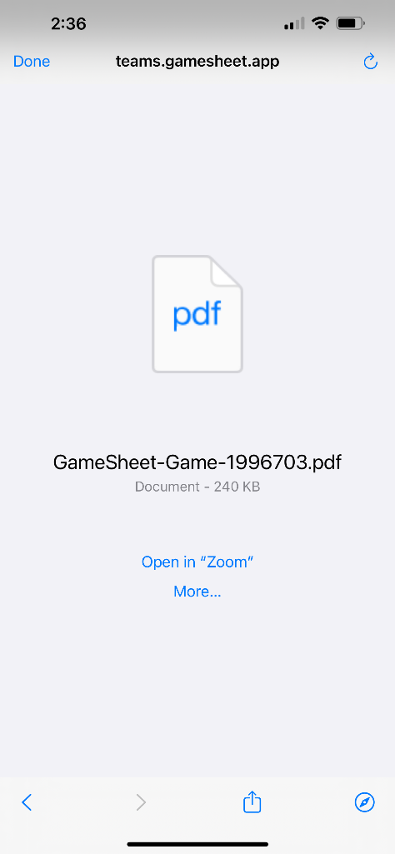
Photo 2: It creates a PDF of the game, upload to files on your phone.

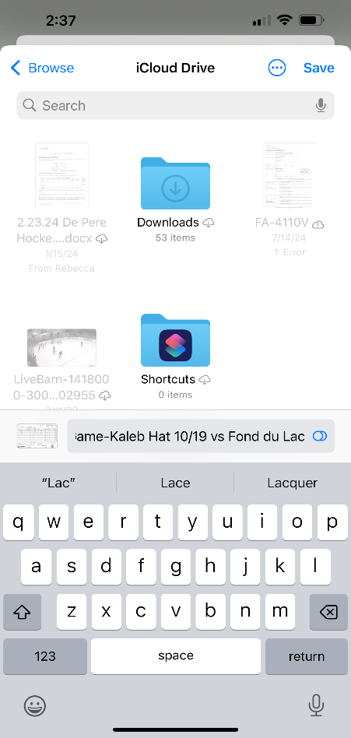

Photo 3: Name your file – Player, Patch, Date of game

Create a folder for 2024-2025 patches, move to folder.
At the end of the season, these are sent to the tournament coordinator.

