The following awards will be presented to three players per team during the main ceremony at the 30th Anniversary / Season-end Event on 3/21/26. NIHA Hockey Director, Jeff Laird, will announce the winners. Each recipient will receive a commemorative challenge coin at the event.

Coaches are asked to select their three award recipients and share names with Summer Dougherty asdougherty85@gmail.com no later than February 27th.

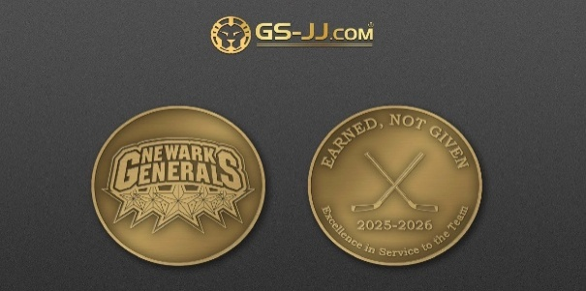
League-Wide Team Awards (3 per team)

Team/Division ______________________________________ Head Coach: _________________________________

Iron Standard Award (MVP)
Recognizes the player who sets the standard through consistent effort, grit, and accountability. This athlete shows up prepared with a strong attitude, puts in daily work, and makes a meaningful impact on gameplay, contributing to team success.
- Recipient name ______________________________________________________

Unit First Award
Awarded to the player who consistently puts team before self. Plays unselfishly and serves as a positive, supportive presence on the bench and in the locker room, demonstrating respect, collaboration, and commitment to teammates.
- Recipient name ______________________________________________________

Forged in Fire Award (Most Improved)
Honors the player who showed the greatest growth from day one to season’s end—physically, mentally, and emotionally—through effort, coachability, and resilience.
- Recipient name ______________________________________________________

